Potential Areas in England for the Location of Residential Substance Use Treatment Programs

November 2015

Table of Contents

Introduction…………………………………………………………………………………..……3

Summary………………………………………………………………………………………..…4

National Statistics…………………………………………………………………………………6

The Identification of Existing Residential Substance Misuse Programs…………………………8

London……………………………………………………………………………………...…… 9

Review of Drug and Alcohol Needs Assessments………………………………….……10

Hackney and City of London……………………………………………………….……10

Islington……………………………………………………………………………….…12

Tower Hamlets…………………………………………………………………..………12

Wandsworth……………………………………………………………………………..13

Birmingham………………………………………………………………………………..……18

Bristol……………………………………………………………………………………………21

Leeds…………………………………………………………………………………….………24

Liverpool….……………………………………………………………………………………..27

Closing Comments………………………………………………………………………………29

Glossary………………………………………………………………………………….………31

Appendix A –List of Figures…………………………………………………………….………32

Introduction

The purpose of this exploratory report is to examine potential areas in England for the location of new residential substance misuse treatment programs areas. The scope of the report excludes Ireland, Scotland, and Wales to keep the examination manageable. Even with this limitation, approximately 54.3 million persons lived in England in 2014. England comprises approximately 50 thousand square miles. Compared to the United States, England has more population than any American state, but has fewer square miles than 28 American states and has significantly higher population densities. Correspondingly, it has a more complex treatment structure.

Given the size of the geographical area, a decision was made to limit the initial analysis to five geographically distributed, large urban areas in England. Those cities analyzed are shown below:

- London, Southeast
- Birmingham, West Midlands
- Bristol, Southwest England
- Leeds, West Yorkshire
- Liverpool, Merseyside

Existing residential substance misuse treatment programs in these five areas were identified and mapped against socio-demographic data on income and population density. The purpose of the analysis is to identify areas where there is good population density and average to better median household income, but few or no existing detoxification or other residential programs. The report does not measure the number of persons that might use a program at each potential location.

There are systemic differences in the administration of drug and alcohol treatment between the United States and England. In England, these differences include:

- Drug treatment providers voluntarily report treatment data to a National Drug Treatment Monitoring System (NDTMS) and alcohol treatment providers report through a National Alcohol Treatment Monitoring System (NATMS).

- The NDTMS provides needs assessment data to what are called “local authorities” but access to the needs assessment is restricted to staff of the local authorities.

- All health-related programs appear to be required to register with the Care Quality Commission (CQC) and the CQC performs inspection visits of residential rehabilitation programs. However, significant numbers do not appear to have registered.

- Substance misuse programs appear to be registered with the CQC under the category of “residential rehabilitation homes” with the authority to provide substance misuse services. However, this is a general category and entities registered under this can also provide different services e.g., mental health and personal care.

- There appear to be no equivalent English data resources such as the United States’ National Survey of Substance Abuse Treatment Services (N-SSATS) or the National Survey on Drug Use and Health (NSDUH), or the block grant reporting system of the United States’ Substance Abuse and Mental Health Services Administration (SAMHSA).

- Although there are national systems of drug and alcohol treatment reporting which collect residential information, there appears to be no national or local-level public reporting on the occupancy rates or number of persons treated by each residential provider.

- In 2014 and 2015, Public Health England (PHE) supplied approximately £10,000,000 in construction and renovation funds for local programs. Construction funds are not typically provided under SAMHSA funding grants.

Summary

- To keep the report to a manageable scope, the authors decided to limit its focus to five larger urban areas in England excluding Ireland, Scotland, and Wales.

- PHE reports in 2012 and 2014 have focused on rehabilitation programs and provide national perspectives on their operations.

- The urban areas studied are London, Birmingham, Bristol, Leeds, and Liverpool.
- There are widespread statements in the English literature that heroin and other opiate use declined in the last five years especially among young persons. OxyContin use is increasing;

- In 2011-2012 there were an estimated 293,000 persons using opiates or crack cocaine;

- Successful treatment rates for opiate users are in the single digits and range from 30% to 50% for alcohol users;

- Alcoholism remains a difficult problem although rates of alcohol consumption are declining in younger populations;

- From 2008 to 2014, approximately 2.7% of the population treated for alcohol and drugs used residential services. Figure 3

- A search was made for current alcohol and drug needs assessments on the cities studied. A review of these assessments reveals they do not identify which or how many new or different services are needed and where they should be located.

- The area due west of London appears to be the best location in the greater London area for the location of new programs. Figure 8 An area north of London and southeast of Birmingham could also be considered. Figure 9

- A location near the junctions of M5, M6 and M54 just north–northwest of Birmingham and south of Stafford might be worth further analysis. Taking transportation routes into consideration, another potential location would be near the junctions of M54 and M6 and M6 north of Wolverhampton. Figure 13

- An area north- northeast of Bristol was considered, but the population in the studied area was not large enough to maximize the success of a new program. Additionally, Bristol and Super Mare Weston to the south already have about 12 residential programs. Figures 15, 16, and 17

- A new program east of Leeds or at York might be worth further analysis. The 45-minute drive ring around York appears to have the population size to support a new program. A program at York would have to draw from Leeds to be successful. Figure 19. 20, and 21

- A review of potential locations in the Liverpool area revealed no likely locations because of established competition within Liverpool and the presence of programs in adjacent areas. A site at Wigan was considered but rejected due to concerns about low population size. Figure 24

- The report contains capsule descriptions of 4-5 existing programs in each city.

National Statistics

Figure 1 presents English national drug treatment statistics showing that success rates of opiate treatment are in the single digits and success rates for non-opiate treatment range from 35% to 38% for the period 2008-2014. Waiting times for services are short, less than three weeks, and approximately 70% of estimated drug users receive some sort of service. Figure 2 shows opiate and crack cocaine use per 1000 adults for the five areas selected. Bristol and Liverpool have the highest rates and Leeds and London the lowest. English documents and data collection focus on the use of opiates rather than prescription usage, benzodiazepines, methamphetamines, and other topics familiar to American readers.

PHE estimated that in 2011-2012 there were 293,000 opiate and crack cocaine users in England. Considerable public efforts and changing cultural trends since 2000 have apparently resulted in a decline in opiate use especially among younger populations. The decline in use is reflected in a decline in the number treated. In 2013-14, approximately 193,000 persons were provided treatment, the lowest number since 2005. Alcohol misuse remains a significant problem affecting approximately 9% of men and 4% of women.

Residential programs have been an explicit focus of Public Health England since policy changes in 2013 shifted public funding of approximately 90 residential programs to local authorities. As in the United States, public rehabilitation funding is complex provided from a combination of local and central funds.

An informative National 2012 report extensively described residential rehabilitation programs and pointed out substantive difference among them in their success rates for treatment of drug misuse. The ability of programs to prove their treatment is successful is an issue in public decisions as to who to commission services from. In general, rehabilitation programs were more successful in their treatment of alcohol misuse. A survey of residential providers was conducted in 2014 and a snapshot report of publically funded rehabilitation programs was published.

The 2014 report makes the following general points:

- While funding for most providers has not decreased in recent years, both providers and local Commissioners anticipate reduced funding because of declines in funds available to local authorities.

- The numbers of people reported to the NDTMS over the last five years shows a general stability in numbers of people accessing residential rehab for alcohol and drug problems These trends follow the pattern of numbers accessing alcohol and drug treatment overall.

- Over three quarters of rehab providers said they have maintained occupancy at similar levels or increased it over the past five years. Under a quarter said their occupancy levels had decreased.

- For public providers, changes in referrals from local authorities were the largest reasons for changes in occupancy.

- Eighty-five per cent of commissioners reported that over the past five years, the numbers of people they funded for rehabilitation has not decreased. Of these, over half said the number persons served has stayed the same and one third said the number has increased. The commissioners with an increase in the numbers of people accessing rehabilitation indicated it was due to increased current levels of funding or were responding to a greater local need.

- Survey responses suggested that residential rehabilitation is still mostly a national rather than a local resource. About eighty percent of commissioners refer people out of their local area for services, and only fourteen percent keep clients in their home area. Three quarters of providers agreed that their clients mostly came from outside their area.

Data collection for a follow up survey was completed in October 2015 and the results will be published in 2016.

For a non-governmental view of the scope and depth of drug and alcohol treatment a report that is supportive of residential rehabilitation expansion see the Centre for Social Justice’s 2014 report. This 2014 report also raised concern about the increasing use of prescription opiates. OxyContin was prescribed by doctors more than a million times in England in 2014, an increase of 39% since 2010.

This same 2014 report said of residential rehabilitation:

“Residential rehabilitation, the most effective form of abstinence-based treatment, has been continually decommissioned. CSJ FOI requests revealed last year that 55 per cent of local authorities had reduced funding for residential rehab. Nationally, referrals to rehab have fallen 15 per cent between 2008/09 to 2011/12 compared to an overall reduction of 0.3 per cent for other treatments. Even though at the most effective abstinence-based rehabilitation centres over two-thirds of people beat their addiction.”

The 2014 report went on to propose a significant expansion of residential programs.

Figure 3 reports the numbers of persons receiving residential drug and alcohol residential services. The trend from 2008 to 2014 has been slightly down. Approximately 2.7% of persons treated for alcohol and drugs used residential services. The data on residential utilization is consistent with the 2014 provider survey.

The Identification of Existing Residential Substance Misuse Programs

The general category of residential treatment programs encompasses a wide range of programs from short-term detoxification of alcohol or other substances to longer term treatment ranging from month-long to year-long programs. To study potential residential treatment locations, a list of existing programs was created. The list was created from four data sources:

- Rehab Online, a site of Public Health England (PHE), listing rehabilitation services for adult drug and/or alcohol misusers in England and Wales, N=134;
- The searchable records of the Care Quality Commission (CQC) for licensed rehabilitation programs authorized to provide substance misuse services N=225;
- Provider lists of the National Drug Treatment Monitoring System (NDTMS) for the five cities identified above, N=700, and
- Websites of individual providers.

Each name on each list was examined. For each provider location, an effort was made to determine the bed size of the program and whether the program provided detoxification services. CQC is the agency in England that all healthcare providers are supposed to register with and CQC’s transparent data base of approximately 50,000 providers contains their name, address, and type of service in searchable formats. The CQC data does not show “registered beds” or whether detoxification is provided. While the PHE list was derived from CQC records, a comparison of information on bed sizes and detoxification shows differences in the description of programs. Moreover, providers were identified from the NDTMS that were not on other lists. Corroboratory searches of provider websites identified programs that were not on any list.

Residential rehabilitation programs registered with the CQC to provide substance abuse services also can and do provide mental health, personal care, room and board, and dementia services. Where possible, based on readings of program descriptions, programs that only offered mental health or primarily offered other types of services were identified and removed from the final list. Also, administrative office locations of providers were identified and removed from the list.

This extensive checking developed a list of 115 residential programs with 2,000 beds that appeared to offer substance abuse services primarily. An additional list of 63 residential programs with approximately 1,700 beds that offered substance abuse services including detoxification was developed. The lists include specialty mental health hospitals but do not include general hospitals that may have detoxification services.

Figure 4 maps the identified locations. Residential programs with detoxification services are denoted by circles with a red cross in them and programs without detoxification are denoted by a simple red circle. The cities selected for study are also shown on Figure 4.

London

London is divided into 33 regional boroughs which are local government entities that provide essential public services. According to PHE staff interviewed, there are no needs assessments reports for London as a whole. Alcohol and drug needs assessment reports for four of the Boroughs were examined. In general, the “drug treatment penetration rate” in London is 41% meaning 41% of persons using drugs are receiving treatment. In comparison, the rate for all of England is 51%. Figure 5 shows opiate and alcohol prevalence estimates for London’s boroughs.

Review of Drug and Alcohol Needs Assessments

Discussions with English staff at PHE indicate that needs assessments based on the contents of the NDTMS data are provided annually to each local authority commissioning treatment services. Access to these needs assessments is apparently not available to the general public. Rather, individual local authorities may have independent reports produced and a search was made for them in the urban areas studied.

There appears to be good local planning for the distribution of public alcohol and drug grants. Numerous examples of alcohol and drug needs assessments are available. Before identifying potential locations, alcohol and drug needs assessments for the selected cities were reviewed. In general, these assessments do not identify which or how many new or different services are needed and where they should be located. More specifically, only a few reports present a point-of-view on residential services.

Recommendations and factual highlights from needs assessments on the chosen urban areas in general show:

- Needs assessments tend to focus on prevalence and the cost of resulting social problems stemming from the misuse of substances.

- Public policy makers struggle with the same issues as policy makers in the United States.

- There is a widespread belief that heroin and other opiate use declined in the last five years especially among young persons;

- Successful treatment rates for opiate users are in the single digits with methadone maintenance being a major treatment method. Successful treatment rates for alcohol range from 30% to 50%;

- Alcoholism remains a difficult problem although rates of alcohol consumption are declining in younger populations;

Summary recommendations from each needs assessment are shown below.

Hackney and City of London

Hackney is a northeast London borough within Inner London. In 2012, it had an adult population of 181,000 persons. The needs identified in its substance misuse assessment and shown below do not typically state how much of what kind of services should be provided. They describe populations that need specific help, including service users with high social needs, people requiring alcohol detoxification, young people aged 19‐24 years, ‘high’ cannabis users, people in the “increasing risk” drinker category, older people on addictive long‐term prescription medications, and substance misusers needing access to psychological therapies.

The list of needs is a familiar one to American readers as substance abuse agencies in the United States have similar concerns with prevention, screening, assessment procedures, care coordination, transition planning among care settings, and mental health integration. These same policy issues swirl around current residential providers in the United States.

- “Consider more intensive outreach to engage with substance misusers who are not in contact with treatment services of any kind;

- Address service fragmentation issues by considering the option of introducing a single substance misuse service;

- Increase the level of provision available for young people 19-24, and increase the focus on educational and outreach interventions;

- Review the existing approach to implementation of alcohol screening, which evidence reviews have shown to be cost‐effective when carried out in association with a 5‐minute advice session (so‐called ‘brief intervention’);

- Review the existing provision for alcohol withdrawal/detoxification services and explore the potential for providing community‐based alcohol detoxification with GP support;

- Consider greater integration of support for patients with substance misuse problems into primary care;

- Improve services and pathways for substance misusers with high social needs, including facilitating their access to housing and benefits advice and support;

- Increase uptake of Improving Access to Psychological Therapies (IAPT) by people with substance misuse problems with a view to improving recovery rates from substance misuse;

- Develop treatment pathways for people using new psychoactive substances/legal highs and those misusing prescription or over the counter medications;

- Identify and review the medication requirements of older people on long‐term prescriptions for potentially addictive medicines, and

- Those receiving services and support for substance misuse should be regularly assessed for mental ill‐health and provided with the appropriate support and treatment for these conditions.”

Islington

Islington is a borough within Inner London. In 2012, it had an adult population of 157,000 persons and was the third smallest borough. The Islington drug and alcohol needs assessment is different from the Hackney analysis because fewer and vaguer recommendations are made and the text, which is largely comprised of data, does not appear to discuss the recommendations. For example, the Islington data shows treatment penetration rates range from 27% to 45%, but the recommendations make little reference to efforts to improve the treatment penetration rate.

- “Review services to ensure treatment pathway can meet the needs of the changing population of drug and alcohol users including:

  - Supporting clients with different patterns of drug and alcohol use;
  - Increasing uptake of treatment for people, including young people who misuse drugs and alcohol;
  - Supporting the treatment system to better promote recovery in the opiate using population, and

- Develop more flexible and personalised services, with a greater emphasis on community-based programs;

- Strengthen pathways into employment and engagement with housing and other agencies relevant to client’s recovery, and

- Ensure service users, families, partners, and friends are involved and supported.”

Tower Hamlets

The London Borough of Tower Hamlets is east of the city center and covers the traditional east end of London. In 2012, it had an adult population of approximately 193,000. The Tower Hamlets substance misuse needs assessment contains a thorough description of substance misuse patterns and multiple sets of recommendations spanning stakeholder and focus group reactions, key conclusions emerging from the analysis, contractual and operational issues of how the Borough operates its grant programs, and treatment priorities.

The Borough’s needs assessment showed that successful opiate treatment rates were going down, alcohol admissions have been increasing in recent years, and there is a concern that persons needing treatment were not being served. This factual situation is reflected in the “key treatment plan priorities” of the Borough:

- “Tower Hamlets has seen a slow decrease in opiate presentations over the last three years. However, this does not address the wider treatment naive population…;

- Services will need to be maintained and strengthened for non-opiate and other problematic substance misuse;

- There is a clear need to plan for and target the increasing emergence of alcohol;

- Increase the numbers of those entering the treatment system to maintain a steady client flow through;

- Undertake a more dynamic approach to sourcing new clients and or targeting ex-clients who may now be treatment naïve;

- Maximise the number of clients in effective treatment, this is currently falling and may affect future service success;

- Develop programmes to increase the recovery capital available to clients, and

- Work to address the recovery agenda and drive forward the increase in successful [treatment] completions”

Wandsworth

Wandsworth is another inner-city Borough in London. In 2012, it had an adult population of approximately 232,000. Key findings from its drug needs assessment refer to English drug usage. For example, there is an extensive literature about declines in English opiate and cocaine use especially among younger populations including uncertainty as to why the decline is happening and the fact that persons in treatment are older now than in previous years. Wandsworth findings relevant to national use include:

- There has been a decline in the age groups (18-44 years) in drug treatment locally and in London. In Wandsworth, the greatest fall has been among 18–24-year-olds. From 2009/10 to 2012/13 there was 42% decline in the number in drug treatment for this age group;

- There has been a reduction in primary crack users accessing treatment. The national trend estimates numbers of primary crack users are in decline – however, the downturn in Wandsworth is much larger This may well be caused by potential service users considering that the provision available does not meet their needs, and

- Over the past few years, nationally, there have been substantial changes in patterns of drug use including increased use of novel psychoactive substances, (club drugs).

Key findings from the Wandsworth data on alcohol seem to correspond to national trends and are worth mentioning because of their similar resemblance:

- The latest prevalence estimate showed approximately 21% of the adults in Wandsworth were binge drinkers;
- Nationally, there was a marked increase in alcohol-related hospital admissions across all age groups (2002- 2010), but the increase was greatest for older people: for men aged 65 and over, hospital admissions rose by 136% and 132% for women in this age group;
- The rates of alcohol-related hospital admissions for all ages have increased since 2008, the increase in Wandsworth is not significantly different to the England average;
- Alcohol treatment completion rates in Wandsworth have improved from 33% in 2011to 39% in 2014, and
- Mental health services have been the major source of referrals of clients into primary alcohol treatment in Wandsworth.

The recommendations that followed in the Wandsworth report were non-specific regarding what should be done with the aging of opiate treatment populations and increasing alcoholism.

In general, the London needs assessments reviewed above were nonspecific as to how many services of what kind are needed and where such services should be in the greater London area.

Figure 6 maps weekly household income in the London area and shows the location of nearby residential programs. On the income maps in this report, the darker the color the higher the income. As mentioned above, residential programs with detoxification services are denoted by circles with a red cross in them and programs without detoxification are denoted by a simple red circle. Bed sizes of the programs are shown next to the programs. Figure 7 maps population density in the London area and shows the same distribution of residential programs and bed sizes. On the population density maps in this report, the darker the red the higher the population density.

There is a dense concentration of programs in a north-south band in inner London, few to the immediate east and a circle of programs outside the motorway beltline. There is a string of programs between London and the coast and there are programs along the southern coast in the major ports.

The concentration of programs in the downtown core is anchored on the west by the 112-bed Priory Hospital in Reohampton. Priory is the largest behavioral health provider in England and Reohampton is part of the Priory’s chain of behavioral health hospitals. Using Roehampton as a marker, the next residential program is 25 miles to the west; the 24-bed Yeldall Manor. There are two 24-bed detoxification programs about 17 miles to the southwest: the Priory program in Woking, and Life Works. About 52 miles to the northwest is Ley Community’s detoxification program with 46 beds just north of Oxford. North by northwest is the Nascent 9- bed program about 21 miles from Reohampton.

Figure 8 shows a trapezoid west of London. The intent of this diagram is to delimit an area west of London where a new program could be built. This trapezoid encompasses 802 square miles and had an estimated 1,736,000 adults in it in 2011. The area contains Harrow, Watford, High Wycombe, Slough, and Reading which have less supply of residential substance abuse programs. While this area is characterized as less dense compared to English standards, the area nonetheless has a population density of more than 2,000 persons per square mile.

Major motorways are shown in blue on these London maps. Examinations of existing program locations typically shows that most programs are located near a major motorway and locations next to the junction of two or three major motorways have superior location capability
The area due east of London contains has an area approximately 10 by 20 miles that does not have a program in it. This is not as desirable an area as west of London. The eastern London area has both lower income and lower population density. Existing programs have been built on either side of this corridor: in the north above Basildon and Romford and in the south near Maidstone.

A look at programs south of London shows that urban areas along the coast typically have programs in them already. This is true of Brighton, Worthng, Portsmouth, Southampton, Poole, and Plymouth. This would appear to minimize the likelihood of an upscale hotel-like program like those found on the Florida coast.

There is a large area north of London and southeast of Birmingham that has few programs. This area encompasses the towns of Cambridge, Bedford, Milton Keynes, and Northampton. The hand drawn area on the Figure 9 has 1,845 square miles and 1,267,000 adults living in it. The secondary road network is shown on the map, and it provides access to all parts of the area. This would be a potential location that could be studied further.

A look at granular level roads and motorways shows that both the west and north of London areas have ample highway access. Relatively speaking, these areas are not as dense as the urban core and surrounding areas, however, the large population and small size of the country have resulted in a dense transportation network.
Existing programs in the area west of London include:
Life works
Life Works Community operates a focused substance abuse treatment program known as The Grange. Residential treatment, including detoxification, is provided at a Georgian Manor in the “tranquil” Surrey countryside. The Grange is registered to provide accommodation with nursing for up to 24 people, and at the time of the CQC inspection on July 9, 2014, there were eight people who used the service. Like other private programs specializing in substance abuse it tends to emphasize its amenities in addition to its programming. “Life Works is a beautiful Georgian Manor full of charm and elegance. We provide a luxurious atmosphere…” Its website indicates it accepts most private insurance.

Ley Community

The Ley Community Residential recovery program is located on five acres near Oxford. Its accommodations include landscaped grounds and grass areas, a small lake, herb garden, barbeque area, memorial garden, a swimming pool, and an all-weather football pitch and volleyball/badminton court. It has a 28-day detoxification facility, but its programming emphasizes a 26-week residential model. It is licensed for 58 persons and at the time of the last CQC inspection it had 29 residents.

As a non-profit it files an annual report. A review of its 21-page March 2014 report shows it a sophisticated organization with numerous community activities and alliances. Consistent with comments made in the survey of rehabilitation providers discussed above, its 2014 report says its main funding comes from contracts with local statutory authorities and health and social care budgets continue to be reduced creating uncertainty in how much money will be available for residential rehabilitation given competition from non-residential programs. In 2014, it generated about £988,000 of which £732,000 came from local authorities. It’s public funding notwithstanding, it would represent established competition to a new program in the Oxford area.

Nascent House
Nascent House is a nine-bed rehabilitation unit offering a program of recovery of up to six months for persons recovering from alcohol or drug misuse. At the time of the CQC inspection on May 7, 2014, there were two people living at the facility. Although Nascent has an appealing website with attractive pictures, CQC auditors were critical of the management of the program saying
“The manager had been absent from the home for a month. Senior managers were unable to explain or evidence what management was in place in the home. There were no senior staff in the home and none of the care staff had access to the guidance of a senior carer or manager.”

Priory Hospital in Woking
The Priory Hospital in Woking is a member of the Priory Group of behavioral health programs. Like other Priory Hospitals, it offers a broad range of services directed at any type of addiction or dependency. The website for the program in Woking stresses the “tranquil” country location of the large estate. It is difficult to identify statistics on the Priory Hospital programs. A search of the Hospital Estates and Facilities Statistics records of PHE did not show data for the Priory group. The Priory Hospital in Woking does not provide data to NDTMS, so no treatment statistics are reported. In general, the 2012 residential rehabilitation report stated that “Not all residential rehabs submit data to NDTMS. For example, one of the best-known rehabs, The Priory Group, takes private clients but is not commissioned by any local partnership.“

Yeldall Manor

Located on 38-acres of Berkshire countryside, Yeldall Manor operates a male-only medically managed detoxification program at its Manor and a 12 – 24 week residential post-detoxification program is offered in its Lodge. The Manor has a capacity of 24 and the Lodge has a capacity of nine. The program claims an 82% detoxification success rate. Yeldall Manor is a member of the Evangelical Alliance and residents are required to attend prayer service. In 2014, it had an income of £736,000 and a staff of 17.
In 2013, Yeldall Manor had an occupancy of 12.78 versus a budgeted 15.0, approximately 33% completed the program, and its 12-week retention rate was 53%. In 2014, it had an average occupancy of 13.57 versus a budgeted 15.0, 39% completed the program, and its 12-week retention rate was 56%.

Birmingham

Birmingham’s 2013-2014 Drugs & Alcohol Needs Assessment contains numerous maps and tables showing drug and alcohol use and statistics. As with other needs assessments reviewed, the assessment does not actually identify how many of what kind of services are needed and where are the service needed. However, the report lays out basic contextual information well:

- Alcohol is a widespread problem and there are significant gaps between how many persons need alcohol misuse treatment and how many receive it. Only 12% of dependent drinkers are in treatment;

- Opiate treatment success rates are low. On average 8% of opiates clients and 43% of non-opiates clients complete their treatment;

- Treatment services across Birmingham are commissioned to support mainly heroin and crack addicts yet non-Opiate and Crack Users (OCU) clients are increasing – particularly alcohol clients. There were an estimated 3,381 OCU users who had not engaged in treatment in Birmingham since 2011;
- Most treatment agencies have clients from more than 20 different wards in Birmingham, implying that large numbers of clients are travelling outside not only their ward but also their constituency area to obtain drug treatment;

- The population of Birmingham is projected to increase by 150,000 over the next fifteen years. Future strategies need to take this into consideration, and

- Park House, a residential program, opened in July 2010 and demand has outstripped capacity. There are a few non-commissioned religious organisations across the City that can increase bed space capacity for in-patient services.

Figure 10 presents drug treatment data for Birmingham showing that success rates of opiate treatment are in the single digits and success rates for non-opiate treatment range from 32% to 48% for the period 2008-2014. Waiting times for services are short, less than three weeks, and, depending on the year, 63% to 73% of estimated drug users receive some sort of service. Compared to national figures, Birmingham had average rates which were like national rates.

There are interpretational incongruities in these Birmingham data and in comparable data on other English cities. Small percentages complete treatment, but high percentages of persons using drugs and alcohol are said to be receiving treatment. Estimates of persons needing services are available, but assessments based on these estimates are not available to the public. The major public policy focus has been on opiates and crack cocaine and prevalence estimates of prescription drug abuse or other abused substances e.g., benzodiazepines are not available.

Figure 11 contains weekly household income and program locations in the greater Birmingham area. Figure 12 contains population density and program locations. An examination of the two figures shows that existing programs tend to be in the lower income, higher population density sections of the city south of the junction of M5 and M6. There are six programs in the Nottingham area about 40 miles to the northeast of Birmingham and another five in Leicester to about 35 miles to the east. Locations in the south of Birmingham such as the junction of M5 and M42 and in the southeast at the junction of M42 and M40 do not appear to have as many higher density areas as potential locations in the northwest.

A program to the north-northwest of Birmingham might be feasible. The nearest programs to the northwest are 56 and 60 miles from Birmingham. Figure 13 shows a hand drawn polygon around areas in the north-northwest of Birmingham. An analysis of the area shows the polygon covers 1,591 sq. miles and contains approximately 1,272,000 adults. In addition to the major motorways, the secondary road network is shown on the map, and it is a well-developed network. A location near the junctions of M5, M6 and M54 just north of Birmingham and south of Stafford might be worth further analysis.

There appear to be no programs on the east and north of Birmingham. Taking transportation routes into consideration, one potential location would be near the junctions of M54 and M6 and M6 north of Wolverhampton. A program in this area would have the potential of drawing from the north and east side of Birmingham e.g., Wolverhampton and Walsall, as well as from Telford in the northwest via M54. The Manor is located on the eastern side of Birmingham and a program placed on the eastern side would be in direct competition with the Manor.

Existing programs in the Birmingham area include:

Changes UK

Changes UK is a private company although it does have financial arrangements with the Birmingham City Council having received £13,542 from the council in 2014. It is registered for 51 beds and uses some of these for detoxification and others for post detoxification residential care. It also provides recovery related services e.g., to help persons find housing. This is a private company and a review of the financial documents it files shows it files an abbreviated asset and liability sheet and is exempt from more detailed filings because it is a “community interest company.” This is a small company having only £64,000 in the bank in 2014.

Livingstone

Livingstone is a small, 12-bed evangelical Christian program for men providing alcohol and drug detoxification followed by 12-step residential programs. It has three post detoxification residential programs with bed sizes ranging from 7-9 beds.

Manor

Operated by the Bayberry Company, the website of the Manor House sells itself as a luxury accommodation. It has ornamental gardens, individually styled rooms, a gym, a spa, afternoon tea, and equine assisted therapy. Fees start at £2,250 per week and it is a four-week program. The website is frank in saying that this is a private pay facility and referrals from the National Health Service (NHS), or a general practitioner are not needed. Of the NHS, the website says:

“The NHS does offer some residential places. If you are looking for an NHS place, you must visit your GP for a referral. Many clients tell us that they have tried this route and found that this is not always easily accessible and there may be some delay waiting for a place if one is offered. When clients are ready to accept that they need help, that is the time they most need to get help. Waiting lists are not conducive to this, so, for many, private treatment is the only option.”

The Manor is competition for a new program focused on private pay clients. The Manor does not participate in NDTMS, and no occupancy or treatment statistics are available on it.

Park House

Park House has received substantial public funding from the Birmingham City Council. The program had nine detoxification beds and nine post-detoxification beds. In 2014 and 2015 there were City Council discussions on what to do with the beds with one possibility being of transferring the nine post-detoxification beds to the Summerhill program. In 2011-2012, 164 persons completed alcohol detoxification 151 completed drug detoxification. Of all persons, including those who completed treatment and those who were transferred to other programs, 44% cited alcohol as the primary drug, followed by “other drugs” at 33% and heroin was cited by 20%.

Bristol

Bristol, in southwest England is the most populous city in southern England after London. In 2013, the Bristol Post reported that “Bristol has one of the biggest drug problems in the country outside London, comparable with that of Birmingham and Manchester.” The most recent drug and alcohol information for Bristol appears to be the 2012 Bristol Drug and Alcohol Online survey. This online survey, of 600 anonymous, non-random respondents, found:

- High levels of alcohol use were recorded for all groups;

- Cannabis, ecstasy/MDMA, nitrous oxide and cocaine were also frequently recorded;

- There were extremely low levels of heroin and crack use recorded;

- There was evidence of newly emerging substances, including nitrous oxide, ketamine, and benzodiazepines;

- The substance used daily by the highest number of participants was cannabis;

- 60% of the sample were poly substance users;

- A high percentage of participants recorded concerns about their substance use. Most of these related to physical and mental health;

- There were low levels of awareness about Bristol substance misuse services, particularly among those who did not use opiates and crack;

- Respondents also recorded low levels of contact with substance misuse services, and

- Comparison between Bristol residents and non-Bristol residents in the sample showed higher levels of use of a range of substances for those living in Bristol.

Figure 14 presents drug treatment data for Bristol showing that success rates of opiate treatment are in the single digits and success rates for non-opiate treatment range from 36% to 42% for the period 2008-2014. Waiting times for services are short less than three weeks, and, depending on the year, 61% to 64% of estimated drug users receive some sort of service. Compared to national data, Bristol had similar treatment completion rates and percentages of persons using opiates who were served but was noticeably lower in its waiting times indicating longer wait periods.

Figure 15 contains weekly household income and program locations in the greater Bristol area.

Figure 16 contains population density and program locations. There are low-income areas in downtown and southwest Bristol and in Weston Super mare, 20 miles to the southwest. Around these low-income areas are higher income areas with lower population density. The area between the two cities contains scattered concentrations of higher income and or higher population density. Areas of northern Bristol have both higher income and higher population densities.

There are two clusters of programs one in each city. A good location for a program would be between Bristol and Super Mare Weston, however, there is already one 10-bed program offering rehabilitation services in Wrington, located between Bristol and Super Mare Weston.

A potential location for a program might be in north Bristol. Figure 17 focuses on this area. A location near the junctions of motorways M4 and M5 would have excellent transportation access. While northern Bristol has good population density, this general area has lower population density. To estimate the population size of this area, a hand drawn area on Figure 17 was created encompassing northern parts of the city of Bristol, excluding the center of Bristol, and including Newport, Bath, and the area northeast of the city. The population size inside this irregular polygon was analyzed and the polygon was estimated to contain 743 sq. miles and 622,000 adults. The population appears small making this a less desirable area in which to locate new programs. Bristol already has a dozen areas further contributing to the difficulties a new program would encounter.

It might be possible to build a smaller, upscale program between Clevedon and Bristol on the coast. This section of the coast has good income properties and the M5 motorway provides ready access to the coast. A new program in Super Weston Mare would face established competition.

Existing programs in the Bristol area include:

Acer Unit

Acer is a 10-bed, inpatient detoxification and stabilization regional resource and has “treatment episodes” commissioned by Safer Bristol Partnership and Safer South Gloucestershire. Treatment for people from other areas is available to spot purchase. Acer Unit is operated by a charitable fund called the Avon and Wiltshire Mental Health Partnership NHS Trust Charitable Fund. A review of the income of the charity shows it ranged from £89,000 in 2010 to £82,000 in 2014.

Addiction Recovery Agency

Addiction Recovery Agency (ARA) offers a 40-bed accommodation for people who are totally abstinent following a detoxification program and need an environment supporting their abstinence. Residents are likely to come from a “preparation accommodation” or prison after completing a treatment program, detox, or from a “dry accommodation” where their abstinence is possible at risk. Its program completion rate is 58%

A review of ARA’s filings shows it has broken even from 2010 to 2014 but its income has steadily declined from £2,990,000 in 2010 to £2,234,000 in 2014. ARA appears to rely on government grants and is now under financial pressure due to the loss of Bristol recovery and treatment funding in a competitive tender; a loss of approximately 20%-25% of its funding.

Chandos House

Chandos House is an all-male residential treatment facility with 10 licensed beds. On the date of its inspection by CQC, December 11, 2013, there were 9 residents. Chandos House is in the Horfield area of Bristol and provides residents housing up to two years. Chandos charges residential public clients referred by a local authority £700 to £1100 a week and charges private residential clients £1400 to £2800 a week. Although it self reported to PHE that it provides detoxification services, its website makes no reference to detoxification. It does not sell itself as a having superior accommodations and pictures of its rooms show spartan furnishings.

Priory Hospital Bristol

The Priory Hospital Bristol, incorporating The Priory Grange Bristol, is another facility in the Priory which is possibly England’s largest provider of behavioral health. The Hospital specializes in the management and treatment of acute and complex mental health problems including the treatment of alcohol and drugs. It offers a conglomeration of services of which substance misuse addiction is one. Its CQC report indicates it has 68 licensed beds. The facility self reported to PHE that it has 38 registered beds and does not provide detoxification services. Its website contains no information on occupancy and it is not registered with NDTMS, so no reporting of addictions treatment is made by the hospital,

Over 85% of the services provided by the Priory Hospital are publicly funded, but the website of the hospital makes appeals to private pay when by saying:

“There are many reasons why people choose to pay to receive expert and dedicated treatment with the Priory Group. It may be because local NHS providers do not offer the specific treatment necessary, or that there is insufficient capacity and long waiting times. Alternatively, you may simply prefer the peace of mind of receiving rapid-access and expert care from the UK’s leading independent provider of mental healthcare and addiction treatment services”

Salvation Army Bristol Bridge Detox

The Salvation Army Bristol Bridge Detox facility is a 24 registered bed facility providing detox services to homeless people in Bristol. All clients must be homeless people from Bristol. The project will sometimes visit clients in prison. After detox, clients will either go to the Salvation Army rehabilitation unit or to another unit of their choice.

The Salvation Army Bristol Bridge Detox facility provides a ten-day course where Subutex is provided for clients with heroin addiction, plus another four days recovery if required. An eight-day reducing course of Librium for alcoholics is also provided, plus recovery time if required. Detox for Benzodiazepines is not provided but a slow reduction on the preparation unit is allowed.

Wrington and Broadway Lodge

Wrington is a ten-bed post-detoxification program that starts with intensive therapy and moves to strengthening independent living skills. Wrington was registered in 2014 with CQC and has not been inspected. Broadway Lodge contains both rehabilitative services and a detoxification program. The Broadway Lodge was established in 1974 in Weston Super Mare. It opened a new ten-bed detoxification unit in 2010, has a well-established residential program, and would appear to offer substantial competition to a new program. Private pay might prefer to go here than to Chandos and the Salvation Army in Bristol.

A review of Broadway Lodge financial filings showed it generated £2,644,000 in fee income in 2013. Broadway Lodge has been consistently profitable, averaging about £100,000 in profit each year while growing total revenue from £2.3 million in 2010 to £3.1 million in 2013.

Leeds

Leeds is a major urban area in the central north of England in West Yorkshire. In 2012, the Joint Strategic Needs Assessment (JSNA) project published both drug misuse and alcohol needs assessments. The 2012 reports used data from 2009-2010 and it is not clear what prevalence changes may have occurred in recent years such as a leveling off of treatment penetration rates. The 2012 report was primarily focused on showing the cost effectiveness of drug treatment and protecting the region’s budget allocation from the central government’s proposed performance-based allocation cuts. Leeds has low performance rates and new allocations based on performance would have lowered the funding to Leeds.

Figure 18 presents drug treatment data for Leeds showing that success rates of opiate treatment are in the single digits and success rates for non-opiate treatment range from 28% to 34% for the period 2008-2014. Waiting times for services are short, less than three weeks, and, depending on the year, 62% to 65% of estimated drug users receive some sort of service. Compared to national data, Leeds had lower treatment completion rates and lower percentages of persons using opiates who were served.

Figure 19 contains weekly household income and program locations in the Leeds area. Figure 20 contains population density and program locations. The Figures show there is one residential program in Leeds and three on the outskirts. The inner part of Leeds has lower income areas which extend to the northwest, southeast and northeast. Researchers were able to identify only one program, St. Anne’s Community, which offers residential substance misuse treatment. The nearest other programs are Cygnet 13 miles to the north, Bradford eight miles to the west and Linwood Park 16 miles to the south.

There are no programs to the east of Leeds raising the possibility of a potential location in this area. For example, a location at the junction of Motorways A1 and A64 could potentially draw persons from York to the northeast and Wakefield to the south. York is about 15 miles from the junction and Wakefield is about 18 miles from the junction. The next program east of Leeds is at Hull about 50 miles from Leeds.

In 2015, PHE provided £35,000 to the local NHS trust program New Beginnings Service in Doncaster to help it provide more detox services. Doncaster is about 25 miles south southeast of Leeds.

A program at York would be worth considering. Figure 21 shows a 30-minute and 45-minute drive rings around York. The 30-minute drive ring contains 1,090 square miles and about 543,217 adults. The 45-minute drive ring contains 2,859 square miles and about 2,015,000 adults. A program at York would have to draw from Leeds to be successful. The York area has an OCU prevalence percentage of 8.35%. The percentage change in hospital admissions due to alcohol from 2010 to 2015 was 46%.
Existing programs in the Leeds area include:

Cygnet

Cygnet Hospital in North Yorkshire is part of Cygnet Health Care, a nationwide network of hospitals established in 1988. Cygnet is about 14 miles north of Leeds. There are 36 beds at this facility and 11 are designated for detox.

Cygnet’s Detox 5 program is a 5-day medically supervised residential detoxification, program that treats people who have an addiction to heroin and other opiate based drugs including methadone and codeine-based painkillers. After Detox 5, clients are offered a 12-week telephone follow-up service. Cygnet also recommends that naltrexone must be taken for 12 months following detoxification to improve the chances of a successful recovery. The five-day detoxification program costs £3,200. Adding one additional week would cost a total of £5,855 and adding two additional weeks would cost a total of £8,355.

Oasis Communities Bradford
Built in 2009, Oasis Communities Bradford is an inpatient medically managed detoxification and residential rehabilitation center. It is about 8 miles to southwest from Leeds. Originally commissioned by the Department of Health, it was the only accessible detoxification unit in West Yorkshire. The 17-bed detoxification unit is equipped to accommodate people with limited mobility and wheelchair users. Oasis operates rehabilitation programs and persons completing detoxification are referred to the rehabilitation programs in Lancaster and Runcorn.

Linwood Park

Linwood Park is a 34-bed residential detoxification and rehabilitation program located on the outskirts of Barnsley, South Yorkshire. Program descriptions say the alcohol detoxification process usually takes 7 days. Treatment is conceived of as occurring in stages and lasting as long as 12-months. Linwood Park takes those that have served prison sentences but does not accept pedophiles, and those convicted of a sexual offence or arson. The program was registered by CQC on 20 July 2015 and not been inspected yet. Linwood Park Rehabilitation Centre is now operating under new ownership of the Astonbrook Group, a company formed in August 2014.

St. Anne’s Community

St. Anne’s Community is a charity and a housing agency providing assistance to persons with intellectual disabilities and developmental disabilities, mental health circumstances and substance misuse issues. It provides both alcohol and substance misuse detoxification in “premises close to Leeds city centre.” It is a large agency with 1,324 employees in 2014. Its annual report for 2014 and its strategic plan for 2014-2020 indicate that St. Anne’s operates programs in 18 locations in northern England.

The annual report also states that “…we continue to face many challenges as the impact of the many funding reductions in the majority of services we provide continues.” The agency received £4,818,000 in revenue for operating its residential programs in 2014. However, St. Anne’s financial stability is being undermined by the need to make large payments to a regional pension fund which is underfunded, and the agency ran a deficit of £669,000 in 2014.

Liverpool

Liverpool is a port city in Merseyside in northwest England near the Irish Sea. Liverpool discussions of substance misuse say that “…the Liverpool rate of opiate use/crack use was significantly higher than nationally and the highest rate among the core cities.” Liverpool is one of the few cities whose documents summarize a point of view about residential rehabilitation:

“Whilst most drug treatment takes place in the community close to families and support networks, NICE guidance recommends residential rehab is appropriate for the most serious cases, and this option is encouraged as part of an integrated recovery-orientated system. In 2011-12, 123 people (3% of adult drug users in treatment) in Liverpool attended residential rehab during their latest period of treatment, compared to 2% nationally.”

As in other assessment documents, there are clear data showing that supply and demand have balanced in such a way that waiting times have been reduced in recent years. In addition, as in other assessment reports, treatment success rates for persons with opiates are low. Liverpool reports a 7% success rate compared to a national average success rate of 9%. Success rates for non-opiate users were 51% in Liverpool compared to 41% nationally.

Liverpool’s 2014 Alcohol Health Needs Assessment states the city had approximately 98,000 binge drinkers and more than half the city drinks above recommended guidelines for alcohol.
This 101-page report on alcohol documents the widespread problems stemming from alcohol misuse and the need for more treatment.

Figure 22 presents drug treatment data for Liverpool showing that success rates of opiate treatment are in the single digits and success rates for non-opiate treatment range from 44% to 50% for the period 2008-2014. Waiting times for services are short, less than three weeks, and, depending on the year, 77% to 100% of estimated drug users receive some sort of service. Compared to national data, Liverpool had similar rates.

Figure 23 contains weekly household income and program locations in the greater Liverpool area. Figure 24 contains population density and program locations. Liverpool is geographically circumscribed as a port city. There are two programs offering detoxification services on the Wirral Peninsula across the Mersey River. In 2015, PHE provided £178,000 in funding to expand detoxification services on the Wirral peninsula. There are two residential programs in Liverpool per se and a residential program, Oasis Runcorn, is approximately 10 miles to the southeast.

A review of potential locations in the Liverpool reveals no likely locations.

There are four programs in the north ranging from 15 to 27 miles away and a Turning Point program about 15 miles to the southeast. Manchester, 30 miles to the east, has a dense concentration of programs.

A site at Wigan, about 17 miles to the northeast, was examined, but there were only 304,000 adults within ten miles of Wigan. In 2015, PHE provided £253,000 in funding to expand a farm –based recovery program in Wigan.
Existing programs in the Liverpool area include:
Birchwood

Birchwood Residential Treatment Centre is a 20-bed detox facility in Wirral, Merseyside, operated jointly by ARCH and the Cheshire and Wirral Partnership NHS Foundation Trust (CWP) providing medically monitored and managed inpatient drug and alcohol treatment. It sells three “packages” of services: detoxification, stabilisation, and stimulant services. Prices for the packages are not listed on the Birchwood website.

The Havens

The Havens, is a 29-bed residential recovery Center run by Park View Project in Stoneycroft. Although the web site is under Park View Project, according to information provided on the site, Riverside ECHG has acquired the operations of Park View Project on March 4, 2015.

The program describes itself as having a normal stay of between 12 -18 weeks. During this time, clients are taken through Steps 1-5. The second phase of a person’s treatment – steps 6 to 12 is performed at Unity House – also run by Park View Project. Like Unity House, this is a strictly a total abstinence project. Admittance is contingent on a clean urine sample and alcohol test including being free of methadone and sedatives.

Oasis Community Runcorn
Oasis Community Runcorn is 36-bed residential rehabilitation program located in Cheshire.This program was registered by CQC on 26 August 2015 and has not been inspected yet. Run by Oasis, in addition to other clients, the program serves as a post-detoxification program for persons going through the Oasis Bradford detoxification program.

Phoenix Futures Wirral

Operated by a large charity, Phoenix Futures, Futures is a 32- bed residential detox facility located in Wirral, close to Liverpool. The web site says the program provides both on and off-site recreational activities. A stay normally lasts between three and six months. After completing treatment at the residential facility, residents move into one of the program’s supported housing services or their own accommodation. Clients can be referred through their local authority and Futures also takes self-funded clients. Future’s response to the Rehab-Online survey states that it will only accept English-speaking clients because program participation is a necessary part of treatment.

In 2015, the income of Phoenix Futures, across all lines of business was £27,571,000. Their 50-page 2014 annual report describes a large 45-year old parent organization with manifold behavioral businesses in England and Scotland. Phoenix has substantive financial reserves and could respond to arising competitive challenges.

Unity House

Unity House is a 17-bed residential second stage recovery center for men and women located in Newsham Park. The first stage of the program is performed at The Havens, also run by Park View Projects. Although the web site is under Park View Project, according to information provided on the site, Riverside ECHG acquired the operations of Park View Project on March 4, 2015.

Program descriptions say a client’s stay can last up to 6 months and during this time, clients are taken through Steps 6-12 of the 12 Steps program. Park View is a strictly a total abstinence project. Admittance is contingent on a clean urine sample and alcohol test. This includes methadone and sedatives.

Closing Comments

This report has identified five potential areas where new residential programs may be considered:

- West of London;
- North of London and southeast of Birmingham;
- Near the junctions of M5, M6 and M54 just north–northwest of Birmingham and south of Stafford;
- Near the junctions of M54 and M6 and M6 north of Wolverhampton, and
- East of Leeds or at York.

The report also indicates that sites north-northeast of Bristol and in the Liverpool area were not as promising. There are significant operational and cultural differences in how English and American drug treatment programs are administrated and operated. Before any locational decisions are made, local persons knowledgeable about alcohol and substance misuse should be consulted.

The absence of data on current program utilization and the vagaries of how programs are registered to provide substance abuse services make the analysis of current utilization problematical. For example, it is likely that residential utilization is underestimated given a lack of reporting by some providers serving private pay clients. There are also considerably fewer data elements available for local regions in England than there are for the United States. A respectable effort at developing local information should be undertaken before a location is selected.

A search of English literature did not find any analyses of the size of the private rehabilitation market outside of the services commissioned by local authorities.

Les Hendrickson, Ph.D.
Hendrickson Development
leslie.c.hendrickson@gmail.com
http://hendrickson-consulting.com/

Glossary

CQC Care Quality Commission

Commissioners Local public officials that issue contracts for purchasing behavioral health services

Commissioning The purchasing of goods and services

Competitive tender A bidding process in which a public agency solicits offers, or tenders, to provide goods or services to the agency.

JSNA Joint Strategic Needs Assessment

Local Authorities local public governments

NDTMS National Drug Treatment Monitoring System

NDEC National Drug Evidence Centre (University of Manchester)

NTA National Treatment Agency for Substance Misuse

NICE National Institute for Health and Care Excellence

OCU Opiate and Crack Users

PHE Public Health England

Rehab Online A list of residential rehabilitation programs maintained by PHE

Residential rehab setting A structured drug and alcohol treatment setting where residence is a condition of receiving the intervention. A residential program may also deliver an “assisted withdrawal program,” i.e., detoxification

SMS Substance misuse services

Substance misuse A phrase ubiquitously used in English literature that is synonymous with American usage of the phrase “substance abuse”

Treatment Penetration Rate Percentage of the population needing treatment that receives it
Appendix A

When reading a copy of this report in Word, Figures in the Appendix are best viewed using Microsoft Word’s Zoom command. This command is found by clicking on the View tab on the ribbon. One of the commands in the View menu is called Zoom. Clicking on this command will enable you to increase the magnification of that part of the document you are looking at. A magnification of 250% will show the details of the Figure.

List of Figures

Figure 1: English Drug Treatment Statistics, 2008-2014.

Figure 2: Opiate, Crack Cocaine and Alcohol use in Five English Cities, 2010-2015.

Figure 3: Number of Persons Served in Residential Rehabilitation Programs, 2008-2014.

Figure 4: Residential Substance Abuse Programs in England, 2015.

Figure 5 Opiate, Crack Cocaine, and Alcohol use in London Boroughs, 2010-2015.

Figure 6: London Weekly Household Income (2011) and Residential Programs (2015).

Figure 7: London Population Density (2011) and Residential Programs (2015).

Figure 8: West of London Population Density (2011) and Residential Programs (2015).

Figure 9: North of London Population Density (2011) and Residential Programs (2015).

Figure 10: Birmingham Drug Treatment Statistics, 2008-2014.

Figure11: Birmingham Weekly Household Income (2011) and Residential Programs (2015).

Figure 12: Birmingham Population Density (2011) and Residential Programs (2015).

Figure 13: North-Northwest of Birmingham.

Figure 14: Bristol Drug Treatment Statistics, 2008-2014.

Figure 15: Bristol Weekly Household Income (2011) and Residential Programs (2015).

Figure 16: Bristol Population Density (2011) and Residential Programs (2015).

Figure 17: North of Bristol Population Density (2011) and Residential Programs (2015).

Figure 18: Leeds Drug Treatment Statistics, 2008-2014.

Figure 19: Leeds Weekly Household Income (2011) and Residential Programs (2015).

Figure 20: Leeds Population Density (2011) and Residential Programs (2015).

Figure 21: 30 and 45-Minute Drive Rings around York, 2015.

Figure 22: Liverpool Drug Treatment Statistics, 2008-2014.

Figure 23: Liverpool Weekly Household Income (2011) and Residential Programs (2015).

Figure 24: Liverpool Population Density (2011) and Residential Programs (2015).

Figure 1: English Drug Treatment Statistics, 2008-2014.
Adult Primary Drug Clients | 2008-2009 | 2009-2010 | 2010-2011 | 2011-2012 | 2012-2013 | Year to End Oct. 2014
Treatment Completion | - | - | 7.34 | 8.53 | 8.11 | 7.69
(% opiate clients)
Treatment Completion | - | - | 34.83 | 37.55 | 37.69 | 38.34
(% non-opiate clients)
Waiting Times * | - | 94.4 | 95.97 | 97.23 | 97.83 | -
(% under 3 weeks)
% Opiate Treatment Penetration | 69.4 | 71.6 | 72.5 | 71.1 | - | -
Data: National Drug Treatment Monitoring System

Figure 2: Opiate, Crack Cocaine and Alcohol use in Five English Cities, 2010-2015.
Region | Local Authority | 15-64 population  2010-2011 | Opiate and Crack Cocaine User per 1000 Adults 2010-2011 | % Change in Hospital Admissions due to Alcohol 2010 to 2015
Southwest | Bristol | 297,600 | 18.02 | 8.35%
Northwest | Liverpool | 327,300 | 16.52 | 7.91%
West Midlands | Birmingham | 705,200 | 15.23 | 21.86%
Yorkshire & Humberside | Leeds | 511,600 | 10.70 | 10.17%
London | All 33 Boroughs | 5,756,800 | 10.47 | 29.76%
England | England | 34,991,400 | 8.40 | 23.10%
Data: National Treatment Agency, and Local Alcohol Profiles for England (LAPE). Population and Prevalence
Information are the latest available from NTA and are based on 2010-2011 data.
Figure 3: Number of Persons Served in Residential Rehabilitation Programs, 2008-2014.
 | 2008-09 | 2009-10 | 2010-11 | 2011-12 | 2012-13 | 2013-14
Alcohol | 3,950 | 4,325 | 4,132 | 4,268 | 4,134 | 4,368
Drugs | 4,711 | 3,914 | 4,232 | 4,026 | 3,974 | 3,935
Total Residential | 8,661 | 8,239 | 8,364 | 8,294 | 8,108 | 8,303
Total in Drug Treatment | 210,815 | 206,889 | 204,473 | 197,110 | 193,575 | 193,198
Total in Alcohol Treatment | 100,098 | 111,381 | 111,025 | 108,906 | 109,683 | 114,920
Total All Treatment | 310,913 | 318,270 | 315,498 | 306,016 | 303,258 | 308,118
% Total Residential/Treatment | 2.79% | 2.59% | 2.65% | 2.71% | 2.67% | 2.69%
Data: Public Health England 2008-2014 and National Drug Treatment Monitoring System

Figure 4: Residential Substance Abuse Programs in England, 2015.
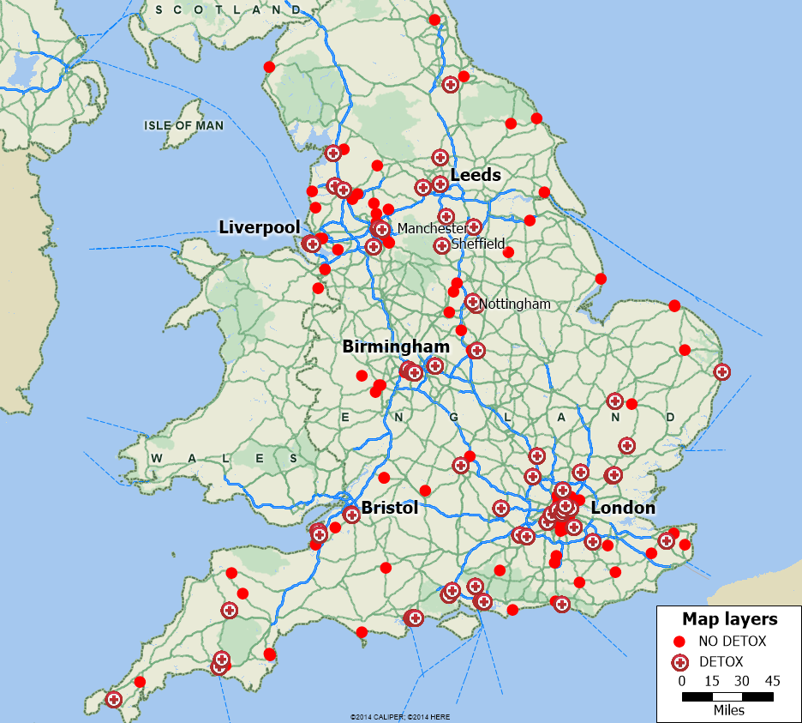
Data: Care Quality Commission, Rehab Online and provider websites
Figure 5: Opiate, Cocaine, and Alcohol use in London Boroughs, 2010-2015
London Borough | 15-64 population 2010-2011 | Opiate and Crack Cocaine Users per 1000 Adults  2010-2011 | % Change in Hospital Admissions due to Alcohol 2010 to 2015
Barking and Dagenham | 121,700 | 8.87 | 30.14%
Barnet | 239,700 | 6.22 | 30.33%
Bexley | 151,000 | 4.01 | 30.34%
Brent | 220,000 | 8.34 | 38.32%
Bromley | 201,200 | 5.55 | 25.04%
Camden | 162,300 | 13.63 | 26.42%
City of London | 5,800 | 5.18 | 49.90%
Croydon | 245,800 | 7.79 | 25.87%
Ealing | 237,600 | 10.87 | 11.23%
Enfield | 208,800 | 7.40 | 50.95%
Greenwich | 176,700 | 10.68 | 36.59%
Hackney | 181,300 | 14.43 | 29.50%
Hammersmith and Fulham | 137,700 | 10.09 | 8.15%
Haringey | 184,000 | 10.04 | 38.08%
Harrow | 161,700 | 5.56 | 47.58%
Havering | 153,800 | 5.54 | 25.45%
Hillingdon | 186,000 | 6.59 | 20.27%
Hounslow | 179,200 | 7.14 | 15.24%
Islington | 157,100 | 16.70 | 32.36%
Kensington and Chelsea | 115,700 | 9.21 | 12.48%
Kingston upon Thames | 111,200 | 4.69 | 17.88%
Lambeth | 229,300 | 13.41 | 61.47%
Lewisham | 196,500 | 12.41 | 36.87%
Merton | 140,400 | 5.66 | 22.73%
Newham | 223,600 | 13.08 | 25.33%
Redbridge | 188,100 | 8.00 | 24.09%
Richmond upon Thames | 126,900 | 5.11 | 25.10%
Southwark | 215,800 | 13.11 | 63.04%
Sutton | 128,000 | 6.30 | 29.65%
Tower Hamlets | 192,700 | 18.48 | 38.45%
Waltham Forest | 181,700 | 8.82 | 6.61%
Wandsworth | 231,700 | 7.05 | 26.70%
Westminster | 163,800 | 15.57 | 8.90%
Total Greater London | 5,756,800 | 10.47 | 29.76%
Data: National Treatment Agency, and Local Alcohol Profiles for England (LAPE).
Figure 6: London Weekly Household Income (2011) and Residential Programs (2015).
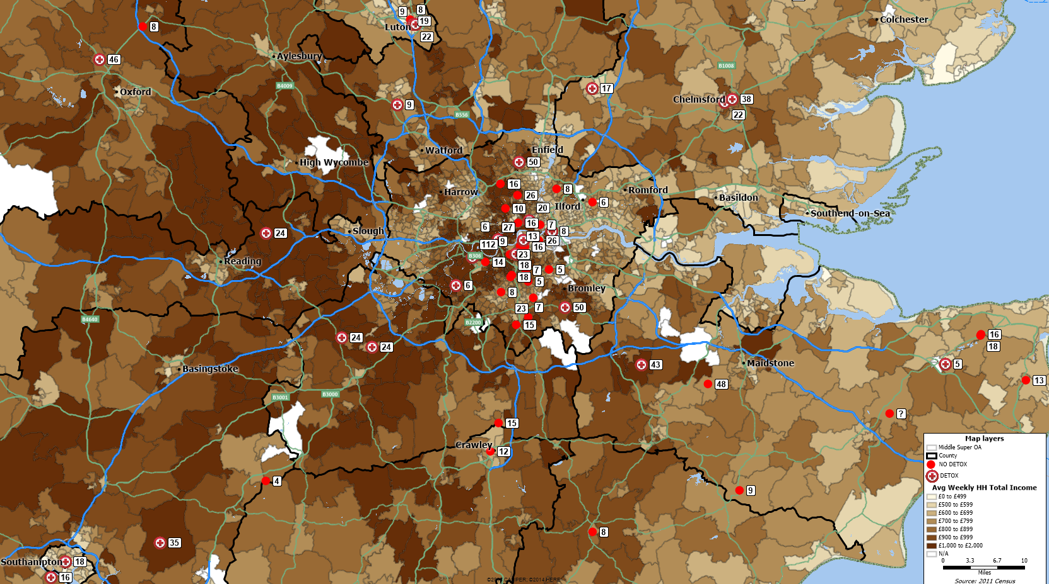
Data: Office of National Statistics, Care Quality Commission, Rehab Online, and provider websites
Figure 7: London Population Density (2011) and Residential Programs (2015).
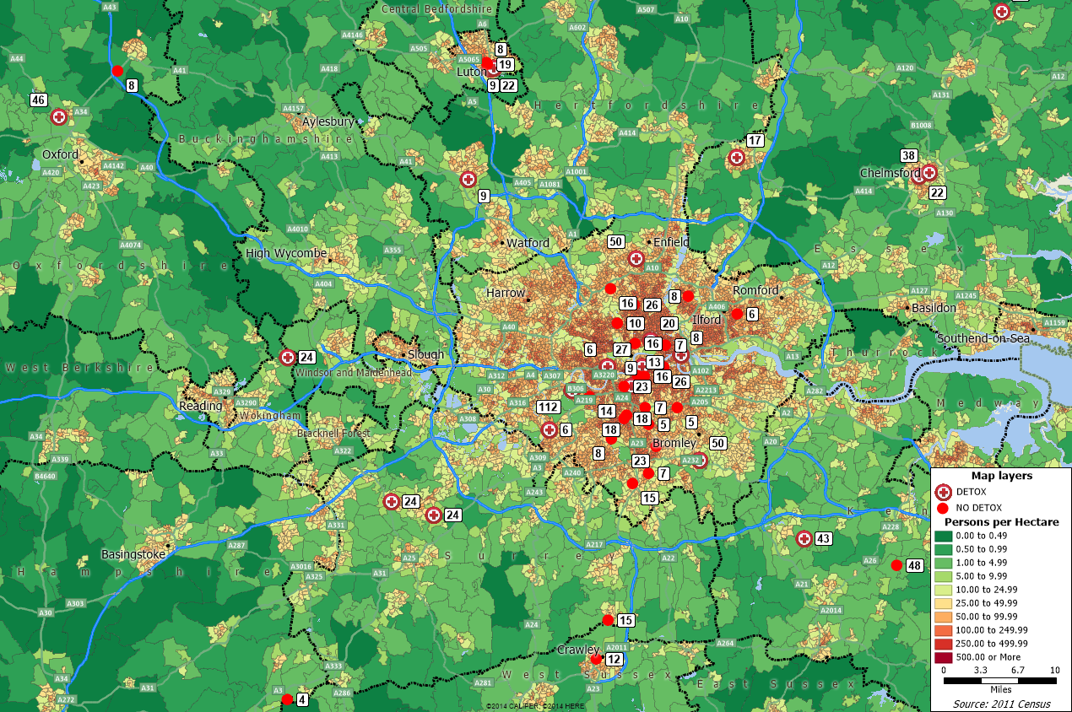
Data: Office of National Statistics, Care Quality Commission, Rehab Online, and provider websites

Figure 8: West of London Population Density (2011) and Residential Programs (2015).
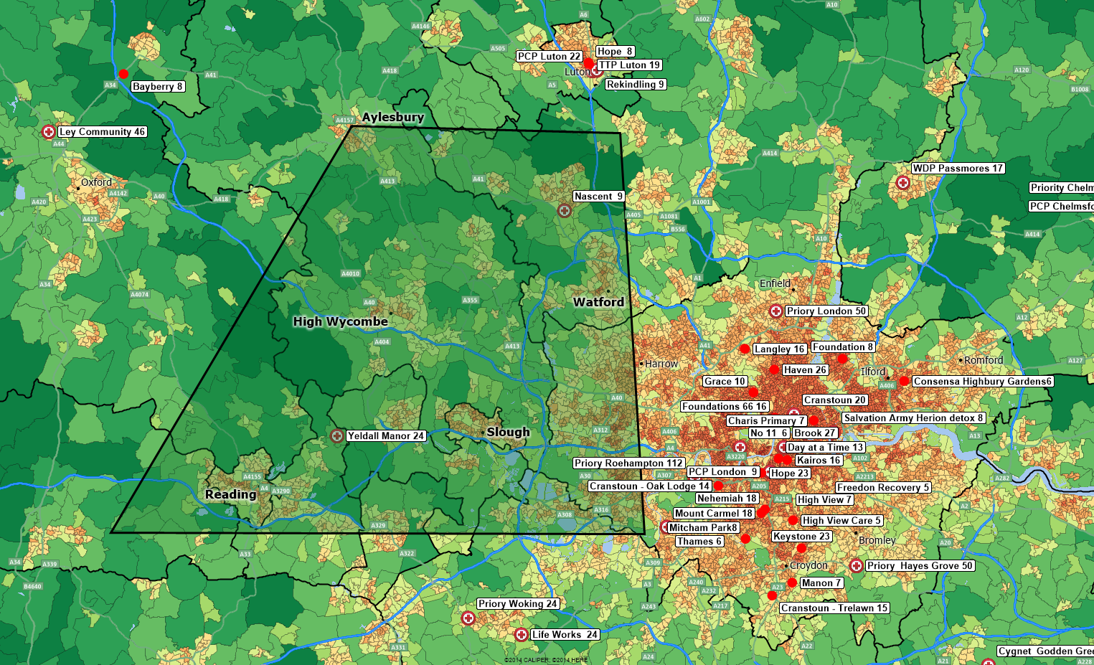
Data: Office of National Statistics, Care Quality Commission, Rehab Online, and provider websites
Figure 9: North of London Population Density (2011) and Residential Programs (2015).
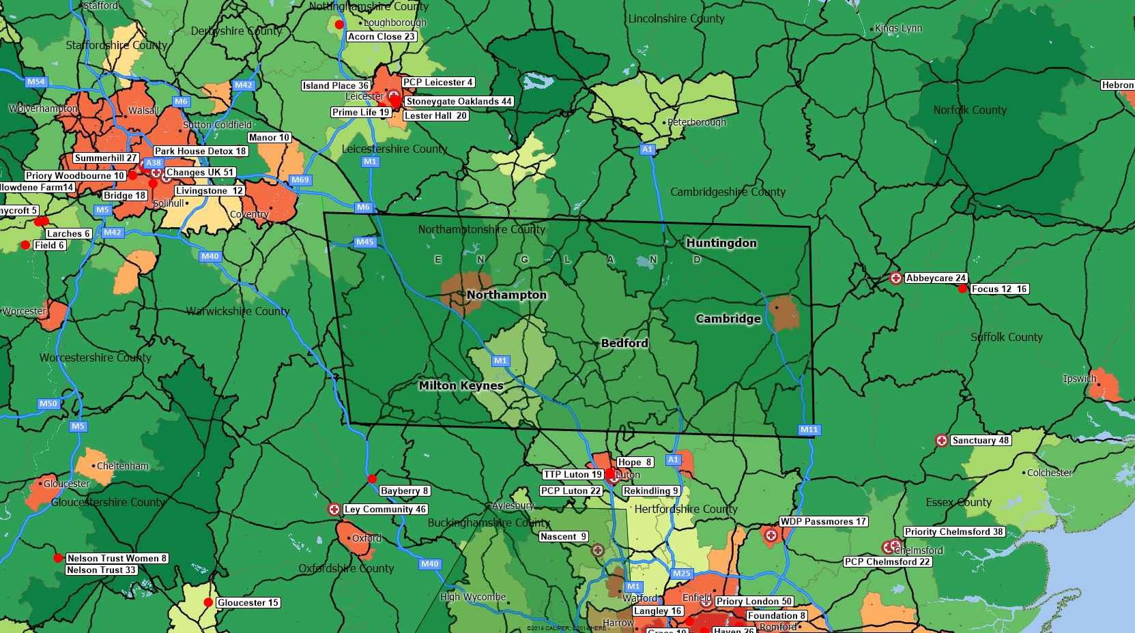
Data: Office of National Statistics, Care Quality Commission, Rehab Online, and provider websites
Figure 10: Birmingham Drug Treatment Statistics, 2008-2014
Adult Primary Drug Clients | 2008-2009 | 2009-2010 | 2010-2011 | 2011-2012 | 2012-2013 | Year to End Oct. 2014
Treatment Completion | - | - | 7.03 | 8.07 | 8.49 | 7.47
(% opiate clients)
Treatment Completion | - | - | 32.08 | 36.92 | 43.95 | 48.47
(% non-opiate clients)
Waiting Times * | - | 94.71 | 96.11 | 98.05 | 97.39 | -
(% under 3 weeks)
% Opiate Treatment Penetration | 67.3 | 73.8 | 70.6 | 63.5 | - | -
Data: National Drug Treatment Monitoring System

Figure 11: Birmingham Weekly Household Income (2011) and Residential Programs (2015).
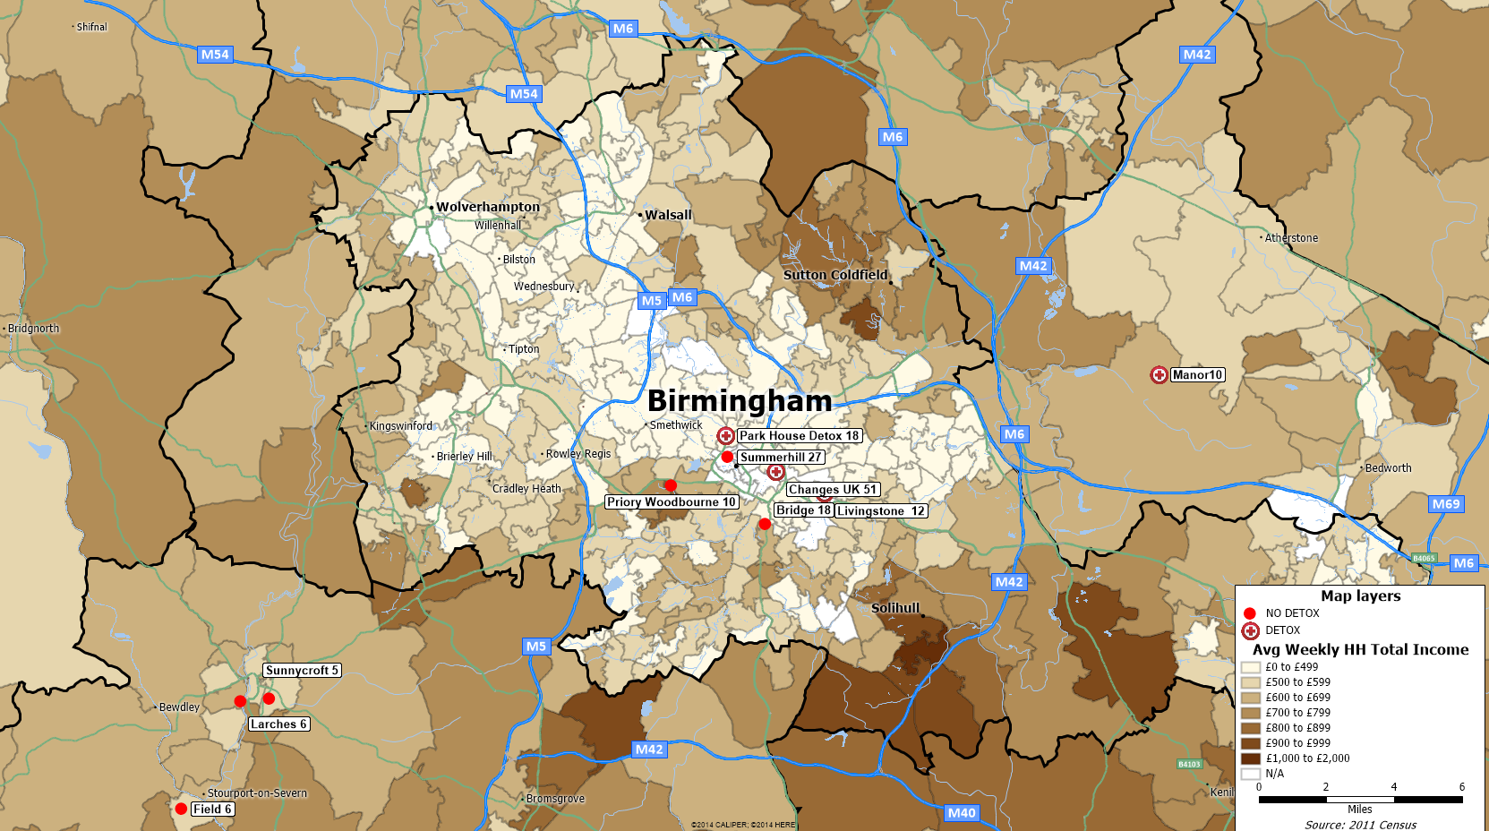
Data: Office of National Statistics, Care Quality Commission, Rehab Online, and provider websites
Figure 12: Birmingham Population Density (2011) and Residential Programs (2015).
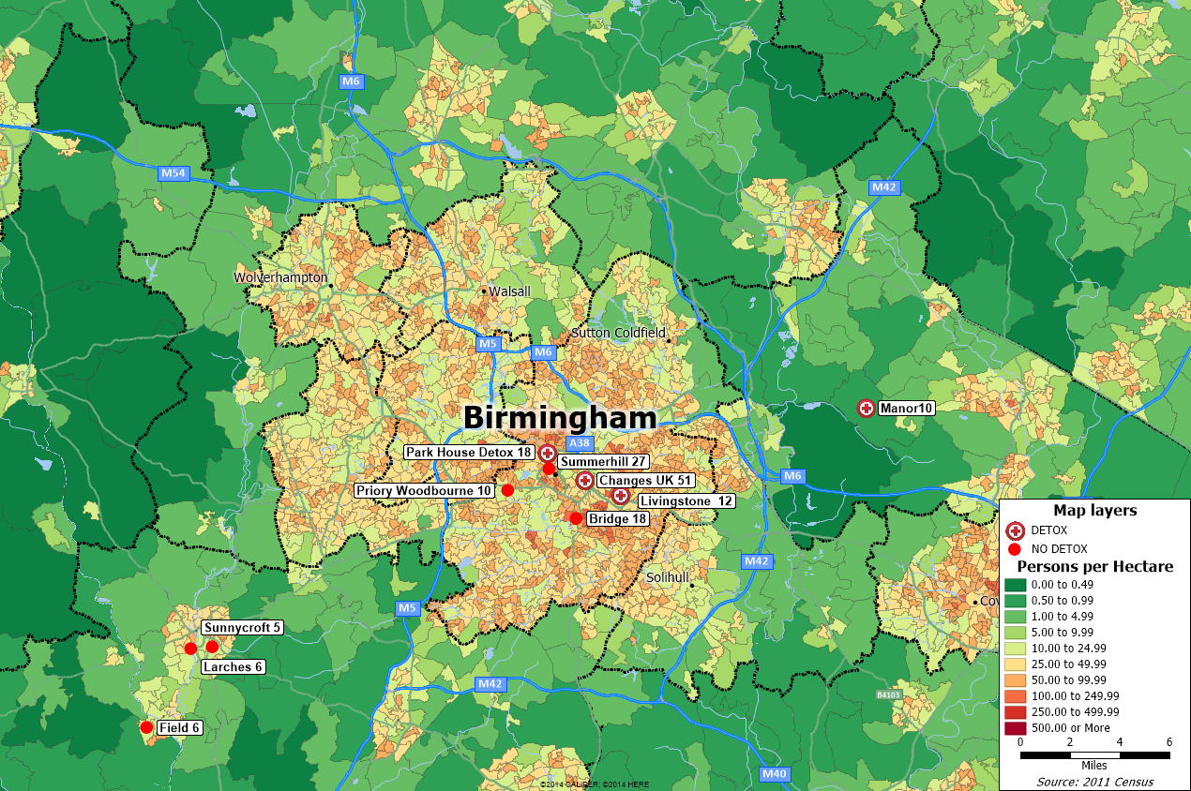
Data: Office of National Statistics, Care Quality Commission, Rehab Online, and provider websites
Figure 13: North-Northwest of Birmingham.
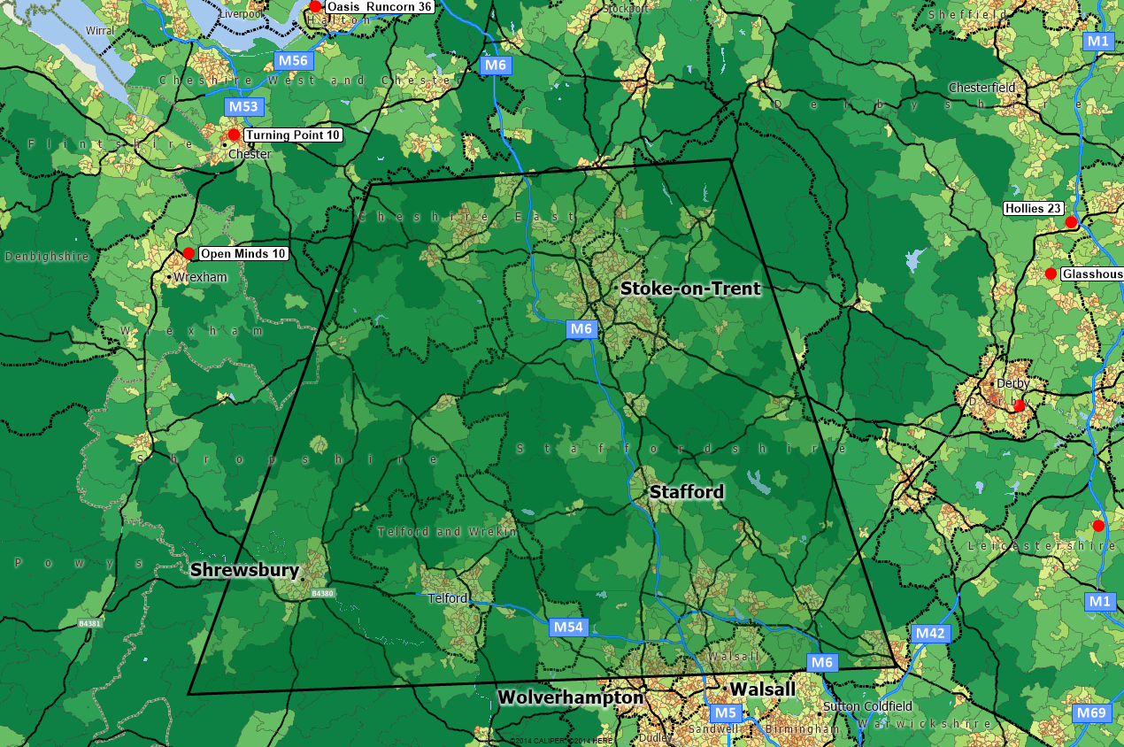
Data: Office of National Statistics, Care Quality Commission, Rehab Online, and provider websites
Figure 14: Bristol Drug Treatment Statistics, 2008-2014.
Adult Primary Drug Clients | 2008-2009 | 2009-2010 | 2010-2011 | 2011-2012 | 2012-2013 | Year to End Oct. 2014
Treatment Completion | - | - | 8.7 | 10.33 | 8.51 | 9.75
(% opiate clients)
Treatment Completion | - | - | 36.34 | 36.49 | 39.82 | 42.75
(% non-opiate clients)
Waiting Times * | - | 76.45 | 88.99 | 91.76 | 97.29 | -
(% under 3 weeks)
% Opiate Treatment Penetration | 61.4 | 68.2 | 66.5 | 64.6 | - | -
Data: National Drug Treatment Monitoring System
Figure 15: Bristol Weekly Household Income (2011) and Residential Programs (2015).
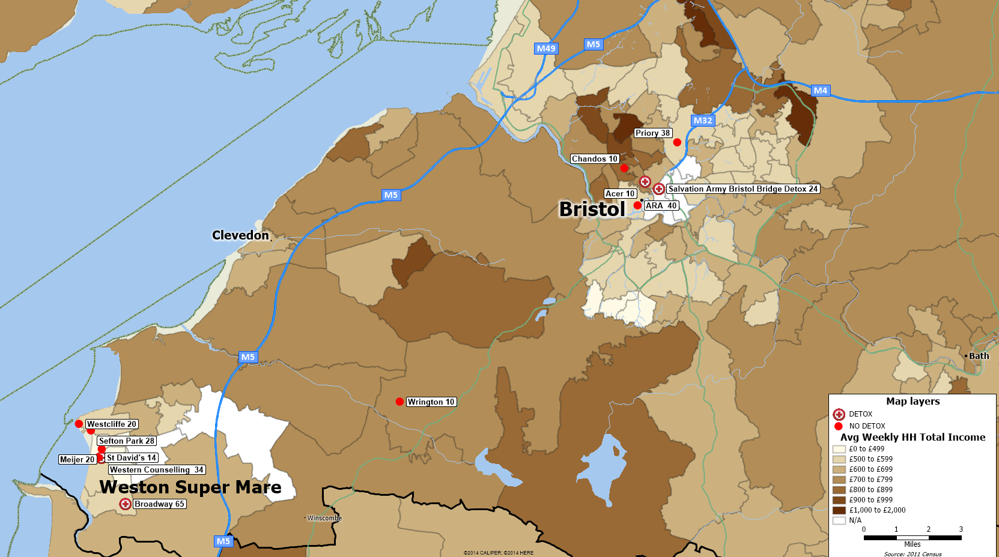
Data: Office of National Statistics, Care Quality Commission, Rehab Online, and provider websites
Figure 16: Bristol Population Density (2011) and Residential Programs (2015).
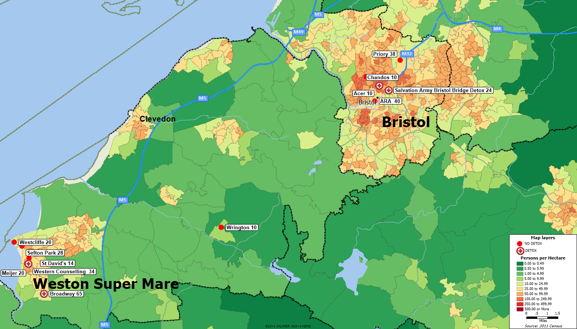
Data: Office of National Statistics, Care Quality Commission, Rehab Online and provider websites
Figure 17: North of Bristol Population Density (2011) and Residential Programs (2015).
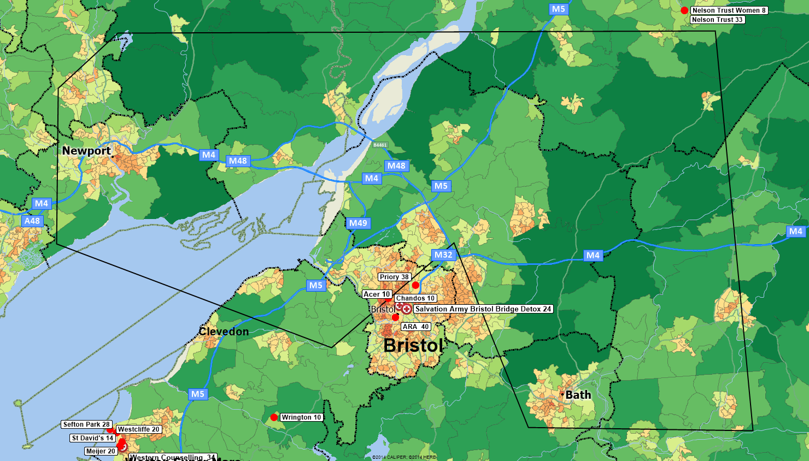
Data: Office of National Statistics, Care Quality Commission, Rehab Online, and provider websites
Figure 18: Leeds Drug Treatment Statistics, 2008-2014.
Adult Primary Drug Clients | 2008-2009 | 2009-2010 | 2010-2011 | 2011-2012 | 2012-2013 | Year to End Oct. 2014
Treatment Completion | - | - | 4.69 | 6.91 | 7.45 | 8.26
(% opiate clients)
Treatment Completion | - | - | 28.18 | 31.29 | 29.76 | 34
(% non-opiate clients)
Waiting Times * | - | 99.19 | 99.02 | 98.25 | 95.17 | -
(% under 3 weeks)
% Opiate Treatment Penetration | 64.7 | 64.7 | 65.3 | 62.3 | - | -
Data: National Drug Treatment Monitoring System
Figure 19: Leeds Weekly Household Income (2011) and Residential Programs (2015).
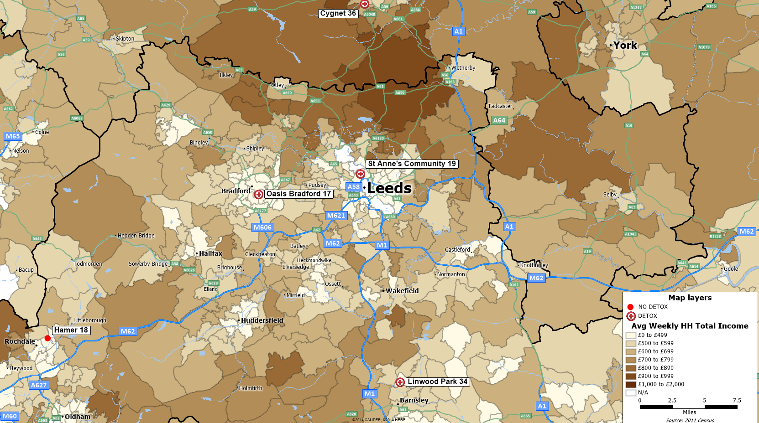
Data: Office of National Statistics, Care Quality Commission, Rehab Online, and provider websites
Figure 20: Leeds Population Density (2011) and Residential Programs (2015).
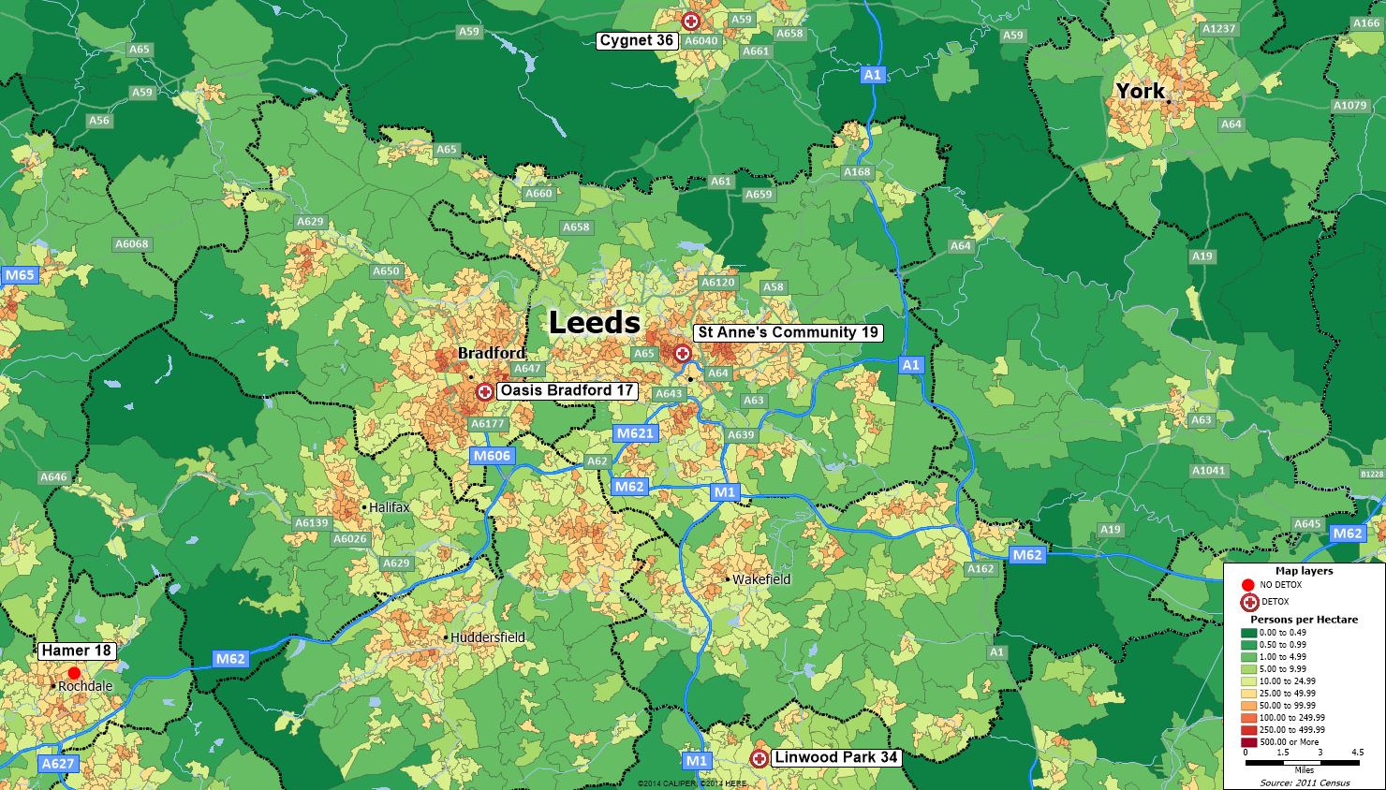
Data: Office of National Statistics, Care Quality Commission, Rehab Online, and provider websites

Figure 21: 30 and 45-Minute Drive Rings around York, 2015.
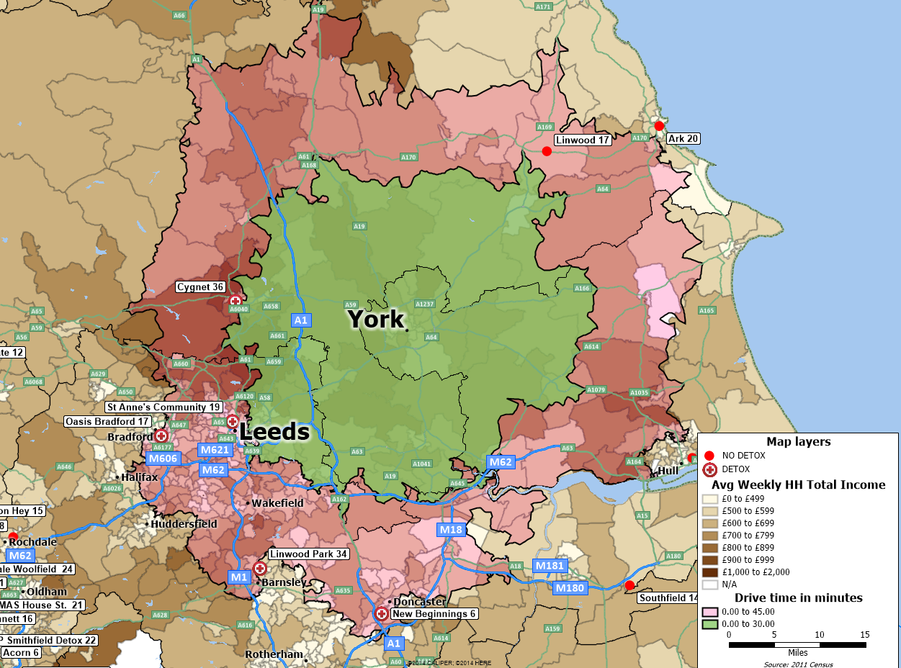
Data: Office of National Statistics, Care Quality Commission, Rehab Online, and provider websites
Figure 22: Liverpool Drug Treatment Statistics, 2008-2014.
Adult Primary Drug Clients | 2008-2009 | 2009-2010 | 2010-2011 | 2011-2012 | 2012-2013 | Year to End Oct. 2014
Treatment Completion | - | - | 7.22 | 6.37 | 7.39 | 7.24
(% opiate clients)
Treatment Completion | - | - | 48.87 | 44.35 | 50.56 | 44.59
(% non-opiate clients)
Waiting Times * | - | 97.97 | 97.32 | 97.21 | 97.57 | -
(% under 3 weeks)
% Opiate Treatment Penetration | 77.3 | 100.5 | 97.5 | 89.7 | - | -
Data: National Drug Treatment Monitoring System
Figure 23: Liverpool Weekly Household Income (2011) and Residential Programs (2015).
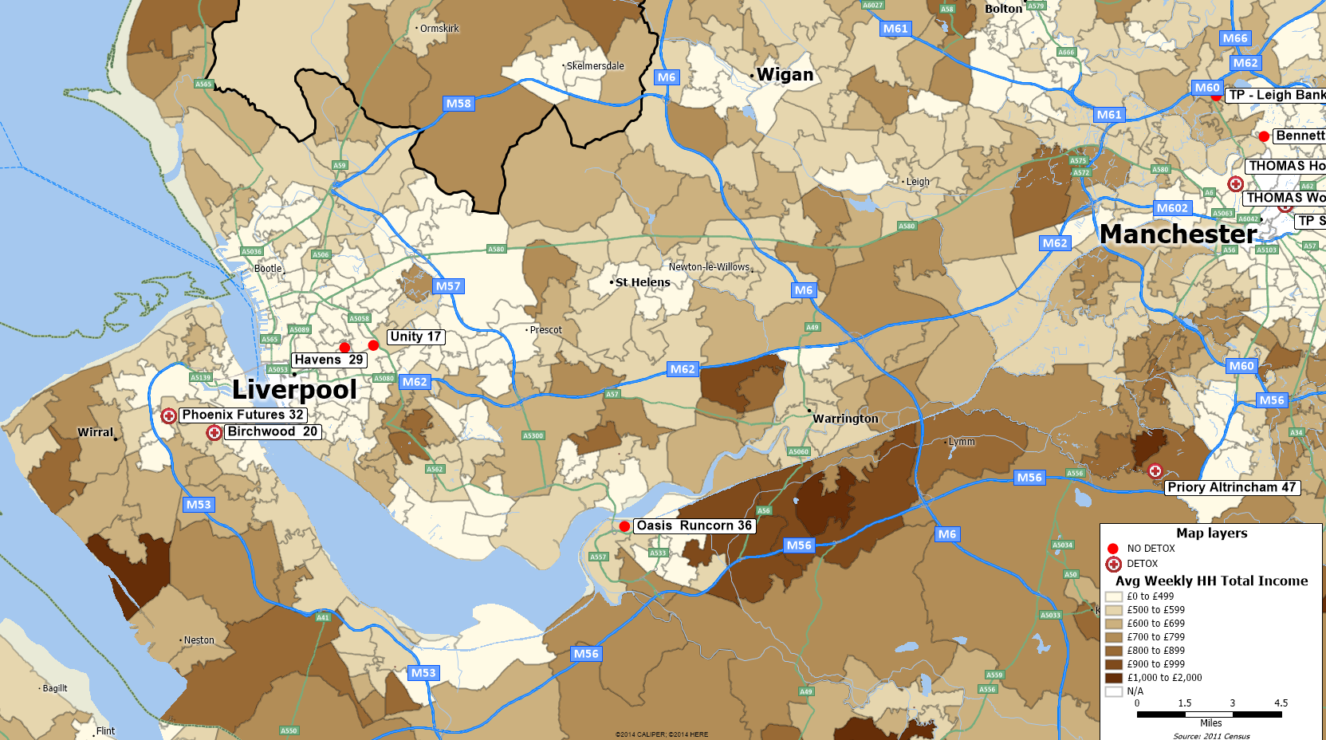
Data: Office of National Statistics, Care Quality Commission, Rehab Online, and provider websites
Figure 24: Liverpool Population Density (2011) and Residential Programs (2015).
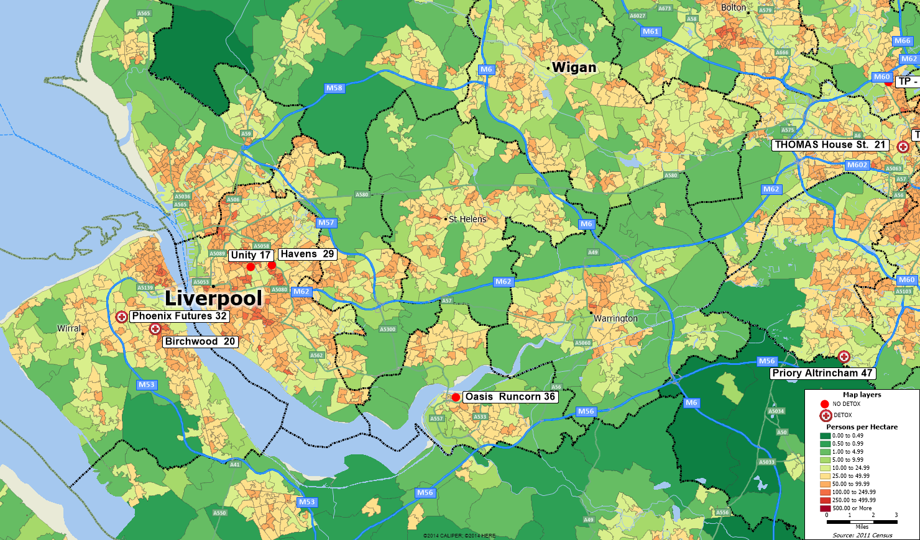
Data: Office of National Statistics, Care Quality Commission, Rehab Online, and provider websites

English nomenclature tends to use the phrase “substance misuse” rather than “substance abuse” and this paper follows English spelling and linguistic conventions. See Glossary at end of report
See 2014 population data at Office of National Statistics, http://www.ons.gov.uk/ons/dcp171778_420462.pdf Table 1, Retrieved 11-5-2015
See http://www.nationsencyclopedia.com/economies/Europe/United-Kingdom.html Retrieved 11-5-2015
See http://www.theus50.com/fastfacts/area.php
See https://thegeographist.wordpress.com/2013/11/23/largest-cities-uk-population/ Retrieved 11-5-2015
This Commission has a searchable database of approximately 50,000 providers including alcohol and drug programs. The consequences of not registering are unclear. One survey of providers found that 21% of providers did not register and staff at 66% reported not knowing if they registered. See https://www.ndtms.net/resources/secure/downloads/Field%20Survey%20Reports/National%20Report.pdf p. 8
For example, a provider can report total persons served across all programs which might include residential and outpatient persons together. Some providers do not appear to participate in the reporting. Moreover, the reporting system does not show data on providers that provide services to fewer than five persons a month. Data on individual providers can found in local needs assessments, but this is unsystematic as some assessments do not contain provider-level treatment statistics,
See 2014 funding, at http://www.nta.nhs.uk/uploads/capital-bids-summary.pdf and 2015 funding at http://www.nta.nhs.uk/PHE%20announces%20new%20capital%20funding%20for%20drug%20and%20alcohol%20recovery%20services.aspx
Alcohol data from http://www.lape.org.uk/
Approximately 15% of the adult population in England engages in binge drinking. See, http://visual.ons.gov.uk/binge-drinking/
National Drug Treatment Monitoring System, See www.ndtms.net/
See http://www.nta.nhs.uk/facts-prevalence.aspx 2011-2012 Facts and Figures, Prevalence estimates by local authority.
See http://www.nta.nhs.uk/facts-prevalence.aspx
See https://www.ndtms.net/Publications/downloads/Adult%20Drug/statisticsfromndtms201314.pdf
Falling Drug Use the Impact of Treatment. See, http://www.nta.nhs.uk/uploads/prevalence-commentary.pdf Retrieved on 11-9-2015
See Adult Statistics from NDTMS 2013-2014, retrieved on 11-9-2015 from https://www.ndtms.net/Publications/AnnualReports.aspx Table 5.4.1
See https://www.alcoholconcern.org.uk/help-and-advice/statistics-on-alcohol/
See http://www.nta.nhs.uk/uploads/roleofresi-rehab.pdf and http://www.nta.nhs.uk/news-resi-rehab-report.aspx
See http://www.nta.nhs.uk/uploads/residential-rehab--state-of-the-sector-in-2014.pdf retrieved on 11-9-2015
The word “Commissioners” refers to local officials that purchase or “commission” services.
See http://www.nta.nhs.uk/PHE%20launches%202015%20survey%20for%20providers%20and%20commissioners%20of%20residential%20rehab.aspx
See http://www.centreforsocialjustice.org.uk/publications/ambitious-for-recovery
sSee http://www.ibtimes.co.uk/fears-raised-heroin-epidemic-uk-use-painkiller-oxycodone-rise-1481727
See http://www.centreforsocialjustice.org.uk/publications/ambitious-for-recovery p. 20
CQC also inspects these providers and individual survey reports on residential rehabilitation substance abuse providers are available on the CQC site. These reports provide descriptive information on registered beds and program services that are not available in the Excel databases of CQC. The extent or nature of local licensing requirements is not commented on in this report and is best left to persons knowledgeable about local conditions and English law.
While report authors have made diligent quality control efforts to identify residential substance misuse treatment locations, there is no guarantee that the resulting list contains all such programs or that there are not programs on the list that provide mental health services primarily and only provide incidental substance misuse services. Similarly, provider questionnaire reporting of their detox services to Public Health England do not always correspond with their website information. Although the authors checked provider websites to confirm the data, there is the potential for misclassification regarding the provision of detoxification services.
http://www.wandsworth.gov.uk/downloads/download/1465/drug_and_alcohol_needs_assessment_201415 p.2. The Wandsworth data on drug penetration rates for England differs from published NDTMS data cited earlier.
The regional NDTMS websites report treatment figures by provider but it is not clear if the data are accurate since there are too many instances of providers that should have treatment counts but do not.
See https://www.ndtms.net/Publications/downloads/Adult%20Drug/statisticsfromndtms201314.pdf
Alcohol data from http://www.lape.org.uk/
http://www.hackney.gov.uk/Assets/Documents/Mental-health-needs-assessment.pdf Retrieved 11-6-2015
See http://www.islington.gov.uk/publicrecords/library/Public-health/Quality-and-performance/Profiles/2014-2015/(2014-07-17)-Alcohol-and-Substance-Misuse-Needs-Assessment-July-2014.pdf Retrieved 11-6-2015.
“Treatment penetration rates” are the percentage of person using substances that are in treatment.
Available on the internet by searching for “Tower Hamlets substance misuse needs assessment”
See http://www.wandsworth.gov.uk/downloads/download/1465/drug_and_alcohol_needs_assessment_201415
Readers of state needs assessments in SAMHSA documents will recognize this same lack of specificity.
The trapezoid is hand drawn on the map. Other shapes could also be drawn, and one is not necessarily better than the other. The purpose of the shape is to demark an area and calculate its demographics to get an approximate idea of how many adults are in the area.
Again, numerous other shapes could also be drawn, and one is not necessarily better than the other. The purpose of the shape is to demark an area and calculate its demographics to get an approximate idea of how many adults are in the area.
http://www.lifeworkscommunity.com/about-us/our-facilities.html
http://www.lifeworkscommunity.com/treatment-programmes/addiction-to-alcohol-or-drugs/drugs.html
See https://beta.companieshouse.gov.uk/company/03736193/filing-history
Nascent website at http://www.druglink.co.uk/pages/oxygen. CQC report at http://www.cqc.org.uk/sites/default/files/1-109731545_Nascent_House_INS1-1089552902_Scheduled_03-06-2014.pdf
See http://www.nta.nhs.uk/uploads/roleofresi-rehab.pdf p. 11
See website at http://www.yeldall.org.uk/
See Charity registered number 1000038 Yeldall Christian Centres
The phrase “non-commissioned” means these providers were not currently public providers. When a local authority purchases substance abuse services from providers, the authority is said to be “commissioning” the services.
Information based on search of Birmingham City Council financial payments.
See http://www.bayberry.org.uk/admissions/
For a discussion of this see http://www.facesandvoicesofrecoveryuk.org/summerhill-campaign/
See discussion of Birmingham public providers in http://www.kikitproject.org/wp-content/uploads/2015/01/Public-Health-Birmingham-Drugs-and-Alcohol-Needs-Assessment-20132014.pdf
See, http://www.bristolpost.co.uk/City-s-drug-problem-UK-s-worst/story-19493610-detail/story.html
Although a Pharmaceutical Needs Assessment was published in 2015, a larger drug and alcohol needs assessment is scheduled to be released sometime in 2015,
See http://www.chandoshouse.org/#!about-us/c21cc
See http://www.priorygroup.com/location-results/item/the-priory-hospital-bristol fees and funding section
See http://apps.charitycommission.gov.uk/Showcharity/RegisterOfCharities/CharityWithPartB.aspx?RegisteredCharityNumber=269167&SubsidiaryNumber=0
Available at http://observatory.leeds.gov.uk/explorer/resources/listbysearch
See http://www.nta.nhs.uk/facts-prevalence.aspx
For reports and plan, see http://www.st-annes.org.uk/publications/
See http://stannes2015.wpengine.com/wp-content/uploads/2015/05/Report-and-Financial-Statements-for-year-end-31-March-2014.pdf
See http://liverpool.gov.uk/media/688965/riskfactorssubstancemisuse.pdf p. 4
Ibid. p. 6 The Hackney needs assessment also referred to residential rehabilitation but conducted by providers.
Ibid. p. 13
See, http://www.liverpooltalkshealth.info/alcohol/documents/401/download Table 2 and p. 9
See Birchwood website at http://www.birchwoodtreatment.com
See http://www.parkviewproject.co.uk/

