timothy E. Corriston  Nicole B. Dory  Connell Foley LLP  56 Livingston Avenue  Roseland, NJ 07068  Tel: (973) 535-0500  Fax: (973) 535-9217 | Gary S. Forshner  Law Offices of  Gary S. Forshner  P.O. Box 3086  South Amboy, NJ 08879  Tel: (609) 577-2121 | of counsel:  James K. Green*  James K. Green, P.A.  501 South Flagler Drive  Suite 306, Flagler Center  West Palm Beach, FL 33401  Tel: (561) 659-2029

Attorneys for Plaintiffs, Quantum Behavioral Health, LLC and Allard21, LLC

UNITED STATES DISTRICT COURT
FOR THE DISTRICT OF NEW JERSEY

QUANTUM BEHAVIORAL HEALTH, LLC and ALLARD21, LLC, on their own behalf and on behalf of their patients and residents,  Plaintiffs,  vs.  TOWNSHIP OF BERKELEY and the BERKELEY TOWNSHIP ZONING BOARD OF ADJUSTMENT,  Defendants. |  | Civil Action No. 3:23-cv-02483  Filed Electronically

LESLIE HENDRICKSON PH.D Expert witness report regarding need for substance use treatment in the Ocean County, NJ area
- I, Leslie Hendrickson Ph.D., have been retained as an expert witness by counsel for the Plaintiffs in this litigation.

- Plaintiffs, Quantum Behavioral Health, LLC and Allard21, LLC, hereinafter collectively referred to as “Quantum,” allege that the Defendants, Township of Berkeley and Berkeley Township Zoning Board of Adjustment, hereinafter referred to as “the Township,” intentionally discriminated against Quantum by denying zoning approvals for Plaintiffs’ proposed treatment facility, treating it differently than comparable residential medical and health care uses, and by imposing distance requirements on the proposed facility, restricting placement of the facility to a remote forest area in the Pinelands that comprises one-tenth of one percent of the area of the Township, and by denying a reasonable accommodation. These actions prohibited treatment and housing for individuals in recovery in violation of the Fair Housing Act (“FHA”), and the Americans with Disabilities Act (“ADA”), 42 U.S.C. § 3604(f)(3)(B), 42 U.S.C. § 12132.

- The Plaintiffs have retained me to analyze the need for detoxification and residential substance use treatment programs in the Ocean County area.

- I am submitting the following report concerning my prospective expert testimony in the above-entitled matter, pursuant to Rule 26(2)(B) of the Federal Rules of Civil Procedure. My qualifications are discussed at length below.

I expect to express my opinions on the following issues:
The Role of Detoxification and Residential Treatment Services;
Estimating Population Size in the Drive-Time Ring;
New Jersey State Assessments of the Need for Substance Use Treatment;
New Jersey State Data on the Number of Admissions to Treatment Programs;
Data by New Jersey County on Where Individuals Receive Treatment;
New Jersey State and County Service Comments;
Distribution of Existing Treatment Programs in Ocean County Area; and
Consequences of Delays in Treatment.

Conclusions
  - All State and County calculations indicate Ocean County has a substantial unmet need for treatment services;

  - Ocean County has weak residential programs. It has no short-term residential programs and has one small long-term program. It has less than 1% of all residential beds in the State;

  - Ocean County has one detoxification program;

  - NJ SAMS annual records contain no utilization data for detoxification services in Ocean County;

  - Half the Ocean County residents receiving treatment services leave the County to obtain them;

  - Treatment programs in other counties have ten admissions a day from Ocean County residents;

  - Every day in Ocean County in 2022, approximately 2.5 Ocean County residents were either dying of a drug overdose or coming perilously close to dying from a drug overdose; and

  - The absence of treatment does serious, immediate injury to individuals seeking treatment.

- The consequences of addiction treatment delays are significant and are well summarized in neighboring Monmouth County’s Comprehensive Plan. “Individuals who are unable to access treatment are often at risk for illness, injury, hospitalization, job loss, incarceration, and death. These risks further stress the family unit and exhaust social, medical, and law enforcement resources.”

I reviewed the following materials in preparation for my work:
Utilization and Need:
- 2016-2019 CCP Ocean County-Finalized-Plan;
- 2019-2021 NJ Department of Human Services, Division of Mental Health and Addiction Services, Substance Abuse Overviews and County specific reports;
- 2020 Burlington County Needs Assessment;
- 2020-2023 Mercer County Addiction Services Plan;
- 2020-2023 The Mercer County Comprehensive Plan for the Organization and Delivery of Alcohol and Drug Abuse Services;
- 2021 NJ Department of Human Services, Division of Mental Health and Addiction Services, Performance Reports;
- 2021 Substance Abuse and Mental Health Services Administration (SAMHSA), 2021 National Survey on Drug Use and Health;
- 2022 Burlington County Healthy Community Planning Report;
- 2022 NJ CARES Opioid- Related Data and Information;
- 2022 Healthier Middlesex Community Health Needs Assessment Report;
- 2022-2023 New Jersey Combined MHBG/SABG Application/Behavioral Health Assessment and Plan, Step Two Needs Assessment;
- 2023-2026 Ocean County Mental Health Plan Update;
- 2023-2025 Middlesex County Community Health Improvement Plan FINAL 04.18.23;
- 2024-2027 The Monmouth County Comprehensive Plan for the Organization and Delivery of Alcohol and Drug Abuse Services Planning Cycle; and
- 2024 Data received from the State of New Jersey on utilization of services at each program site.
Legal documents:
- 2023 March, Quantum vs. Berkeley, Brief in Support of Plaintiffs’ Application for an Order to Show Cause, Civil Action No. 3:23-cv-02483;
- 2023 June, Quantum vs. Berkeley, ORDER, Civil Action No. 3:23-cv-02483;
- 2023 June, Quantum vs. Berkeley, OPINION, Civil Action No. 3:23-cv-02483;
- 2023 June, Declaration of Polly Litner, Quantum vs. Berkeley, Civil Action No. 3:23-cv-02483;
- 2023 June, Declaration of Christine Nazzaro-Cofone, Quantum vs. Berkeley, Civil Action No. 3:23-cv-02483; and
- 2023 June, Certification of Gary Forshner, Quantum vs. Berkeley, Civil Action No. 3:23-cv-02483.

The Role of Detoxification and Residential Treatment Services:
Detoxification
- Quantum proposes to operate a 24-bed inpatient detoxification program. This is a medical facility where individuals stay for a period of approximately six days and receive medically supervised care while the physiological effects of the substances they are abusing are removed from their body. Residential detoxification programs do not typically detox residents from codeine, methamphetamines, or marijuana; rather, they focus on alcohol, prescription drugs, and opiates. One reason the facility needs medical oversight is because it is possible to die from alcohol detoxification. These programs provide medical treatment as well as short-term residences to persons choosing to detoxify.

- Detoxification is usually a necessary precondition, a gateway, for admittance to programs where the treatment for the abuse occurs. New Jersey state records indicate that in 2021, approximately 21 per cent of all admissions were to non-hospital detoxification programs, indicating their gateway status.

- A residential detoxification program is a specialized medical service and draws individuals from a surrounding region. A surrounding region could be defined in terms of a drive-time ring around the program, or the county the program is within and contiguous counties.
Residential Treatment Services
- Quantum also proposes to operate a 34-bed residential program at the site. Residential programs are inpatient treatment centers where the resident lives and receives treatment. These programs treat both the substance use and the mental health needs of individuals. The treatment usually consists of drug testing, medication administration, group activities, skill building, and counseling. Programs differ in the number of days an individual stays in them. This is a suitable placement for individuals that have been recently “detoxed” and need a transitional treatment residence before returning to the environment where they used substances. In 2021, approximately 18% of all admissions in the State were to short- or long-term residential programs.

- Programs can be called “long” or “short” term residential, but these words have no standardized meaning across states. New Jersey distinguishes “short-term” residential from “long-term” residential. In New Jersey in 2021, 8,245 unduplicated individuals used short-term programs where the average length of stay was 18 days, and 5,096 unduplicated individuals used long-term services where the average length of stay was 64 days.

- Placement in a residential program is a frequently used next step after detoxification. Industry practice is for a detoxification staff member to accompany the individual to the treatment program, which is usually a residential or intensive outpatient program. This is commonly called a “warm hand off” where there is a seamless transfer of the patient to the next facility. Nineteen of the current 33 substance use providers, approximately 60%, have both a residential program and a detoxification unit.

- Both detoxification and inpatient residential treatment programs are analyzed assuming longer travel times than outpatient programs which require daily visits. Unlike outpatient programs and opioid maintenance programs, usually only one or two initial visits are necessary for the prospective inpatient resident and family to decide if they wish to use its services where daily visits are not required.
Estimating Population Size in the Drive-Time Ring
- The Centers for Medicaid and Medicare (CMS) publishes a “reference file” known as the HSD file, each year outlining time and distance network adequacy standards for health plans. These standards describe the maximum times and distances that CMS beneficiaries should take to travel to types of health care providers. CMS assigns counties to one of five categories. Ocean County, with a 2022 population of 655,735 and a population density of 917 inhabitants per square mile, falls under the CMS definition of a “Metro” county.

- The 2023 HSD reference file does not classify types of substance use treatment programs but does have a provider type 52, which is “inpatient psychiatric facility services.” For this provider type, the network adequacy standards for a Metro county are 70 minutes driving time and a 45 miles distance standard.

- Figure 1 shows the 70-minute drive time ring around the proposed detoxification facility on Allard Road near Bayville. Counting all census tracts, it encompasses approximately 2,993 square miles and contains approximately 2.6 million persons over the age of 18. For purposes of comparing county data, it is reasonable to disregard blocs of census tracts outside the main counties in the analysis. These disregarded tracts are on the periphery of the 70-minute drive time ring in Cape May County, Camden County, and counties north of Middlesex. Disregarding these peripheral census tracts results in an estimate shown in Figure 2 that there are about 2.3 million persons over the age of 18 in the modified 70-minute drive time ring.

Figure 1: The 70-Minute Drive Time Ring Containing 2.6 million individuals over the age of 18
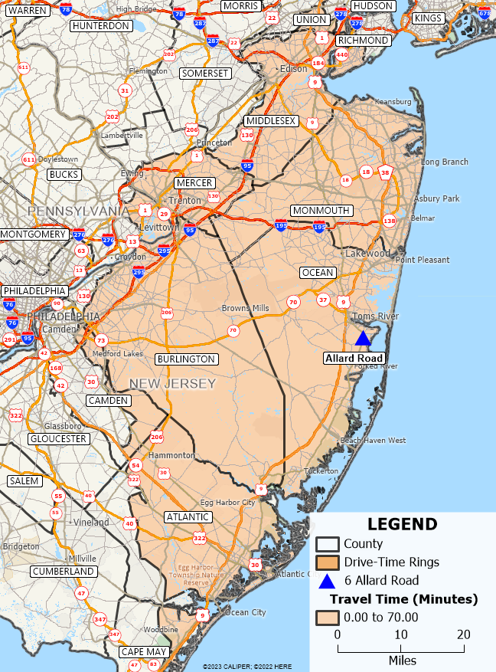

New Jersey State Assessments of the Need for Substance Use Treatment
- The New Jersey Division of Mental Health and Addiction Services (DMHAS) operates the New Jersey Substance Abuse Monitoring System (NJSAMS). This is a web-based system that collects and reports data on substance use treatment utilization for all providers in the State. Most states, with the exception of New Jersey and Iowa, only collect data on providers that receive money from State behavioral health funds.

- In addition to NJSAMS, the DMHAS creates periodic needs assessments of treatment for drug and alcohol use. DMHAS’s methodology includes the analysis of social indicators by county, a statewide household survey, and statistical modeling. Statewide needs assessments were done in 2015 and 2022, and results for Ocean County and nearby counties are also shown in Figure 2. Since data on two relatively recent years were available, I constructed a weighted average of the two assessments. I applied the resulting percentages to the population of the census tracts that were deemed to be within the 70-minute drive time ring.

Figure 2: Estimating the Number of Adults that Need Services
County | Population of Adults within the 70-minute drive time ring | 2015 Total Need as % of the County Adult Population | 2022 Total Need as % of the Adult County Population | Weighted Average of 2015 and 2020 | Number of Adults Needing Services
Atlantic | 94,208 | 19.0% | 10.3% | 14.56% | 13,720
Burlington | 363,832 | 11.8% | 9.6% | 10.66% | 38,780
Mercer | 302,290 | 18.0% | 8.5% | 13.07% | 39,524
Middlesex | 557,036 | 10.2% | 6.0% | 8.08% | 44,991
Monmouth | 505,924 | 17.6% | 9.4% | 13.41% | 67,828
Ocean | 475,570 | 13.8% | 10.5% | 12.12% | 57,644
Total | 2,298,860 |  |  |  | 262,487

- The result of this analysis as seen in Figure 2 is that there are an estimated 262,487 persons in the 70-minute drive time ring that need treatment for drug and/or alcohol abuse.

New Jersey State Data on the Number of Admissions to Treatment Programs

- Each year NJ DHMAS reports county data on the number of admissions to types of substance use programs. Its annual reports provide data showing how many individuals received services in the county they lived in and how many individuals from that county received services outside of their county. The reports also contain data on the number of admissions and the number of unduplicated individuals generating the admissions.

- Figure 3 indicates that in the six-county Ocean County area, only 26,747 unduplicated individuals received services in 2021, compared to the 262,487 individuals estimated to need services. Using these estimates, only a little over 10% of those in need received services, leaving 90% or approximately 235,000 individuals needing but not receiving services. This number is based on a single year and not a multi-year lifetime period.

Figure 3: In 2021 Where Individuals Received Services
County Residents | Number of Adults Needing Services | Admissions in County of Residence | Total Admissions  of County Residents to All Counties | Admissions Outside County of Residence | Percent of Admissions in County of Residence | Un-duplicated individuals Admitted from any County
Atlantic | 13,720 | 5,339 | 7,314 | 1,975 | 73% | 6,881
Burlington | 38,780 | 1,559 | 4,069 | 2,510 | 38% | 2,877
Mercer | 39,524 | 2,247 | 3,771 | 1,524 | 60% | 2,370
Middlesex | 44,991 | 3,443 | 5,803 | 2,360 | 59% | 5,353
Monmouth | 67,828 | 3,779 | 5,949 | 2,170 | 64% | 5,451
Ocean | 57,644 | 3,560 | 6,915 | 3,355 | 51% | 3,815
Total | 262,487 |  |  |  |  | 26,747

- These state calculations are consistent with national data. Addiction researchers and state staff are familiar with the annual reports published by SAMHSA. Two widely used and significant surveys are the National Survey on Drug Use and Health (NSDUH) and the National Survey of Substance Abuse Treatment Services (N-SSATS). However, these surveys report annual data. A multi- year view of life-time prevalence provides other information useful in understanding the need for an adequate number of substance use treatment programs.

- The National Epidemiologic Survey on Alcohol and Related Conditions (NESARC) studies are large longitudinal studies following the same group of respondents, approximately 35,000 individuals, over a multi-year period. Analysis of the NESARC-III data found that the lifetime prevalence of alcohol use disorder (AUD) was 29.1%, and of these individuals, about 19.8% will have treatment. In other words, the most reliable national research available indicates that 29.1% of the population will have an alcohol-related use disorder sometime in their lifetime.

- If 29.1% seems high, consider that the SAMHSA 2021 National Survey on Drug Use and Health found that in the previous month, approximately 32% of the New Jersey adults aged 18-25 reported binge drinking, and 24% of adults aged 26 and older reported binge drinking. Given an adult population of 2.298 million in the 70-minute drive time ring counties, approximately 669,000 persons will have an alcohol use disorder sometime during their lifetime, and of these individuals, about 132,000 will receive treatment and about 536,000 will not. A similar analysis from the NESARC data can be made for persons with a substance use disorder (SUD).

- NESARC data estimates that the lifetime prevalence of a drug use disorder (DUD) is 9.9%, and of them, only 19.8% will receive treatment. In an adult population of 2.292 million individuals, approximately 9.9% or 229,000 will have a drug use disorder once in their lifetime, but only approximately 19.8%, or about 45,000, will receive treatment. The NSDUH annual data estimate that Illicit Drug Use Other Than Marijuana in the Past Month was engaged in by 4.5% of New Jersey adults aged 18-25 and 4% of adults aged 26 and older.

- As established by these credible studies, there are substantial gaps between the number of individuals with alcohol and drug problems and the number that will receive treatment. Counties that discourage treatment programs are not appropriately serving the residents of their county for the long-term needs created by substance and alcohol use. Such lack of service is just as unacceptable as if the county was not providing adequate routine hospital care for its residents.

Data by County on Where Individuals Receive Treatment

- The data for Ocean County in Figure 3 indicate that 51% of the admissions by Ocean County residents to substance use treatment in 2021 were to programs in Ocean County. The other 49%, or 3,355 Ocean County admissions, incurred the cost and delays of obtaining services outside Ocean County. Each day, Ocean County residents make approximately 10 admissions (3,355/365) to programs outside of Ocean County. A higher proportion of residents in other counties received services in their own county, indicating a more widespread availability of services in these counties.

State and County Service Comments

- Ocean County’s Mental Health Plan and Update for 2023-2026 succinctly describes statistics of the current population of Ocean County:

More than 50,000 may experience frequent mental distress and symptoms consistent with a mental illness. Just over 75,000 likely have a history of depression. More than 27,000 adults may be struggling with serious mental illness in our community, among 100,000 who experience any mental illness. 33,000 adults may have co-occurring mental health and substance use conditions, and an additional 42,000 live with a substance use disorder alone.

- The Monmouth Comprehensive Plan presents a sobering review of the ubiquity of drug use in Monmouth, including the widespread use of fentanyl and xylazine. The Monmouth Plan concludes its prevalence analysis saying “…capacity remains an issue in Monmouth County and throughout the state as the number of residents accessing treatment continues to increase.”

- Ocean and Monmouth Counties are not the only Counties with capacity problems. The 2020-2023 Mercer Comprehensive plan focuses on halfway houses, which provide room, board, and services designed to improve recovery skills, prevent relapses, improve emotional stability, and help persons with substance use disorders transition back into the community. In its Plan, Mercer County stated its number one treatment priority was to expand access to halfway houses. In New Jersey, halfway houses are not state-designated as short- or long-term residential programs. Nor are they for individuals released from prison. Their absence does point to the need for more residential programs that help individuals transition into the community. In 2021, the average stay in a New Jersey halfway house was 114 days.

- The State requests federal money each year to support its alcohol and drug programs. Step Two of the annual Application reviews the state’s current programs and perceived needs. The 2022-2023 Combined Application indicates that the State believes that approximately 600,000 individuals are in current need of drug or alcohol treatment. Approximately 80,000 individuals have an unmet demand for services. In its planning, the State, in addition to Prevention efforts and growing Recovery programs, is focusing on expanding ambulatory treatment programs relying on the use of Medication Assisted Treatment using methadone, buprenorphine, and Vivitrol.

Distribution of Existing Treatment Programs in the Six-County
Ocean County Area

- Data were obtained from the State showing the number of beds and number of persons reported to have received service for each provider of detoxification, short-term residential and long-term residential services.

- Figure 4 indicates that providers run multiple programs. There are 61 providers of either detoxification, short-term or long-term residential, but because a provider can operate more than one type of program, of the 61, there are only 33 unique providers.

Figure 4: Statewide -- Providers, Locations, and Beds
Type of Program | Number of Providers | Number of Locations | Number of Beds
Detoxification | 22 | 26 | 710
Short-Term Residential | 21 | 22 | 818
Long-Term Residential | 18 | 23 | 1,306
Total | 61 | 71 | 2,834
Unique Providers and Locations | 33 | 39
Number of providers putting on one type of service | 11
Number of providers putting on two types of service | 16
Number of providers putting on three types of service | 6

- Figure 4 also indicates that providers operate multiple programs at the same location. Services are provided at 71 addresses, but because more than one program can be located at the same address, there are only 39 unique physical locations.

- Statewide, licensing records identify 22 detoxification providers that provide services at 26 locations with 710 current detoxification beds. Figure 5 shows the locations of licensed detoxification programs in the area around Ocean County. In the six counties comprising the Ocean County area, there are nine providers of detoxification services, and all combined, they have 337 beds. Ocean County has 38 beds in its one program, which is approximately .05% of all detoxification beds in the State or approximately 11% of all detoxification beds in the six-county area.

- NJSAMS’ “Substance Abuse Overview for 2021” reports there were 1,399 admissions by Ocean County residents to detoxification programs.
Figure 5: Licensed Detoxification Programs in the Ocean County Area
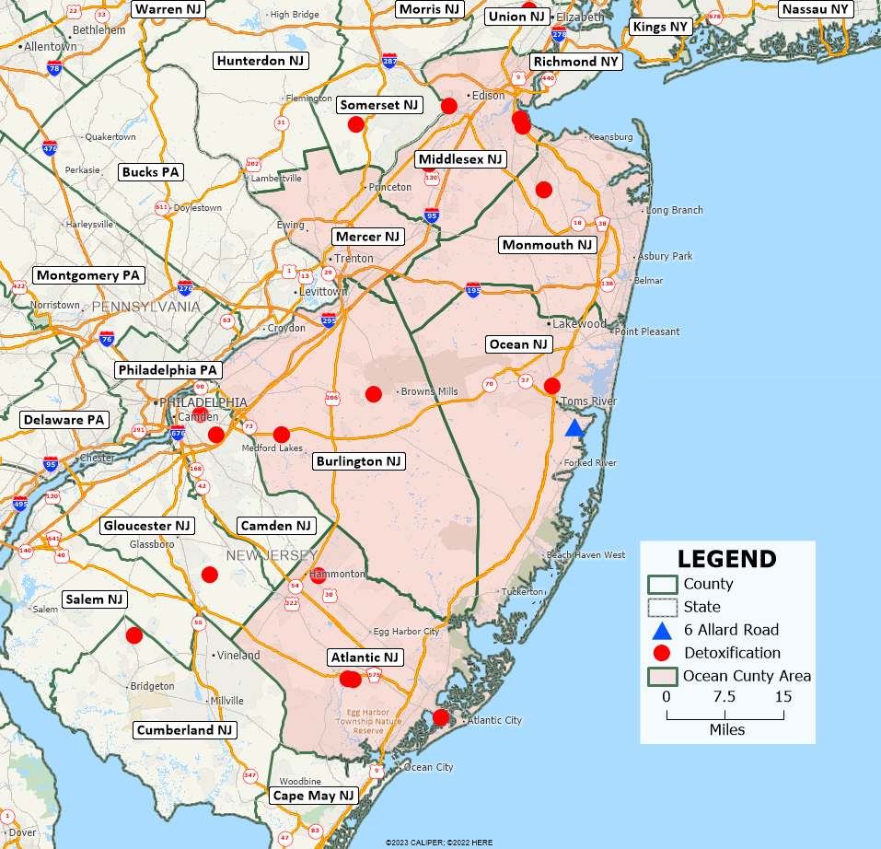

- Statewide, licensing records identify 21 short-term residential providers providing services at 22 locations with 818 current short-term residential beds in New Jersey. Figure 6 shows the locations of licensed short-term residential programs in the area around Ocean County. In the six counties comprising the Ocean County area, there are nine providers of short-term residential services, and they have 360 beds. Ocean County has no short-term beds.

Figure 6: Licensed Short-Term Residential Services
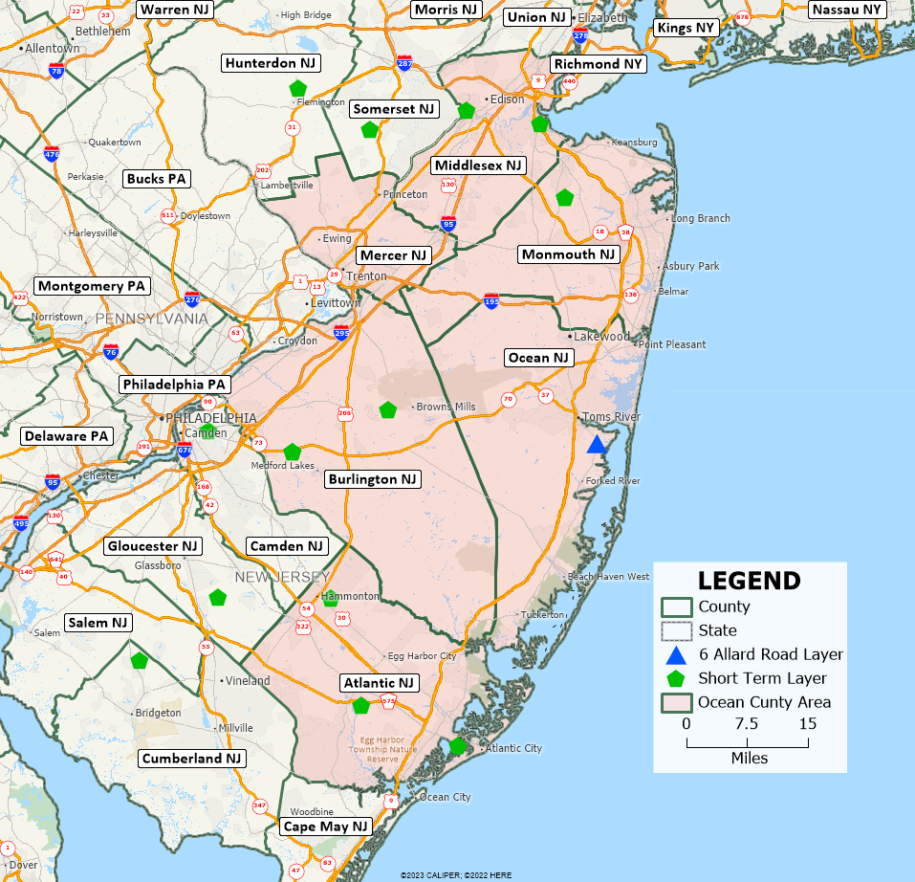

- Statewide, licensing records identify 18 long-term residential providers providing services at 23 locations with 1,306 short-term residential beds in New Jersey. Figure 7 shows the locations of licensed long-term residential programs in the area around Ocean County. In the six counties comprising the Ocean County area, there are eight providers of long-term residential services, and they have 450 beds. Ocean County has 21 beds in one program, approximately .01% of all long-term beds in the State or approximately .04% of all long-term residential beds in the six-county area.

Figure 7: Licensed Long-Term Residential Programs in the Ocean County Area
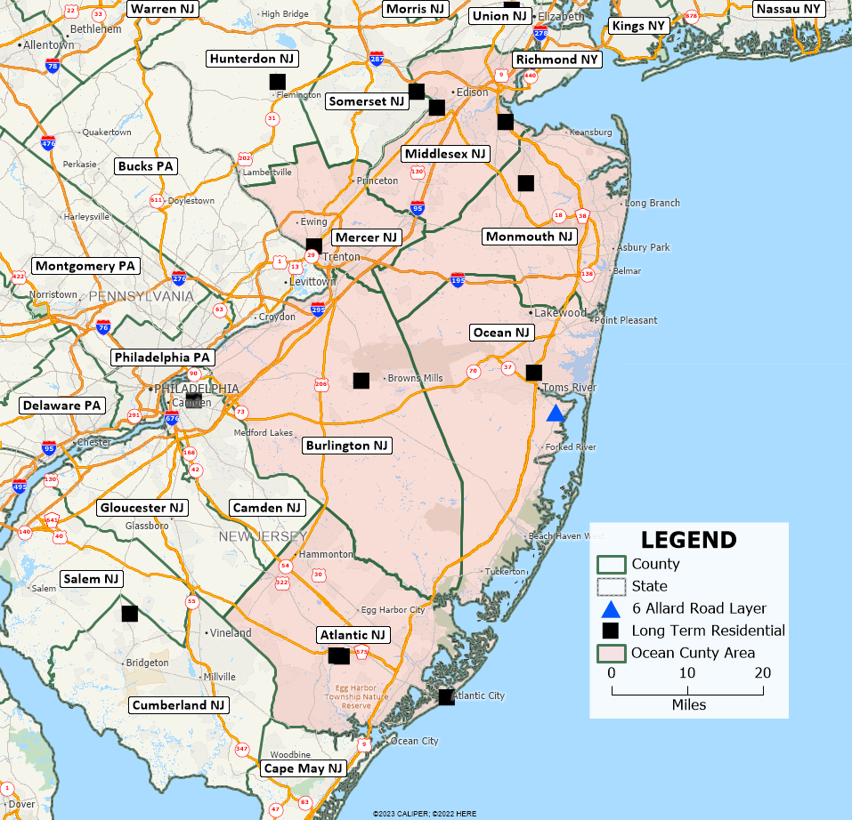
- Figure 4 indicates that almost two-thirds of the providers operate more than one type of program. If a program provides detoxification services, then it likely also provides a residential component, and the locations of programs across Figures 5 and Figure 6 are substantially similar, as is Figure 7, which maps long-term residential services.

- Four of the counties in the Ocean County area offer all three types of programs. Ocean offers two, and Mercer offers only a small, long-term-care residential program. The Ocean County program located in Toms River contains a 38-bed detoxification capacity and a 21-bed residential component.

- Since Ocean County only has two programs in one location, existing service levels appear insufficient to meet the unmet needs for detoxification and residential treatment, given the size of the existing long-term residential program, the numbers of individuals needing services, the outmigration of individuals seeking services, and the number of overdose deaths and near deaths that occur in the County.

Consequences of Delays in Treatment

- In 2022 in New Jersey, there were 2,893 deaths suspected to be related to illicit drug use. This amount would have been higher had there not been 15,452 naloxone administrations. In Ocean County, in the five-year period from 2018 through 2022, there were 1,096 deaths due to drug overdoses and 4,092 administrations of naloxone. The death total would have been higher without the 4,092 naloxone administrations and the decreasing number of opiate prescriptions issued by physicians.

- Adding the 186 deaths in 2022 to its 748 naloxone overdose recoveries in 2022 and dividing by the number of days in the year yields a sobering fact. Every day in Ocean County in 2022, approximately 2.5 Ocean County residents were either dying of a drug overdose or coming perilously close to dying from a drug overdose.

- A delay in medical treatment has consequences. A delay of two weeks for treatment of breast cancer and surgery increases death rates by 4%. Delays for any hospital inpatient admission of more than 5 hours from time of arrival at the emergency department are associated with an increase in all-cause 30-day mortality.

- Delaying treatment also injures individuals with substance and alcohol use disorders. If individuals cannot obtain substance use treatment in the geographical area where they live, then treatment is less accessible, and delays and costs are incurred. These injuries are not as dramatic as the tumor discovery, car crash, or the stroke, but they are real. Untreated substance use has a gradual harmful daily effect. It is a progressive chronic disease and should be treated as soon as the individual is willing to seek treatment.

- Effects vary by the individual, but broadly speaking, a substance use disorder can:

- Impair an individual’s ability to function in daily life, leading to poor performance at work or school, difficulties in interpersonal relationships, and increased risk of accidents or injuries;

- Affect an individual’s productivity, motivation, and decision-making skills, resulting in job loss, reduced income, or debt;

- Alter the brain’s reward system, making it harder to quit or reduce drug use, and increasing the likelihood of developing dependence or addiction. Addiction is a chronic and relapsing physiological disease that requires prolonged treatment;

- Contribute to housing instability, as people may lose their homes due to eviction, foreclosure, or family conflict. People who are homeless also face greater challenges in accessing treatment and recovery services;

- Affect an individual’s physical and mental health, causing various symptoms such as changes in appetite, movement, speech, mood, and cognitive function. SUDs can also increase the risk of developing or worsening other mental health conditions, such as depression, anxiety, or psychosis;

- Increase the risk of developing or worsening course of disease for cardiovascular illness or other long-term health issues such as coronary arterial disease, high blood pressure, diabetes, and chronic pain. SUDs can damage various organs and systems in the body, such as the heart, liver, kidneys, lungs, and brain. SUDs can also interfere with the management of chronic conditions, leading to poorer outcomes and complications; and

- Increase the risk of suicidal thoughts and behaviors, especially among people who also have a mental health disorder. SUDs can also impair a person’s judgment and impulse control, making them more likely to act on their suicidal impulses.

- These consequences are summarized in the Monmouth Comprehensive Plan:

Individuals who are unable to access treatment are often at risk for illness, injury, hospitalization, job loss, incarceration, and death. Delay-related risks further stress the family unit and exhaust social, medical, and law enforcement resources.

Conclusions
- It is reasonable to conclude that Ocean County needs more substance use treatment sooner rather than later:

  - All State and County calculations indicate there is a substantial unmet need for treatment services;

  - Ocean County has weak residential programs. It has no short-term residential programs and has one small long-term program;

  - Ocean County has one detoxification program;

  - NJ SAMS annual records contain no utilization data for detoxification services in Ocean County;

  - Half the individuals receiving treatment services leave the County to obtain them;

  - Treatment programs in other counties have ten admissions a day from Ocean County residents;

  - Every day in Ocean County in 2022, approximately 2.5 Ocean County residents were either dying of a drug overdose or coming perilously close to dying from a drug overdose; and

  - The absence of treatment causes serious, immediate injury to individuals seeking treatment.

- Unlike most other counties in New Jersey, Ocean County has only one location where substance use treatment can be found. There is a detoxification program in Toms River with a small, attached long-term residential program. Existing service levels appear insufficient to meet both the detoxification and residential treatment needs of the population in Ocean County, given the numbers of individuals needing services, the outmigration of individuals seeking services, and the number of overdose deaths and near deaths.

Professional Qualifications Relevant to the Analysis of Need
- Because of my education and experience, I am qualified to provide the Court with this expert witness testimony. Based on my qualifications, I have been accepted as an expert witness in eleven zoning board proceedings, have submitted declarations or testified in six federal district courts, three state courts, and before administrative law judges in two states. Within the last five years, I have served as a litigative consultant to the Special Litigation Section of the United States Department of Justice.

- A complete list of all publications with associated weblinks, resume, and court appearances can be found at my website, https://hendrickson-consulting.com/

- My Sociology Ph.D. training specialized in quantitative methods and research.

- During the period 1986 to 1997, I spent six years as the Senior Budget Analyst in the Oregon Medicaid program, where I conducted hundreds of fiscal impacts spanning routine projections of monthly and biennial costs, the impact of new state and federal legislation, and the impact of increases and decreases in payment rates and program users.

- I received successive promotions within the Oregon and New Jersey Medicaid programs and retired as an Assistant Commissioner in the New Jersey Department of Health, overseeing a staff of 250. As a Medicaid official, I have participated in discussions regarding the need for substance use treatment programs and where they should be located.

- Upon retiring from state service, I was hired by the Maximus consulting company as “Director, Revenue Services,” and for two years performed revenue maximization studies in a dozen states. I reviewed CMS 2552 state mental hospital cost reports, cost reports and budgets of state-operated intermediate care facilities for persons with Intellectual and Developmental Disabilities (ICFs/IDDD), state-operated nursing home cost reports, intergovernmental fund transfers, and federal regulations regarding Medicaid and Medicare reimbursement to states.

- I left Maximus in 2004 and started my own consulting company, working as a subcontractor or consultant for national research companies and behavioral health treatment organizations along with state Medicaid programs. In 2007-2008, I was a Visiting Professor at Rutgers University in the Center for State Health Policy. I have worked continuously as an independent consultant or worked on reports to state agencies that were published in the name of the company that subcontracted with me.

- My website contains reports where I am listed as an author or worked as a subcontractor.

- In addition to working for national research organizations and state agencies as a subcontractor, I have conducted approximately ninety quantitative studies for private clients studying the adequacy of existing provider networks and locations where health-related programs are needed. Due to the proprietary nature of business development, this work was done under confidentiality agreements. These analyses typically used quantitative Geographical Information Services (GIS) techniques.

- I conducted the needs assessments/site selection studies by:

- Identifying the state’s regulatory structure affecting the type of service(s) to be provided;
- Finding health insurance statistics and household income in the geographical area;
- Checking population density and transportation routes;
- Identifying the locations and utilization capacity of existing providers;
- Establishing the prevalence of mental health issues and substance use in the geographical area, and
- Estimating the number of individuals that may use a new program in that geographical area.

- My studies that I presented to federal and state courts, administrative law judges, and zoning boards are listed on my website. I prepared litigation-related documents in:

  - 2022 Trinity Sober Living v. Village of Hinsdale, United States District Court for the Northern District of Illinois Eastern Division, Case No. 1:19-cv-7321, Damage Assessment Report;

  - 2020 Wisna Serenity Homes v. Borough of Pottstown, United States District Court for the Eastern District of Pennsylvania, Case No. 2:20-cv-01284, Damages Assessment Report and Expert Witness Declaration;

  - 2018-2019 United States of America v. The State of Mississippi, United States District Court for the Southern District of Mississippi, Case No. 3:16-cv-00622-CWR-FKB, Analyses of Managed Care and Community Mental Health Costs;

  - 2017 Sunrise Detox LLC, v. Simone Investment Group LLC, et al., Superior Court of New Jersey, Law Division, Mercer County, Case No. MER-L-2465-12, Testimony and Expert Certification;

  - 2017 Waters Edge Recovery vs. the City of Stuart, United States District Court for the Southern District of Florida, Case No. 13-14491-cv-Martinez-Lynch, Testimony and Expert Witness Declaration;

  - 2016 Maxxam Partners, LLC et al v. Kane County, Illinois Zoning Board of Appeals et al., United States District Court for the Northern District of Illinois, Case No. 17-cv-5707, Testimony and Expert Witness Report;

  - 2014 Toms River New Jersey Zoning Board of Adjustment, Application of Lapid Ventures, Testimony and Expert Witness Report;

  - 2014 Waters Edge Recovery LLC vs. City of Stuart, United States District Court for the Southern District of Florida, Case No.13-14491-cv-Martinez-Lynch, Testimony and Expert Witness Report;

  - 2014 CC Recovery Inc. v. Cecil County, Maryland, United States District Court for the District of Maryland, Case No. 1:12-cv-03786-JKB, Deposition and Expert Witness Report;

  - 2013 Mazel and Dorca v. Township of Toms River and Dover Woods Healthcare Facility, Superior Court of New Jersey, Ocean County, Case No. OCN-L-3505-12, Expert Witness Report;

  - 2013 Simone Investment v. Township of Lawrence Zoning Board of Adjustment, Superior Court of New Jersey, Mercer County, Case No. MER-L-2325-11, Expert Witness Report;

  - 2013 Town of Juno Beach, Florida, testimony before Special Magistrate regarding the need for substance abuse services in the Juno Beach area. Oceanside Detox, Testimony and expert witness report;

  - 2013 Sunrise Detox vs. City of White Plains, United States District Court for the Southern District of New York, Case No. 7:13-cv-01614-VB, Affidavit;

  - 2012 Westchester County New York zoning board. Sunrise Detox application, Expert witness report;

  - 2012 Alpharetta, Georgia Planning Commission, Sunrise Detox Application, Expert witness report;

  - 2011-2012 Darling, et al. vs. Douglas, et al., United States District Court for the Northern District of California, Case No. C09-03798 SBA, Three Declarations;

  - 2011 Lawrence, New Jersey Township Zoning Board of Adjustment, Simone Investment Group Application, Testimony and Expert Witness Report;

  - 2011 Township of Teaneck, New Jersey Board of Adjustment, CareOne at Teaneck application, Testimony and Expert Witness Report;

  - 2009 In Re: Abingdon Health Investors, LLC, Commonwealth of Virginia, Department of Health, Testimony for Administrative Law Judge hearing, Affidavit on culture change and nursing homes;

  - 2009 In Re: Abingdon Health Investors, LLC, Commonwealth of Virginia, Department of Health, Testimony for Administrative Law Judge hearing, Affidavit on nursing home size and nursing home costs;

  - 2008-2009 Oradell, New Jersey Board of Adjustment, Blauvelt Associates application, Testimony and expert witness report;

  - 2008 745 Highland Avenue LLC vs. Cheshire Zoning Board of Appeals and the Town of Cheshire, United States District Court for the District of Connecticut, Case No. 3:2009cv00499, Expert Witness Report;

  - 2008 Cheshire, Connecticut Zoning Board of Appeals, 745 Highland Avenue LLC application, Testimony and Expert Witness Report;

  - 2008 Township of Hamilton, New Jersey Zoning Board of Adjustment, CareOne at Hamilton application, Application No. 99-01-005B, Testimony and Expert Witness Report;

  - 2008 Whippany, New Jersey Board of Adjustment, CareOne application, Testimony, and Expert Witness Report, and

  - 2009 Oradell Board of Adjustment, Bergen County, New Jersey, Denial of Use Variances, Testimony and Expert Witness Report.

Compensation

- My compensation is $225 per hour. I charge eight hours per day for testimony at trial or deposition.

Respectfully submitted:
D/S/ Leslie Hendrickson

_________________________
Leslie Hendrickson, Ph.D.
Date: 8/16/2023

https://www.co.monmouth.nj.us/documents/41/MONMOUTH-COUNTY-DMHAS-CCP_Final-2023.pdf p9
https://www.ochd.org/wp-content/uploads/2018/09/DMHAS-2016_2019-CCP-OUTLINE_OC-Finalized-Plan.pdf
https://nj.gov/humanservices/dmhas/publications/statistical/index.html
https://www.nj.gov/dcf/about/divisions/opma/docs/Burlington.County.Needs.Assessment.Report.2020.pdf
https://www.mercercounty.org/home/showpublisheddocument/16645/637135767045730000
https://www.mercercounty.org/home/showpublisheddocument/16645/637135767045730000
https://nj.gov/humanservices/dmhas/publications/performance/PR_State_2021.pdf
https://www.samhsa.gov/data/report/national-survey-substance-abuse-treatment-services-n-ssats-2018-data-substance-abuse
https://www.nj.gov/health/hcpnj/documents/county-reports/HCPNJ_fullreports/BURLINGTON_BURLINGTON%20CITY.pdf
https://www.njoag.gov/programs/nj-cares/
ibid
https://bgas.samhsa.gov/Module/BGAS/Users. Use “citizennj”: as username and “citizen” as password. Click on “View an existing Application”
https://www.co.ocean.nj.us/OC/OCDHS/frmMentalHealth.aspx Then click on “Files of Interest”, then click “MHB Plans”
https://www.healthiermiddlesex.com/assessments-plans
https://www.co.monmouth.nj.us/documents/41/MONMOUTH-COUNTY-DMHAS-CCP_Final-2023.pdf
https://www.state.nj.us/humanservices/dmhas/publications/performance/index.html See 2021 Performance Report p. 12 for 6-day length of stay.
https://www.state.nj.us/humanservices/dmhas/publications/statistical/Substance%20Abuse%20Overview/2021/statewide.pdf
Ibid. p. 2
https://www.state.nj.us/humanservices/dmhas/publications/performance/PR_State_2021.pdf see p.9-10.
Data obtained from the licensing unit of the NJ DMHAS program.
https://www.cms.gov/medicare/medicare-advantage/medicareadvantageapps Then click on “HSD 2023 Reference file.”
Ibid.
https://www.census.gov/quickfacts/fact/table/US/ In the search box enter name of county from the drop down menu.
U.S. Census tract data from the American Community Survey (ACS) 2021 5-Year estimates.
https://www.state.nj.us/humanservices/dmhas/publications/need/index.html
Percentage data for 2015 and 2022 taken from DMHAS at https://nj.gov/humanservices/dmhas/publications/need/ Drive time ring calculations made by Hendrickson Development. County and census tract figures from American Community Survey 5-Year 2021. Weighted average calculated by Hendrickson Development and done by averaging State percentages for 2015 and 2022 then calculating number of adults needing services.
Except for population estimates in the 70-minute drive time ring, all other statistics on the number of persons needing and receiving substance abuse services are drawn from State of New Jersey sources.
Data from 2021 annual reports of Division of Mental Health and Addiction Services. Data note: Percentages and admission data from Monmouth and Ocean do not tie together.
https://www.samhsa.gov/data/report/national-survey-substance-abuse-treatment-services-n-ssats-2018-data-substance-abuse
See Hasin, et al. at Soc Psychiatry Psychiatric Epidemiology (2015) 50:1609–1640 and Grant, et al. at JAMA Psychiatry. 2015 August, 72(8): 757–766. doi:10.1001/jamapsychiatry.2015.0584; See also https://www.niaaa.nih.gov/research/nesarc-iii
Grant, B.F. et al., Epidemiology of DSM-5 Drug Use Disorder Results from the National Epidemiologic Survey on Alcohol and Related Conditions–III, JAMA Psychiatry. 2016;73(1):39-47, https://jamanetwork.com/journals/jamapsychiatry/fullarticle/2470680
https://www.ncbi.nlm.nih.gov/pubmed/26039070
http://archpsyc.jamanetwork.com/article.aspx?articleid=2470680
https://www.samhsa.gov/data/report/2021-nsduh-state-specific-tables New Jersey State Table. Table 72A Substance Use, Perceptions of Great Risk, and Mental Health Measures: Among People Aged 12 or Older in New Jersey; by Age Group, Percentages, 2021
Plan obtained from Ocean County staff.
https://www.co.monmouth.nj.us/documents/41/MONMOUTH-COUNTY-DMHAS-CCP_Final-2023.pdf pp. 13ff
Ibid. p. 18.
See program definitions at N.J.A.C. 10:161A-1.1.
https://www.state.nj.us/humanservices/dmhas/publications/performance/PR_State_2021.pdf p.8 A halfway house is an ASAM III.1 low-intensity program. It is not intended to perform long- or short-term treatment; rather, its focus is on preparing persons to live in the community.
https://bgas.samhsa.gov/Module/BGAS/Users. Use “citizennj”: as username and “citizen” as password. Click on “View an existing Application” Go to 2022-2023 Combined Application, click “My Dashboard,” look for Part 2 of Planning Steps see p. 12.
Ibid. p. 13.
Data obtained from NJ Division of Mental Health and Addiction Services (NJ DMHAS). These data exclude programs in prisons.
The only detoxification program in Ocean County does not report utilization data to the State. It cannot be determined how many County residents received services within and outside the County. The last time it reported data was in 2017, and it reported 821 admissions. See 2017 data at https://www.state.nj.us/humanservices/dmhas/publications/statistical/index.html
On Figure 6 it looks like there are eight providers. This is because there are two separately licensed programs in Burlington next to one another..
https://www.njoag.gov/programs/nj-cares/nj-cares-data-by-county/
Ibid. Look under “County” tab.
Hanna et. al. Mortality due to cancer treatment delay: systematic review and meta-analysis, BMJ 2020;371:m4087 https://pubmed.ncbi.nlm.nih.gov/33148535/
Moulton et al. Association between delays to patient admission from the emergency department and all-cause 30-day mortality, Emerg. Med. J., 2022 Mar;39(3):168-173. https://pubmed.ncbi.nlm.nih.gov/35042695/
https://www.co.monmouth.nj.us/documents/41/MONMOUTH-COUNTY-DMHAS-CCP_Final-2023.pdf p. 9; For example, see the discussion of delay discounting in Stevens, et al. Delay discounting, treatment motivation and treatment retention among substance-dependent individuals attending an inpatient detoxification program. J. Subst. Abuse Treat. 2015 Feb; 49:58-64.

