The Need for Day/Night Substance Abuse Treatment Services
in the area around Stuart, Florida

A report prepared for Waters Edge Recovery

January 2014

The Situation of Waters Edge Recovery

SUMMARY POINTS………………………………………………………………..……….3

The Day/Night Model

AREA CHARACTERISTICS…………………………………………………………………..5

Population Density

The Area around the Waters Edge Program

The Rate of Substance Use Disorders in Martin and nearby Counties

Location of Existing Day/Night Programs

ESTIMATE OF NEED …………………………………………………….…………………..8

Impact on Substance Abuse Treatment if Waters Edge is Restricted to Six Beds.

The Situation of Waters Edge Recovery

Waters Edge Recovery (Waters Edge) seeks to operate a 12-bed community housing program in conjunction with its substance abuse treatment program. In 2013, zoning officials informed Waters Edge that a 12-bed program was not compliant with code and perhaps a six-bed program might be allowed. Based on the City’s apparent agreement that Waters Edge could operate six beds, the Waters Edge program began providing community housing to six of its patients, which is far below its 14-bed capacity. The purpose of this report is to address the need for at least 12 beds for the Day/Night substance abuse treatment with community housing provided by the Waters Edge program.

All figures referred to in the text are contained in the Appendix which also contains a list of figures.

SUMMARY POINTS

- Day/Night programs are a specific substance abuse licensure category of the Florida Department of Children and Families.

- Day/Night programs require more hours of treatment than other substance abuse treatment programs.

- Waters Edge is providing approximately 50% more treatment hours than it is required to do so by its license.

- Stuart is in a densely populated area with efficient north-south transportation routes.

- Waters Edge patients come from an area populated by approximately 2.7 million persons over the age of 18.

- There is a need for services in the area and Waters Edge is part of meeting that need:

- Waters Edge has a history of being fully occupied;
- Two existing treatment programs in the Stuart area other than Waters Edge are proposing a substantial expansion;
- Another program providing Day/Night services recently opened;
- The number of persons estimated to need Day/Night services in the area around Waters Edge is approximately in line with the existing bed capacity in the area. Since some existing bed capacity is used by out-of-state persons, what is likely happening is that there is a need for more bed capacity to offset the out-of-state usage; and
- Requiring a 12-bed program to downsize to 6 beds effectively denies needed services to about 34 acutely ill persons that would have received services there but now will no longer be able to do so.

The Day/Night Model

A Day or Night Treatment with Community Housing program, sometimes known as the Florida model, has a treatment component and a housing component. State licensing practices recognize two types of Day/Night programs. One type does not provide housing while the other does. Day/Night programs that provide housing fall into the licensure category of “Day or Night Treatment with Community Housing” (“Day/Night”). The Waters Edge program provides housing and is licensed in this Community Housing category.

Day/Night programs are not comparable to residential programs because of the higher treatment levels required for patients in Day/Night programs. Day/Night programs are required to provide 25 hours of treatment per week whereas the highest level of residential services, level 1, only requires 14 hours a week of treatment services. Day/Night programs also are more intensive than a regular intensive outpatient program which may provide 9 to 10 hours a week of group therapy and perhaps some individual therapy.

Day/Night programs are intended for persons who need a more acute level of care. Indicative of the acuity is the average length of stay in the program of eight weeks. Short-term residential programs tend to have more intensive treatment programs than longer-term programs. SAMHSA block grant reporting categories define a short-term residential program to be “up to 30 days”. Waters Edge is operating an intensive program for eight weeks, which is a longer duration than most other treatment programs serving acute patients, because Waters Edge is serving persons with the most acute needs.

While Florida administrative regulations require 25 hours of treatment per week for Day/Night programs, a review of documents submitted by Waters Edge indicates that it provides 37 hours per week, 50% more hours than are required. These hours assume a five-day week and consist of:

- 1.25 hours of group therapy twice daily
- 1 hour of relapse prevention daily
- 1 hour of spiritual component daily
- 1.5 hours of life skills daily
- 1 hour of attendance at Alcohol or Narcotics Anonymous (AA/NA)
- 2 hours of individual counseling per week per patient

The Waters Edge program substantially exceeds state requirements. The depth of this effort can be gauged by the Bureau of Labor Statistics’ occupational wage data for the Port St. Lucie area that shows Substance Abuse and Behavioral Disorder Counselors (Occupational Code 21-0111) had a median hourly wage of $15.92. In providing an additional 12.0 hours of treatment each week beyond state standards, Waters Edge is incurring costs of approximately $15.92 multiplied by 12, or $191.04 per week per patient more than is necessary by state treatment requirements.

The most common reason for a treatment program to exceed state hourly requirements is the decision of the clinical staff that the acuity levels of patients require additional treatment to be successful.

AREA CHARACTERISTICS

Population Density

In considering the need for a program’s service, it is useful to first look at the population density near the program. Figure 1 shows the population density in census tracts near Stuart. The census tracts along the Atlantic Coast in central Florida are densely populated. Many of these tracts have more than 5,000 persons per square mile. A major U.S. interstate, I-95, runs the length of this coastal section, permitting efficient access to Stuart from areas north and south. Parallel state highways, including Florida’s Turnpike, permit similar north-south access. There are also densely populated areas to the southwest toward the Cape Coral area and to the northwest toward the Lakeland area but each is more than 100 miles from Stuart. A review of Figure 1 indicates that Stuart is in a densely populated area with efficient north-south transportation routes.

The Area around the Waters Edge Program

The “area around” a program is defined to be the area that most persons attending a program are likely to come from. This area depends on the type of program provided. This report focuses on the need for a Day/Night program. The “day” component is where treatment is provided, and the “night” component is a housing program.

Persons attending an in-patient detoxification or residential program are typically willing to travel longer distances to enroll in a program. The distance cost for a residential program is infrequently incurred; a preliminary visit may be made to view the potential program and compare it to other programs, and the enrollment trip will be made to enter the program. This is in sharp contrast to the willingness of persons to make a daily commute to an outpatient or intensive outpatient program where the daily time spent commuting competes with other priorities and demands on the person’s daily life.

A list of the zip codes of persons that attended the Waters Edge program in the Fall of 2013 was obtained from the program. The program is small and new to the current owners, and the size of the population does not provide a robust base on which to estimate the geographical area of its patient base. However, it is possible to make initial observations and calculate projections from them.

Figure 2 maps the zip codes that the patients come from. While most residents come from within 30 miles of Stuart, what is surprising is the geographical reach of the program. Not only did it attract persons from St. Petersburg to the west but also from Delray Beach to the south. Figure 2 also shows a hand-drawn area on the map that contains the greater geographical area encompassed by the zip codes of the Waters Edge patients. Aggregated block-level census data produce an estimate that there are approximately 2,761,772 adults in this area.

The Rate of Substance Use Disorders in Martin and Nearby Counties

Stuart is the seat of Martin County in what is called Florida’s Treasure Coast. The federal agency that provides federal funds to states to support substance abuse and mental health programs is called the Substance Abuse and Mental Health Services Administration (SAMHSA). This agency conducts annual household surveys of drug use and health and aggregates the data for multiple years to produce estimates of the percentage of persons that have alcohol and other substance abuse problems. SAMHSA prepares multiple state-level estimates and substate estimates.

Reliance on federal data is necessary since neither the Department of Children and Families nor the Data Collection, Quality Assurance & Patient Safety unit of the Florida Agency for Health Care Administration was able to provide utilization information or bed counts for Day/Night programs.

Martin County is contained within SAMHSA’s substate estimates for “Circuit 19” which includes Indian River, Martin, Okeechobee, and St. Lucie counties. Figure 3 shows the substance use disorder rates for Florida and Circuit 19.

Figure 4 calculates the number of adults with substance use disorders within the area where the Waters Edge patients are from. Approximately 240,550 adults within this catchment area were dependent on or abused illicit drugs or alcohol in the past year, 74,292 needed but did not receive treatment for illicit drug use, and 177,306 needed but did not receive treatment for alcohol use.

Location of Existing Day/Night Programs

Figure 5 shows that Waters Edge is one of eight Day/Night programs in St. Lucie and Martin counties. What is striking is the relative absence of Day/Night programs in much of central Florida and their concentration on the coast. In part, this is due to the rural nature of the interior such as the sparse population in rural Okeechobee County, and in part, it is due to the business advantages of locating in scenic coastal areas.

A review of available information about the programs in St. Lucie and Martin Counties indicates the following:

12 Palms Recovery describes itself as “a 30 bed residential facility situated on the Indian River Lagoon in South Florida. We are in Jensen Beach, a very small quaint village. We provide Detox, PHP & IOP with housing. We also offer outpatient & transitional care.”

The website for A Road to Recovery does not refer to community housing. A You Tube video says the program can serve a maximum of 36 persons. It has a large staff and provides a full range of services, including detoxification, residential, and outpatient services. A September 2013 news article contains the information that “A lawsuit filed in federal court by A Road to Recovery, which wants to build three sober homes, is still pending. A Road to Recovery also filed a discrimination complaint with the U.S. Department of Housing and Urban Development, which was dismissed.”

The website for Artesian Wellness Recovery states that its Partial Hospitalization program, PHP, “is our most structured program offering 26 hours of treatment programming per week. While living in our community housing…” The website also describes its community housing as follows: “Artesian is a pioneer of integrative addictions treatment. Our celebrated program has capacity for up to 60 people at a time. Patients live on a quaint, Key West-style, campus in our pleasant Florida community housing while participating in the Artesian Program. The average stay lasts between 4 and 8 weeks.”

New Life Addiction Treatment Center operates five residential buildings. It describes its program as a 90-day treatment program of which the first 30 days are a partial hospitalization program with community housing. Doing business as (dba) the Torino Treatment Center, on December 31, 2013, New Life sued the Port St. Lucie Zoning Board to be allowed to open a proposed 30-bed detox building and a 40-bed rehabilitation building for post-detox treatment. Originally the request was for an 80-bed program, but New Life scaled it back to 40 beds because of objections to the size of the proposed building. The application indicated that current program patients were scattered in residential sites throughout the area. The website for New Life shows videos of five buildings but does not discuss the number of beds.

Restoration Ministries is a small program that has earned between $700,000 and $800,000 per year in revenue for the period 2007 to 2011. Quantitative information on the program was not available.

Press releases for Treasure Coast Recovery dated September 27 and December 12, 2012 describe it as an 18-bed program in Stuart. It joined the Chamber of Commerce in late 2013 and appears to have opened in September of 2012. Treasure Coast Recovery has two licenses; however, references to its program do not mention having beds in separate locations.

Unity Recovery operates a 46-bed site in Hobe Sound, which is south of Stuart. Utilization statistics are not publicly available. The videos and pictures of the program stress luxurious Florida settings with 72 degree weather, the therapeutic values of the ocean, and the upscale living accommodations.

A copy of the Hobe Sound project from the builder’s website is shown below.

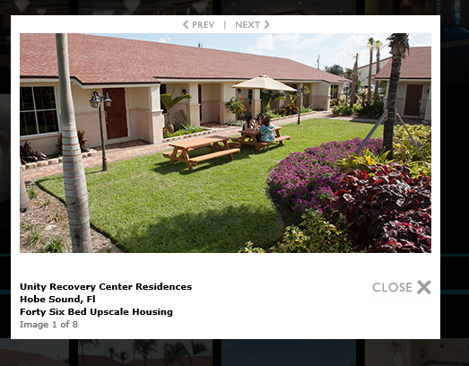

ESTIMATE OF NEED

There are multiple indicators of the need for Day/Night substance abuse treatment in the Stuart area.

1. The Waters Edge program has utilized all six beds of its 12-bed capacity for some time. There is a substantial difference in estimating the need for a current program and estimating the need for a future program. Historical occupancy rates can be used to gauge future needs. An existing program at full occupancy means the program is meeting a need for its services. A full occupancy rate should be sufficient proof that a treatment program is serving an existing need and that more beds are needed.

2. The fact that New Life is attempting to open its Torino program and that Road to Recovery wishes to expand by 36 beds is an indication that its owners have made a financial judgment that there is a demand for additional treatment services in the area.

3. An additional factor that supports the need for a program is the example of the recently-opened program at Treasure Coast Recovery. Its owners would not have opened a Day/Night program with 18 beds in the Fall of 2012 without having done comprehensive research concluding that a need for the program existed in that location.

4. As discussed below, the number of persons estimated to need Day/Night services in the area around Waters Edge is approximately in line with the existing bed capacity in the area. Since the programs are clearly marketing their services to out-of-state persons, what may be happening is a “crowding out” of local persons, implying that there is a need for some existing bed capacity in the area.

Figure 5 estimates the need for a Day/Night program in the Stuart area. The figure:

- Begins with the adult population in the Waters Edge catchment area;
- Multiplies the adult population by the percentage of persons that were dependent on or abused illicit drugs or alcohol in the past year;
- Factors out adults without health insurance;
- Assumes that 30% would be motivated to seek substance abuse treatment; and
- Assumes only 3% of them would use a Day/Night program.

The result of these calculations indicates that approximately 1,500 persons from Florida will use a Day/Night program in this geographical area.

A count of the bed sizes in the existing Day/Night Programs in the Stuart area shows that there are an estimated 245 beds in Day/Night programs. Assuming an average length of stay of eight weeks, 245 beds could serve about 1,470 persons at 100% occupancy.

It is reasonable to conclude that the number of persons that need Day/Night Service is approximately in line with the existing bed capacity in the area. A review of these provider websites shows that the Florida environment and coastal setting are attractions for these programs. The marketing on the websites seems to be presented with the intention that out-of-state persons will be attracted to the region. Given that bed supply is approximately in line with population levels, what is likely occurring is that some level of occupancy is due to out-of-state patients, implying that there is a local unmet need.

The amount of local need cannot be estimated without knowing the occupancy levels in area programs due to out-of-state patients.

Impact on Substance Abuse Treatment if Waters Edge is Restricted to Six Beds

The state of New Jersey is the only state east of the Mississippi that collects data on all persons that use substance abuse treatment programs. The New Jersey data show that only 2-3% of persons treated for substance abuse use an intensive, long-term residential program like Waters Edge. Waters Edge is serving the most acutely ill persons among those that seek substance abuse treatment services.

Although Waters Edge Day/Night program has a 14-bed capacity, local authorities have informally restricted it to 6 beds. A 12-bed program at 95% occupancy with an eight week average length of stay (ALOS) will provide services to about 68 persons per year. Limiting a 12-bed program to 6 beds effectively denies needed services to about 34 acutely ill persons who have made the difficult decision to seek treatment. A look at the zip code data shows that 16% of the persons served in the Fall of 2013 came from zip codes in the immediate Stuart area.

The enforcement of a 6-bed limit at Waters Edge will result in persons from Stuart traveling further distances to obtain services and will force other acutely ill persons in the nearby region to undergo additional hurdles to obtain service.

Les Hendrickson, Ph.D.
Hendrickson Development
leslie.c.hendrickson@gmail.com
http://www.hendricksondevelopment.biz
609-213-0685 (cell)

Appendix

List of Figures

Figure 1: Population Density in Census Tracts near Stuart, Florida, 2011

Figure 2: Area around Stuart, Florida encompassing Zip Codes that Waters Edge patients come from, 2013

Figure 3: Rate of Substance Use Disorders in area around Stuart, Florida, 2008-2010.

Figure 4: Estimated Number of Adults in Waters Edge Catchment Area impacted by Alcohol and Illicit Drugs, 2008-2010

Figure 5: Location of Day/Night Programs in Central Florida, 2014

Readers who are using a computer to read this report can magnify maps by using the View Tab in Word and then selecting the Zoom command. A magnification of 250% or more will show the details of the maps with clarity. If the report is copied, the copy should be done with color printing.

Figure 1: Population Density in Census Tracts near Stuart, Florida, 2011
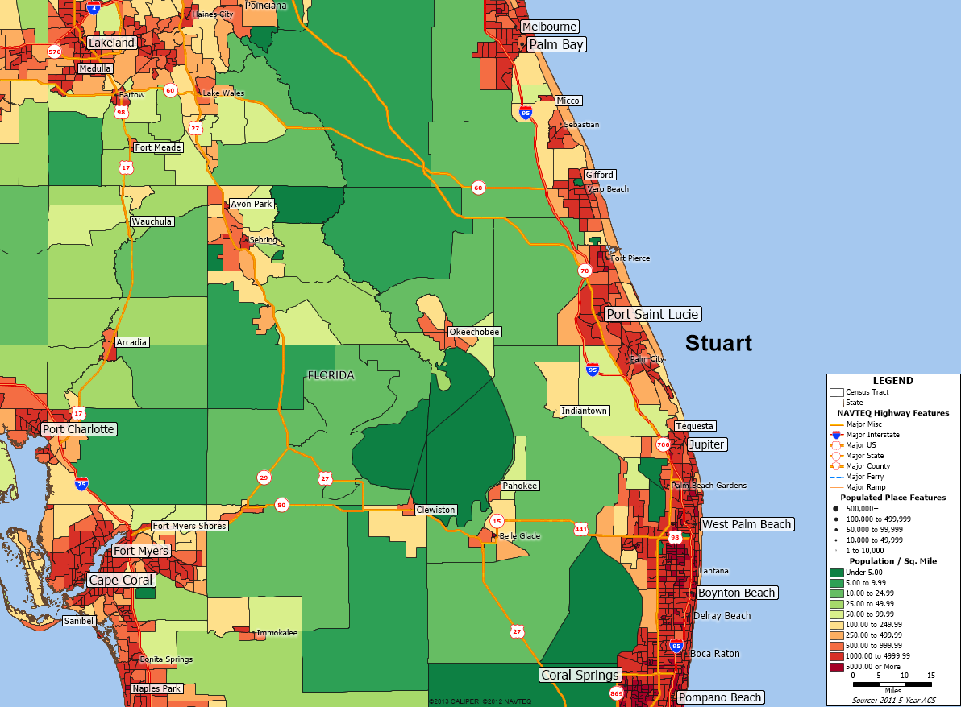
Data: U.S. Census, American Community Survey 2011

Figure 2: Area around Stuart, Florida encompassing Zip Codes that Waters Edge patients come from, 2013
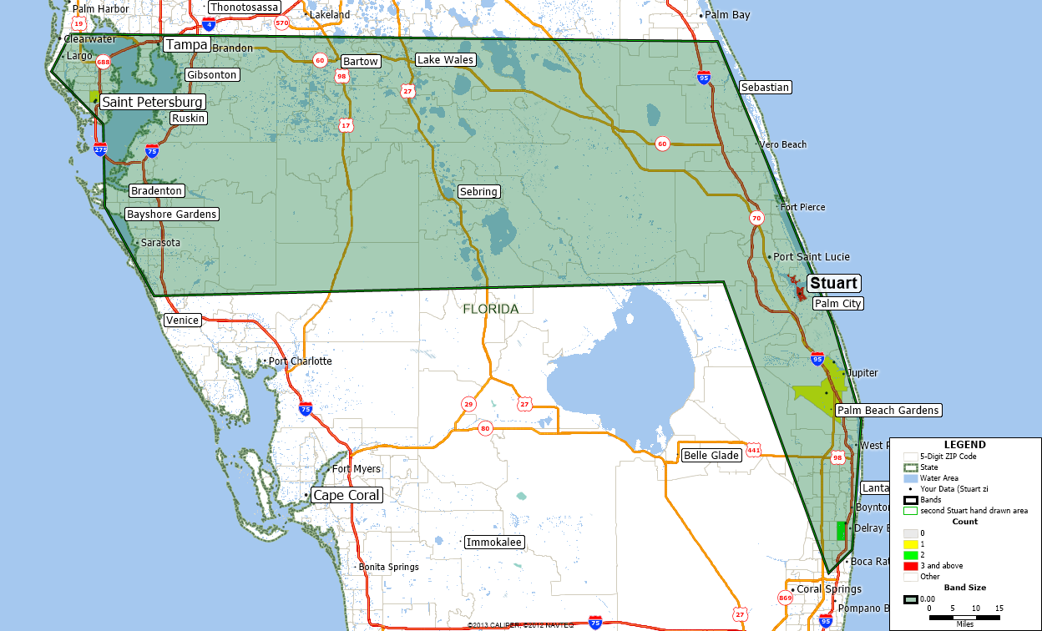
Data: Waters Edge and Caliper Corp.
Note: Zip codes for Waters Edge patients are shown in the yellow, green, and red colors as per the legend in the lower right-hand corner of the Figure.

Figure 3: Rate of Substance Use Disorders in area around Stuart, Florida, 2008-2010
Geographical Area | Dependence or Abuse of Illicit Drugs or Alcohol in the Past Year | Needing But Not Receiving Treatment for Illicit Drug Use in the Past Year | Needing But Not Receiving Treatment for Alcohol Use in the Past Year
Florida | 8.54% | 2.28% | 6.67%
Indian River, Martin, Okeechobee, and St. Lucie counties | 8.71% | 2.69% | 6.42%
Data: Substance Abuse and Mental Health Administration (SAMHSA), NSDUH Survey,
Pooled Estimates, 2008-2010. Tables 19, 20, and 21.

Figure 4: Estimated Number of Adults in Waters Edge Catchment Area impacted by Alcohol and Illicit Drugs, 2008-2010
Geographical Area | Dependence or Abuse of Illicit Drugs or Alcohol in the Past Year | Needing But Not Receiving Treatment for Illicit Drug Use in the Past Year | Needing But Not Receiving Treatment for Alcohol Use in the Past Year
Florida | 8.54% | 2.28% | 6.67%
Indian River, Martin, Okeechobee, and St. Lucie counties | 8.71% | 2.69% | 6.42%
Population of Adults within current catchment area | 2,761,772 | 2,761,772 | 2,761,772
Percent of Adults with substance use disorder | 240,550 | 74,292 | 177,306
Data: Substance Abuse and Mental Health Administration (SAMHSA), NSDUH Survey, and Caliper Corporation. Note: SAMHSA methodology develops these as separate calculations and counts of persons needing but not receiving treatment for illicit drug use or alcohol do not add up to the number of persons dependent or abusing such substances.

Figure 5: Location of Day/Night Programs in Central Florida, 2014
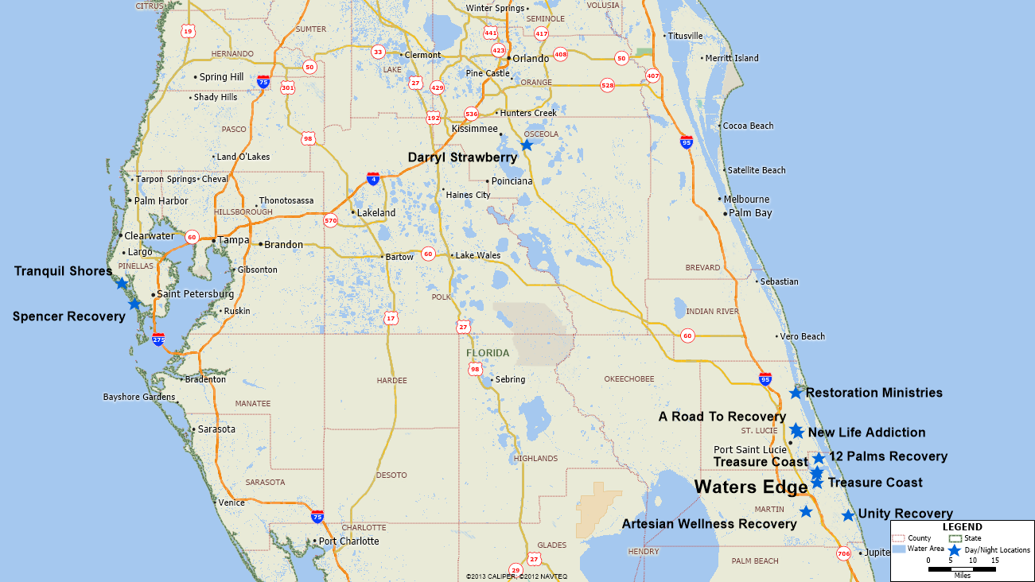
Data: Florida Department of Children and Families

Figure 5: Estimate of Need Calculations
Calculation Steps
Estimate number of adults in catchment area | 2,761,772
Percentage with substance use disorder | 8.71%
Estimate percentage with insurance | 69.87%
Assume percentage that might come to treatment | 30%
Estimate percentage that will use Day/Night programs | 3%
Total number of persons using Day/Night services | 1,513
Data: Calculations by Hendrickson Development

Day or Night Treatment with Community Housing is a type of substance abuse treatment licensed by the State of Florida where the treatment is provided at one location and the community housing at another. See 65D-30.0081, Florida Administrative Code.
This report relies on color to convey information and is best printed in color if hard copies are made or viewed with magnification when looking at those Figures that are maps.
See Florida administrative rules at 65D-30.0081 Standards for Day or Night Treatment with Community Housing, and Residential Treatment, https://www.flrules.org/gateway/ChapterHome.asp?Chapter=65D-30, retrieved on 1-2-2014.
In contrast, Florida rules for intensive outpatient services only require nine hours a week of treatment. See https://www.flrules.org/gateway/RuleNo.asp?title=SUBSTANCE ABUSE SERVICES OFFICE&ID=65D-30, retrieved on 1-2-2014.
For example, see Table 11, Substance Abuse Block Grant Behavioral Health Report, in which “short-term residential is defined as “up to 30 days.” Examples of Behavioral Health Report can be found at the website https://bgas.samhsa.gov/Default.aspx Sign in as “citizenfl” and use “citizen” as the password. Then look for Behavioral Health Reports.
See http://stat.bls.gov/oes/current/oes_38940.htm#21-0000, retrieved on 1-16-2014.
See http://www.samhsa.gov/data/NSDUH/substate2k10/AgeGroupTables/NSDUHsubstateAgeGroupTabs2010.pdf, retrieved on 1-1-2014.
SAMHSA methodology develops these as separate calculations and counts of persons needing but not receiving treatment for illicit drug use or alcohol do not add up to the number of persons dependent or abusing such substances.
See https://www.naatp.org/facility/12-palms-recovery/, retrieved on 1-17-2014.
See http://www.youtube.com/watch?v=Q1ZBp5LZbpc, retrieved on 1-17-2014.
See http://www.tcpalm.com/news/2013/sep/23/torino-treatment-campus-port-st-lucie-city-council/ , retrieved on 1-17-2014.
See http://www.artesianrecovery.com/community-housing.html , retrieved on 1-17-2014.
See http://www.tcpalm.com/news/2013/dec/31/torino-treatment-center-sues-port-st-lucie-city/ . See New Life zoning application, http://psl.granicus.com/MetaViewer.php?view_id=6&event_id=725&meta_id=92231, retrieved on 1-17-2014.
Information obtained from Form 990 for 2011.
See http://www.prlog.org/11984961-treasure-coast-recovery-now-accepting-those-suffering-from-drug-alcohol-problems.html, retrieved on 1-17-2014.
The bed size of the program can be found on the builder’s website. See http://www.ibisbuild.com/projects.html, retrieved on 1-17-2014. There are two photos of the Unity Recovery project. Clicking on them will result in a gallery which has text captions of the project.
The adult population in the catchment area in Figure X is calculated from block-level census data.
The percentage is based on the SAMHSA Circuit 19 substate estimates.
A weighted average of the percentage of adults aged 18-65 with health insurance was made for the four counties in the SAMHSA Circuit 19 substate area from U.S. Census data. The percentage of persons without insurance should decline as the Affordable Care Act improves its enrollment levels.
SAMHSA has also studied how many persons would actually seek treatment and concluded that nationally, about one third of the persons who are not getting treatment but say they need treatment actually make an effort to get treatment. See http://www.samhsa.gov/data/NSDUH/2k11Results/NSDUHresults2011.pdf, retrieved on 10-15-2013. A 30.8% figure is discussed on page 85 of the PDF version of the 2011 NSDUH report. See also the lower estimates in Carlson, R. Et al. (2010), Predictors of Substance Abuse Treatment Entry among Rural Illicit Stimulant Users in Ohio, Arkansas, and Kentucky, Subst Abus. 2010 January 31(1): 1–7. doi: 10.1080/08897070903442459, retrieved on 10-15-2013 from http://www.ncbi.nlm.nih.gov/pubmed/20391264.
The estimate of 3% is obtained from the New Jersey Substance Abuse Monitoring System (NJ-SAMS) data for SFY 2012. The New Jersey data indicate that 2.3% of all substance abuse treatment discharges were for partial hospitalization. New Jersey is the only state, to the best of the author’s knowledge, that collects and reports information on all persons that use substance abuse services. All other states report only data for state-funded programs.
See http://www.state.nj.us/humanservices/das/news/reports/statistical/Substance%20Abuse%20Overview%20Reports%202012/Sub_Abuse_Overview_2012_Atl.pdf, retrieved on 1-1-2014. The New Jersey data show that the most frequent service used is outpatient, used by 28%, and intensive outpatient, used by 22% of all persons seeking treatment.
If occupancy were at 100%, then 72 persons would receive services each year.

