Age and Medicare Utilization in Ocean County, New Jersey
Presentation to Zoning Board of Adjustment

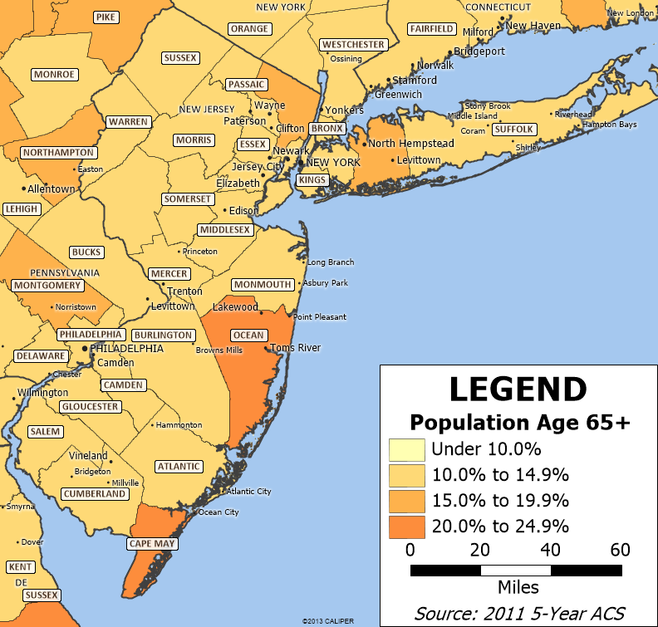

October 16, 2014
I have been asked to provide an opinion on two topics. First, is there a need in Toms River for a nursing home providing skilled post-hospital nursing services? Second, are occupancy rates in existing nursing homes so low that no new nursing homes of any kind should be built in Ocean County?

The proposed 124-bed nursing program at Toms River is needed and will provide short-term skilled medical and rehabilitation services required by persons being discharged from the hospital. This facility will have no impact on the occupancy rates of homes providing long-term custodial care.

Summary of Findings

- The beds used in the proposed 124-bed skilled nursing care program in Toms River were transferred from other nursing homes in Ocean County and were part of a transaction involving 291 beds of which 124 were included in the proposed Toms River home, 114 beds were transferred from Ocean to Atlantic County and 53 beds were transferred from Ocean to Monmouth County. Thus the net result of this transaction will be an increase in the occupancy rates of existing homes in Ocean County because 167 beds were transferred out of Ocean County. (Figure 1)

- Data from the state of New Jersey project that an additional 183,313 adults over the age of 65 will be added to the four counties of Atlantic, Burlington, Monmouth and Ocean between 2010 and 2030. Approximately 50,296 of these persons will be in Ocean County. (Figures 2 and 3)

- Two distinct groups of patients use nursing homes. The first group consists of persons discharged from hospitals who need skilled nursing and rehabilitative care for short periods of time, typically 28 days or less. The care for these persons is primarily paid for by Medicare. The second group consists of persons who need custodial care for long periods of time. The care for these persons is primarily paid for by Medicaid and the average length of stay in a New Jersey nursing home of these persons is about two and a half years.

- Patients needing post-hospital skilled nursing care are typically treated in a separate unit of the nursing home whose nurses are more specialized because the patients have more complicated medical conditions. These units may have higher staffing levels. Patients receiving this level of care routinely receive more rehabilitative services.

- The proposed program at Toms River is designed to provide the skilled medical rehabilitative services that persons discharged from the hospital require.
- An examination of Medicare hospital discharge data by zip code shows that out of 39,000 zip codes, two of the top five zip codes with the highest rate of Medicare hospital discharges are in the Toms River area. Other zip codes in Ocean County also have unusually high rates of Medicare hospital utilization. (Figures 4 and 5)

- The number of persons that have been using short term skilled services has been increasing and the number of persons that are receiving long-term custodial care is decreasing. (Figures 6 and 7)

- Based on utilization rates of persons using short-term skilled and long term custodial care, it is reasonable to infer that occupancy problems, to the extent that they exist in some homes, are due to declines in the number of persons using their long-term custodial care beds. (Figure 8)

- Nursing home utilization in the United States has been declining since 1997. An examination of 2014 nursing home occupancy rates in the four-county area shows that 75% of the homes have occupancy rates higher than 80% and another 14% have rates between 70% and 79%. (Figure 9)

- State Department of Health records indicate that 423 beds have been added in the four-county area since January of 2012. It is reasonable to conclude that significant numbers of nursing home owners thought there was a demand for new beds. If owners had concerns about excess bed supply they would not be opening new beds.(Figure 10)

- An analysis of projected Medicare utilization of skilled nursing facilities indicates that by 2030, only 15 years from now, there will be approximately 14,385 more annual Medicare admissions to nursing homes in the four-county area and an estimated 3,947 of those admissions will be in Ocean County. (Figure 11)

- Contemporary medical architecture emphasizes the use of single-occupancy rooms like those proposed in Toms River because they prevent medical infection, promote family caregiving by including the family in caring for the patient, and are more efficient to operate. (Figure 12)

- There is a demonstrable need for the proposed program in Toms River and it will satisfy the need for skilled services in the Ocean County area given the County’s unusually high rate of Medicare hospital utilization and projected population growth.

Discussion of Figures

Figure 1 shows that the beds for this Toms River facility were transferred from other locations within Ocean County and are simply an inter-county change in the location of existing beds. Moreover, the transfers resulted in 114 beds being moved from Ocean County to Atlantic County and 53 beds being moved from Ocean County to Monmouth County. Thus not only are no new beds being built, but the equivalent of a large nursing home has been moved out of Ocean County. The net impact of the bed transfers is to increase occupancy rates in Ocean County.

Figure 1: Beds Transferred to the Proposed Facility and Other Counties
Where beds came from |  |  | Where the Beds Went
Beds Transferred From | Number of Beds Transferred |  | Atlantic County | Monmouth County | Toms River
Country Manor /Kensington Manor both already in Ocean County | 224 |  | 47 | 53 | 124
HealthSouth also in Ocean County | 67 |  | 67
Total | 291 |  | 114 | 53 | 124
Data: Lapid Ventures

Figure 2 uses projections from the state’s Department of Workforce and Labor Development which indicate that an additional 183,313 persons over the age of 65 will be added to the population in the four counties of Ocean, Atlantic, Burlington and Monmouth between 2010 and 2030.

Figure 2: Growth in Ocean, Atlantic, Burlington and Monmouth Counties in Number of Persons Aged 60 and Older, 2010-2030.
Ocean | 2010 | 2015 | 2020 | 2025 | 2030 | Older Population Increase
65-69 | 31,740 | 37,900 | 39,300 | 44,300 | 44,400 | 12,660
70-74 | 26,474 | 30,500 | 36,500 | 38,100 | 42,900 | 16,426
75-79 | 23,556 | 22,900 | 26,400 | 31,800 | 33,200 | 9,644
80-84 | 19,724 | 18,700 | 18,300 | 21,300 | 25,800 | 6,076
85+ | 19,610 | 21,600 | 22,300 | 22,800 | 25,100 | 5,490
All 65 plus | 121,104 | 131,600 | 142,800 | 158,300 | 171,400 | 50,296

Atlantic | 2010 | 2015 | 2020 | 2025 | 2030 | Older Population Increase
65-69 | 12,034 | 14,900 | 16,700 | 19,900 | 19,800 | 7,766
70-74 | 9,054 | 10,500 | 13,100 | 14,800 | 17,700 | 8,646
75-79 | 7,035 | 7,500 | 8,700 | 10,900 | 12,400 | 5,365
80-84 | 5,567 | 5,300 | 5,700 | 6,700 | 8,400 | 2,833
85+ | 5,212 | 5,900 | 6,200 | 6,700 | 7,600 | 2,388
All 65 plus | 38,902 | 44,100 | 50,400 | 59,000 | 65,900 | 26,998

Burlington | 2,010 | 2,015 | 2,020 | 2,025 | 2,030 | Older Population Increase
65-69 | 18,562 | 23,400 | 25,500 | 30,500 | 31,800 | 13,238
70-74 | 13,884 | 16,400 | 20,800 | 22,800 | 27,300 | 13,416
75-79 | 11,612 | 11,900 | 14,200 | 18,100 | 19,900 | 8,288
80-84 | 9,417 | 9,200 | 9,500 | 11,400 | 14,600 | 5,183
85+ | 8,715 | 10,100 | 10,700 | 11,400 | 12,800 | 4,085
All 65 plus | 62,190 | 71,000 | 80,700 | 94,200 | 106,400 | 44,210

Monmouth | 2010 | 2015 | 2020 | 2025 | 2030 | Older Population Increase
65-69 | 26,194 | 33,500 | 37,100 | 42,700 | 42,900 | 16,706
70-74 | 18,148 | 22,900 | 29,400 | 32,700 | 37,700 | 19,552
75-79 | 15,444 | 15,700 | 19,800 | 25,500 | 28,500 | 13,056
80-84 | 13,154 | 12,400 | 12,600 | 16,000 | 20,600 | 7,446
85+ | 13,751 | 15,300 | 15,800 | 16,400 | 18,800 | 5,049
All 65 plus | 86,691 | 99,800 | 114,700 | 133,300 | 148,500 | 61,809

Total | 2010 | 2015 | 2020 | 2025 | 2030 | Older Population Increase
65-69 | 88,530 | 109,700 | 118,600 | 137,400 | 138,900 | 50,370
70-74 | 67,560 | 80,300 | 99,800 | 108,400 | 125,600 | 58,040
75-79 | 57,647 | 58,000 | 69,100 | 86,300 | 94,000 | 36,353
80-84 | 47,862 | 45,600 | 46,100 | 55,400 | 69,400 | 21,538
85+ | 47,288 | 52,900 | 55,000 | 57,300 | 64,300 | 17,012
All 65 plus | 308,887 | 346,500 | 388,600 | 444,800 | 492,200 | 183,313
Data: New Jersey Department of Workforce and Labor Development. See http://lwd.dol.state.nj.us/labor/lpa/dmograph/lfproj/lfproj_index.html
Figure 3 shows a graph of this increase in the population of persons over the age of 65 in the four-county area.
Figure 3: Graph of Growth in Ocean, Atlantic, Burlington and Monmouth in the Number of Persons Aged 65 and Older, 2010-2030

Data: New Jersey Department of Workforce and Labor Development. See http://lwd.dol.state.nj.us/labor/lpa/dmograph/lfproj/lfproj_index.html

For at least three decades, utilization of American nursing homes has been characterized as being composed of two distinct populations:
1) A Medicare population that is discharged from a hospital to receive post-hospital rehabilitation and skilled care for a short period of time lasting from 17 to 28 days, and
2) A Medicaid population with less acuity that stays for an extended period and receives custodial care. The average Medicaid length of stay in a New Jersey nursing home is approximately two and a half years. The care of the post hospital group is typically provided in a separate section of the nursing home that resembles a mini-hospital where nurses typically have more specialized training, patients have more complex acuities and receive more intensive rehabilitation services.
The proposed program at Toms River is designed to provide the skilled rehabilitative services that persons coming out of the hospital need.
Figure 4 shows the top five zip codes in the country of where Medicare hospital patients come from. The data were developed by analyzing a file showing the number of Medicare patients that came from each zip code to each hospital. The file contained data on patients from approximately 39,000 zip codes. An analysis of the data showed that out of the 39,000 zip codes, two of the top five zip codes were in Ocean County.
Figure 4: Top Five Zip Codes of Medicare Hospital Patients in the United States for 2012
Count of Medicare Discharges | Zip code of Patients | Location of Zip Code
7,841 | 08759 | Manchester Township, NJ
7,533 | 32162 | The Villages, FL
6,824 | 08757 | Berkeley Township, NJ
6,471 | 85351 | Sun City, AZ
6,301 | 11235 | Brooklyn, NY
Data: Centers for Medicare and Medicaid Services, Hospital Service Area File.
http://www.cms.gov/Research-Statistics-Data-and-Systems/Files-for-Order/NonIdentifiableDataFiles/HospitalServiceAreaFile.html

Figure 5 shows a map of Medicare discharges by zip code and it can be seen that Medicare hospital users not only come from Manchester and Berkeley Townships but also come in large numbers from other parts of Ocean County. These data show that the Ocean County area has an exceptionally heavy concentration of Medicare hospital utilization.

Figure 5: Map of Ocean County Area showing Home Zip Code of Medicare Patients Discharged from a Hospital, 2012
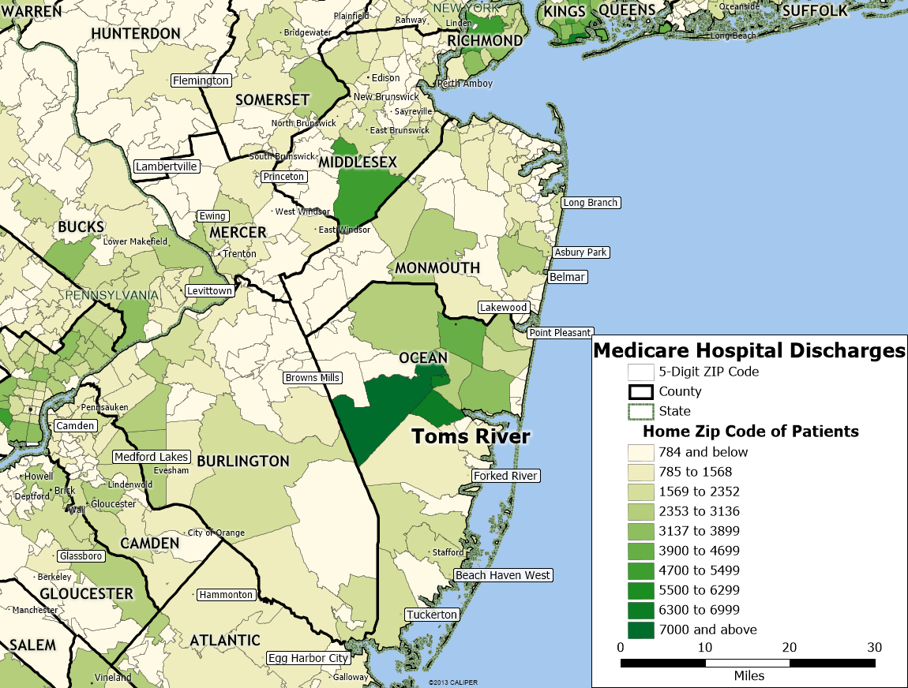
Data: Center for Medicare and Medicaid Services, Hospital Service Area File.
http://www.cms.gov/Research-Statistics-Data-and-Systems/Files-for-Order/NonIdentifiableDataFiles/HospitalServiceAreaFile.html

Utilization in American nursing facilities has been characterized since 1997 by a gradual, but continued decline in the custodial population because of the increasing availability of alternatives such as the use of assisted living and in-home services, improvement of health in older populations, low Medicaid reimbursement, and continued Federal policy efforts to provide Medicaid services outside of institutions. These national factors have created declines in all states. At the same time Medicare utilization has gradually increased.
Figure 6 shows the growth in Medicare utilization in the United States and in New Jersey.

Figure 6: % Growth in Medicare Use of Nursing Homes United States and New Jersey, 2001-2013

Data: Centers for Medicare and Medicaid Services, Online Survey, Certification and Reporting file. http://www.ahcancal.org/research_data/oscar_data/Pages/default.aspx

The state of New Jersey does not track the number of its beds that nursing homes use for the skilled services and the number used for custodial services. The beds used to provide these services are not readily interchangeable. As noted before, the skilled beds are usually in small, separate units, that require more skilled nursing and rehabilitative staff, and have higher staff levels.
For example, a nursing home with a skilled unit might negotiate with a cardiology practice at a local hospital to provide particular protocols of cardiology post-operative care to the patients that the cardiologists discharge from the hospital. The nursing home benefits by obtaining the referrals from the cardiology practice and the cardiologists benefit by ensuring their patients get optimal post-operative care.
In New Jersey as well as other states, nursing home operators have been opening or expanding skilled units to accommodate the increased demand for such services. The proposed Toms River project is intended to meet the demand for the skilled services needed by persons discharged from hospitals. The Toms River program will not provide custodial services and will not compete with existing nursing homes that provide custodial services.
Figure 7 shows that monthly Medicare utilization in New Jersey has increased from 5,000 plus persons a month in 2001 to 8,000 plus persons a month in 2013.
Figure 7: Number of Persons using Medicare in New Jersey Nursing Homes, 2001-2014

Data: Centers for Medicare and Medicaid Services, Online Survey, Certification and Reporting file. http://www.ahcancal.org/research_data/oscar_data/Pages/default.aspx
Note: Persons whose nursing home use is paid by Medicare

Figure 8 shows the decline in the number of non-Medicare persons in New Jersey nursing homes from over 39,500 in 2001 to 37,000 plus in 2013. This decline has created vacancy problems in homes with sizeable numbers of custodial beds. As noted above, the program in Toms River is intended to provide skilled services, not custodial services, and will neither increase nor decrease the occupancy rate of custodial beds.

Figure 8: Number of Non-Medicare Persons in New Jersey Nursing Homes, 2001-2014

Data: Centers for Medicare and Medicaid Services, Online Survey, Certification and Reporting file. http://www.ahcancal.org/research_data/oscar_data/Pages/default.aspx
Note: Persons whose nursing home use is not paid by Medicare

Figure 9 reviews the current occupancy rates of nursing homes in Atlantic, Burlington, Ocean and Monmouth County.
Nursing home utilization in the United States has been declining since 1997. As discussed above, vacancy issues in nursing homes are primarily due to declines in the number of Medicaid and private pay persons that received custodial care for long periods in homes. In addition to national factors affecting all states, there are three state-specific factors that influence the occupancy rates reported for New Jersey nursing homes.
First, occupancy is dependent on the existence of alternatives. Nursing home care in New Jersey is expensive. In 2013 the average semi-private room in a New Jersey nursing home costs $109,500 a year. However, assisted living cost $65,160 and in-home services cost $48,345. It is hard for families to pay for nursing homes especially during economic recessions such as we are experiencing in New Jersey.
Second, an occupancy rate is dependent upon the number of beds that a nursing home provider owns. Owners have an economic incentive to have more beds than they need since beds can be sold in New Jersey. Providers with too many beds can sell them and there is an active market in New Jersey around the buying and selling of beds. Beds are currently being sold for $10,000 to $12,000 per bed. The economic incentive to have more beds than you need lowers reported occupancy rates, but represents an economic benefit to owners of nursing home beds.
Third, the resident data reported on the Department of Health website are self-reported data from nursing homes provided in compliance with federal requirements. Nursing homes are publically judged on the basis of the staff to resident ratios reported. Even a slight downward bias in the number of reported residents would increase the staffing ratio and make the nursing home appear to more in compliance with federal staffing standards. The downward bias in resident counts would lower reported occupancy rates.
Figure 9: 2014 New Jersey Nursing Facility Occupancy Rates
2014 | Number of Facilities with Occupancy Rates | Number of Facilities with Occupancy Rates | Number of Facilities with Occupancy Rates | Number of Facilities with Occupancy Rates
 | under .699 | .70 to .799 | .80 to .899 | .90 +
Atlantic | 2 | 5 | 4 | 1
Burlington | 2 | 0 | 4 | 12
Monmouth | 2 | 5 | 11 | 13
Ocean | 3 | 3 | 20 | 9
Total | 9 | 13 | 39 | 35
% of Total | 9% | 14% | 41% | 36%
Data: New Jersey Department of Health,
Note: Data is missing for Neptune in Monmouth County

Figure 10 presents data on the number of new nursing home beds that have been added in the four counties since January 1, 2012. If there were concerns about occupancy, then we would likely not find that nursing home owners were opening hundreds of new beds and acquiring new facilities. Instead, the data show that a net of 423 beds have been added in the four counties. Moreover, in February 2014, AristaCare Health Services of South Plainfield acquired the 165-bed former Manchester Manor in Manchester Township, which is now operating as AristaCare at Manchester.

Figure 10: Net Beds Added (or Reduced) between 1-1-2012 and 9-20-2014 in Atlantic, Burlington, Monmouth and Ocean Counties
County | Name of Nursing Home |  | Change in Beds
Atlantic County | Eastern Pines Convalescent Center |  | 10
 | Egg Harbor - Opened in 2013 |  | 106
 | Linwood Care Center |  | 16
 | Meadowview Nursing & Respiratory |  | 42
 | Royal Suites H&R |  | 26
Burlington County | Burlington Woods |  | -12
 | The Evergreens - Opened in 2012 |  | 34
Monmouth County | Bayshore Health Care Center |  | 31
 | Chapin Hill at Red Bank |  | 50
 | Laurel Bay Health & Rehab. Center |  | 5
 | Monmouth Cc - John L. Montgomery Division |  | 18
 | Victoria Health Care Center |  | 32
 | Wedgewood Gardens Care Center |  | 31
Ocean County | Manahawkin Convalescent Center |  | 15
 | Shore Meadows Rehab. & Nursing Center |  | 19
All Four Counties | Total Beds added since 1-1-2012 |  | 423
Data: New Jersey Department of Health

Figure 11 calculates that by 2030 there will be 14,385 more Medicare post-hospital admissions for skilled nursing facility services in the four-county area of Atlantic, Burlington, Monmouth, and Ocean counties. In Ocean County alone there will be approximately 3,947 more admissions.

Figure 11: Projection of Medicare Utilization in the Atlantic, Burlington, Monmouth, and Ocean Counties by 2030
Rows | Data | Name of Data | Data Source
Row 1 | 1,398,000 | Medicare beneficiaries | 2012 CMS Data for NJ
Row 2 | 377,092 | Hospital discharges | 2012 CMS Data for NJ
Row 3 | 73,524 | Persons admitted to SNFs | 2012 CMS Data for NJ
Row 4 | 109,708 | Admissions to SNFs | 2012 CMS Data for NJ
Row 5 | 5.26% | Percent of persons admitted to SNFS | Row 3/Row 1
Row 6 | 29.09% | SNF admits over discharges | Row 4/Row 2
Row 7 | 1.49 | Ratio admissions to persons | Row 4/Row 3
Row 8 | 183,313 | Older population increase in the four Counties | Figure 1
Row 9 | 9,641 | Yearly Increase in number of persons admitted to SNFs | Row 5*Row 8
Row 10 | 14,385 | Yearly increase in SNF Admissions in the four counties | Row 7*Row 9
Row 11 | 50,296 | Older population increase in Ocean County | Figure 1
Row 12 | 2,645 | Yearly Increase in number of Ocean County persons admitted to SNFs | Row 5*Row 11
Row 13 | 3,947 | Yearly increase in SNF Admissions in Ocean County | Row 7*Row 12
Data: Centers for Medicare and Medicare Services.
https://www.cms.gov/Research-Statistics-Data-and-Systems/Statistics-Trends-and-Reports/MedicareMedicaidStatSupp/2013.html

The proposed program in Toms River will use single occupancy rooms. All hospitals built in New Jersey in the last decade have been built with single occupancy rooms and there are clear public preferences for such rooms.

Figure 12 discusses the characteristics of single occupancy rooms and its advantages indicate why contemporary medical architecture emphasizes such rooms.

Figure 12: Beneficial Characteristics of Private Rooms
The private room controls infection risk by minimizing the additional traffic and infection complications that come with two residents to a room.
The room has many small design features which minimize infection. For example, a wash sink is built near the door, but the sink is automatic and has no faucet handles thus minimizing the transmission of bacteria and other organisms from hand to hand.
The rooms are family friendly and are designed to encourage family participation in the care of the person. The rooms are built with fold out sofas that can be used as a bed and may have reclining chairs with big comfortable cushions. They have refrigerators for use by family members where they can bring their own food and drinks. Break rooms for families are often built with vending machines, a microwave, and computer access encouraging family members to stay longer.
The room is private and permits private conversations with the physicians and nurses as there is the possibility that patient conversations can be inhibited when third parties are present;
The technology of the private room is different. A computer is placed in the room so changes can be entered into the medical record immediately rather than later The large television screens are also linked to the acute care center’s electronic records so patient information such as x-rays can be shown on the screen.
The room is designed to accommodate the person. For example, beds and bathrooms are built on the same wall to minimize falls and there is often a grab bar on the wall from the bed to the bathroom. Windows are large and permit ample light and open views

Conclusions

There is a demonstrable need for the program in Toms River. The proposed program will satisfy the need for skilled services in the Ocean County area given its unusually high rate of Medicare hospital utilization and projected population growth.

The proposed skilled nursing program at Toms River is intended to only provide the short term skilled services needed by persons being discharged from the hospital. The proposed program will have no impact on the occupancy rates of homes providing long-term custodial care.

Les Hendrickson, Ph.D.
Hendrickson Development
leslie.c.hendrickson@gmail.com
http://www.hendricksondevelopment.biz
609-213-0685 (cell)

See Genworth cost of care by state https://www.genworth.com/corporate/about-genworth/industry-expertise/cost-of-care.html

