The Assessment of Need for Residential Level 1
and Detoxification Programs
in Juno Beach, Florida

April 2014

TABLE OF CONTENTS
SUMMARY…………………………………………………………………………………….3
FLORIDA ADMINISTRATIVE ULES……………………………………………………..…4
CHARACTERISTICS OF THE JUNO BEACH AREA……………………………………….4
Population Density
Income
Population in Drive Bands around Juno Beach
AVERAGE SIZE AND LOCATIONS OF EXISTING RESIDENTIAL LEVEL 1 AND DETOXIFICATION PROGRAMS………………………………………………………….. ..6
Residential Level 1 Programs
Detoxification Programs
ESTIMATING THE DEMAND…………………..………………………………..………….7
Areas West and North of Juno Beach
Numbers of Persons Potentially Treated by a Residential and Detoxification
Program in Juno Beach

CONCLUSIONS………………………………………………………………….…………….9
APPENDIX…………………………………………………………………….….……………10
List of Figures
SUMMARY
The purpose of this report is to examine the need for a small 11-bed substance abuse Residential Level 1 program and a 9-bed substance abuse detoxification program in Juno Beach, Florida. The programs already exist and are currently operated under the business name of Oceanside Detox. This report is generated by the fact that the existing program may have its zoning authority removed or curtailed.
- The Juno Beach Residential Level 1 and Detoxification programs supply a need for services. These are small programs located in an area of higher than average need. Even if they operated at 100% occupancy, more services are still needed in this geographic area.

- Assuming statewide average length of stays, approximately 138 patients a year could be treated in the Juno Beach Residential Level 1 program and 582 persons in its Detoxification program.

- The geographical area around Juno Beach is densely populated.

- Within a ninety-minute driving distance of Juno Beach there are an estimated 4.3 million people over the age of 18.

- An examination of the distances from Juno Beach to the other Residential Level 1 and Detoxification programs shows that the area west and north of Juno Beach has fewer programs than the area south of Juno Beach. The heaviest cluster of programs is about 20 miles south. Given the distribution of existing programs the analysis focuses on the areas west and north of Juno Beach where there few other residential and detoxification beds.

- In Florida, the statewide average size of a Residential Level 1 program is 24 beds and the average size of a Detoxification program is 18 beds approximately.

- There are an estimated 740,028 persons over the age of 18 in the area west and north of Juno Beach within a 90-minute driving distance.

- Federal statistics estimating the percentage of the population over the age of 18 that is involved with alcohol and drugs can be applied to estimates of population size in the area west and north of Juno Beach. This analysis indicates that in the area west and north of Juno Beach approximately 64,456 persons were dependent on or abused illicit drugs or alcohol. Approximately 19,907 needed but did not receive treatment for illicit drugs, and approximately 47,510 needed but did not receive treatment for alcohol.

FLORIDA ADMINISTRATIVE RULES

In the Florida Administrative Code regulating the Department of Children and Families (DCF), at Rule 65D-30.007, a Level 1 Residential program is described as “… those that provide services on a short-term basis. This level is appropriate for persons who have sub-acute biomedical problems or behavioral, emotional, or cognitive problems that are severe enough that they require inpatient treatment, but do not need the full resources of an acute care general hospital or a medically managed inpatient treatment program.” Descriptions of the other residential levels in Rule 65D-30.007 assume longer stays than Level 1 Residential programs and serve less acute persons.

These same regulations at Rule 65D-30.006 of the Florida Administrative Code describe the standards for a Residential Detoxification program. A reading of the Rule indicates that medical staffing is associated with these programs since Detoxification treats persons at a sub-acute stage of drug addiction which is a slightly more intense level than Residential Level 1 treatment but less intense than actual hospitalization. The program not only provides medical and nursing care while the patient is helped to detoxify from substances, but also provides social services addressing personality and social conditions that led to the drug addiction. The program requires a range of skilled staff that is expensive to provide. In the architecture of drug treatment, the Residential Detoxification programs are an essential gateway to successful drug addiction treatment.

CHARACTERISTICS OF THE JUNO BEACH AREA

Population Density
Figure 1 maps the population density in the greater Juno Beach area and shows the coastal area is densely populated. Census tracts along this part of Florida contain 1,000 to 5,000 persons per square mile. For contrast, New Jersey is the most densely populated state in the country and in 2010 it had a population density of 1,195 persons per sq. mile.
Income
Persons who can afford to pay for their own services usually seek and find their services from private or non-profit medical providers rather than relying on services provided by public agencies which often have income limits on who can use their services. Middle-income and above persons have higher utilization rates of medical services since the higher the income the more likely someone in the household is employed and either has health insurance through an employer or is self insured. Household income is thus a potential measure of the ability to obtain access to medical services including all varieties of mental health and substance abuse treatment services.

Income has a dual effect. Not only does it permit the purchase of medical services but it increases the demand for substance abuse services. Nationally published research of opioid availability by county indicates that the availability of active physicians is positively correlated with the amount of opioids prescribed. It is ironic and unfortunate that the ability to purchase health services brings with it an increase in prescription drug abuse via access to physicians that prescribe opioids. An understanding of which geographic areas might generate a demand for substance abuse services from private or non-profit providers needs to take into account areas of middle income and above.

Figure 2 shows average household income in census tracts in the greater Juno Beach area. The coastal regions are mixed with areas of high income interspersed with areas of low income. Census tracts immediately adjacent to the coast tend to have higher income. Florida interior tracts tend to have lower income. Figure 3 presents a close up of the Juno Beach area showing it has numerous higher income census tracts near it.

Population in Drive Bands around Juno Beach

Figure 4 maps 30, 60, and 90-minute driving zones around Juno Beach that encompasses a significant population. Based on U.S. Census statistics from the 2011 American Community Survey (ACS), there are an estimated 625,959 persons over the age of 18 in the 30-minute drive band around Juno Beach, an estimated 1,482,057 persons in the 30-60 minute drive band, and an estimated 2,161,919 persons in the 60-90 minute drive band persons in the 30-60 minute drive band. Roughly speaking, within an hour and half drive of Juno Beach there are approximately 4.3 million persons over the age of 18.

AVERAGE SIZE AND LOCATIONS OF EXISTING RESIDENTIAL LEVEL 1 AND DETOXIFICATION PROGRAMS
Residential Level 1 Programs
Florida data supplied by DCF indicate that in August 2013 there were 36 licensed Residential Level 1 programs with a total licensed bed capacity of 850 beds. The average licensed bed capacity was approximately 24 beds. At 11 beds, the Juno Beach residential program is less than half the size of the average Residential Level 1 program.
Figure 5 maps the locations of existing Residential Level 1 programs in the Juno Beach area. Figure 6 shows the distances of nearby Residential Level 1 programs to Juno Beach. Except for one program, all the other Residential Level 1 programs are 20 miles or more from Juno Beach. The nearest program to the north is about 38 miles away in Fort Pierce. The nearest program to the south is about 7 miles away. After that, to the south, there is a cluster of programs in the Lake Worth area, which is about 20 miles from Juno Beach. There are a sizeable number of beds in these programs. An internet search for information about these programs shows that the Palm Beach County area is known for a concentration of expensive treatment programs marketed primarily to wealthy out-of-state individuals. These programs are not comparable to the modest treatment program in Juno Beach.
Figure 7 is an “area of influence” map. A green polygon, denoting the “area of influence” is calculated around each Level l program in the Juno Beach area. The polygon is drawn so that all locations in in the polygon are closer to that program than they are to any other program. In other words, if you live in a given polygon then the distance to another program outside your area is farther than the distance to the program within your area.
Figure 7 shows that in the area of influence of the Oceanside Recover Center, there are 165,437 adults. Should the Oceanside Recovery Residential Level 1 program in Juno Beach have to close, any of the 165,437 persons that would wish to use this type of program would have to travel further to obtain the services. This is a direct measure of the impact of a potential closure.
Detoxification Programs
Florida data supplied by DCF establish that in August 2013 there were 58 licensed Detoxification programs with a total licensed bed capacity of 1,057 beds. The average licensed bed capacity was approximately 18 beds. At nine beds, the Juno Beach Detoxification program is half the size of the average detoxification program.
Figure 8 maps the location of Detoxification programs in the Juno Beach area.
Figure 9 shows the distances of nearby Detoxification programs to Juno Beach. Two of the programs are within 20 miles of Juno Beach and six others are 20 miles or greater from Juno Beach. There is a 10 bed program in Tequesta to the north and the next programs to the north are about 40 miles away in Fort Pierce. These two programs are licensed for 12 and 18 beds. To the south, the nearest program is seven miles away and is a small one with six licensed beds. There is a cluster of programs in the Lake Worth area with a sizeable number of beds among them.
This location information show that there are, relatively speaking, few programs to the north of Juno Beach and the nearest concentration of beds to the south is about 20 miles away. Given the distribution of existing programs the analysis focuses on the areas west and north of Juno Beach where there are few other residential and detoxification beds.
ESTIMATING THE DEMAND
Areas West and North of Juno Beach
Figure 10 contains a hand-drawn green polygon roughly corresponding to the area due west of Juno Beach and north that is within the 90-minute driving zone. The analysis of block-level data within the coordinates of the polygon shows there are an estimated 740,028 persons over the age of 18 in this area. These persons could potentially use programs in Juno Beach.
Substance Abuse Treatment Need in Florida
The federal Substance Abuse and Mental Health Services Administration (SAMHSA) estimates the need for substance abuse treatment services by interviewing households and aggregating the data across multi-year periods. The answers are further broken out by substate estimates. SAMHSA provides data on each circuit in Florida. The area around Juno Beach spans Circuit 15 to the south and Circuit 19 to the west and north. Circuit 19 includes the counties of Indian River, Martin, Okeechobee, and St. Lucie. These Circuit 19 counties are generally those that would be potentially served by a program in Juno Beach and are captured in the green polygon on an attached map.
Figure 11 contains the SAMHSA estimates for Florida as a whole and substate estimates for Circuits 15 and 19. These estimates are in terms of the percentages of persons over the age of 18. Each column in the Table represents a separate question and the percentages in one column are independent of the percentages in the other two columns across answers The data show the Juno Beach area to the west and north has higher rates of substance abuse characteristics than the state as a whole and Circuit 15 to the south.
Federal statistics estimating the percentage of the population over the age of 18 that is involved with alcohol and drugs can be applied to estimates of population size in the area west and north of Juno Beach. Figure 12 takes the federal percentages for the drug and alcohol conditions and calculates the number of persons affected by them in the geographical area west and north of Juno Beach. The data indicate that these are sizeable numbers of persons impacted by problems with drugs and alcohol in this area.
Numbers of Persons Potentially Treated by a Residential and Detoxification Program in Juno Beach
Data was obtained from the DCF on the number of patients treated and the number of units of service provided for each of the 171 state-funded Residential and Detoxification programs in FY 2012-2013. This Information was aggregated for each of Florida’s five Residential Levels and Detoxification services and an average length of stay was calculated. The results of this calculation are shown in Figure 13. Consistent with the regulatory descriptions provided above, the Residential Level 1 service level has the lowest average length of stay (ALOS) of the five Residential Levels and Detoxification is a short intensive program whose ALOS reflects its brevity.
Figure 14 takes the statewide ALOS data and uses it to estimate the number of patients that could be treated at the Juno Beach programs given the bed sizes of those programs. The number of beds is discounted by 10% to reflect the fact that programs rarely operate at 100% occupancy for an entire year and, instead, a conservative 90% occupancy rate is assumed. The data show that the number of patients that can be served is low compared to the number of persons needing services in the area west and north of Juno Beach.

CONCLUSIONS
Based on these data, I conclude that the Juno Beach Residential Level 1 and Detoxification programs at Oceanside Recovery supply much needed services. These are small programs located in an area of higher than average need. Even if they operated at 100% occupancy, more services are still needed in this geographic area.
Leslie Hendrickson Ph.D.
leslie.c.hendrickson@gmail.com
http://hendrickson-consulting.com/

APPENDIX
List of Figures
Figure 1: Population Density in Census Tracts around Juno Beach Area

Figure 2: Household Income in Census Tracts around Juno Beach Area

Figure 3: Close Up of Household Income in Census Tracts around Juno Beach Area

Figure 4: 30, 60, and 90-minute driving bands around Juno Beach

Figure 5: Residential Level 1 Programs near Juno Beach
Figure 6: Location of Residential Level 1 Programs Closest to Juno Beach, August 2013

Figure 7: Areas of Influence around each Residential Level 1 Program in Juno Beach area and Number of Persons aged 18 years of age and older

Figure 8: Detoxification Programs near the Oceanside Detox Program in Juno Beach

Figure 9: Location of Detoxification Programs Closest to Juno Beach, August 2013.

Figure 10: A Hand-Drawn Polygon of the 30, 60, and 90 Minute Drive Bands in Areas West and North of Juno Beach

Figure 11: Substance Abuse and Mental Health Services Administration Substate Estimates for Florida, 2008-2010

Figure 12: Estimated Number of Persons and Drug and Alcohol Conditions in area West and North of Juno Beach

Figure 13: Average Length of Stay in DCF Residential and Detoxification
Programs, FY 2012-2013

Figure 14: Estimates Number of Patients that could be Treated in Existing Juno Beach Programs, FY 2012-2013

Figure 1: Population Density in Census Tracts around Juno Beach Area
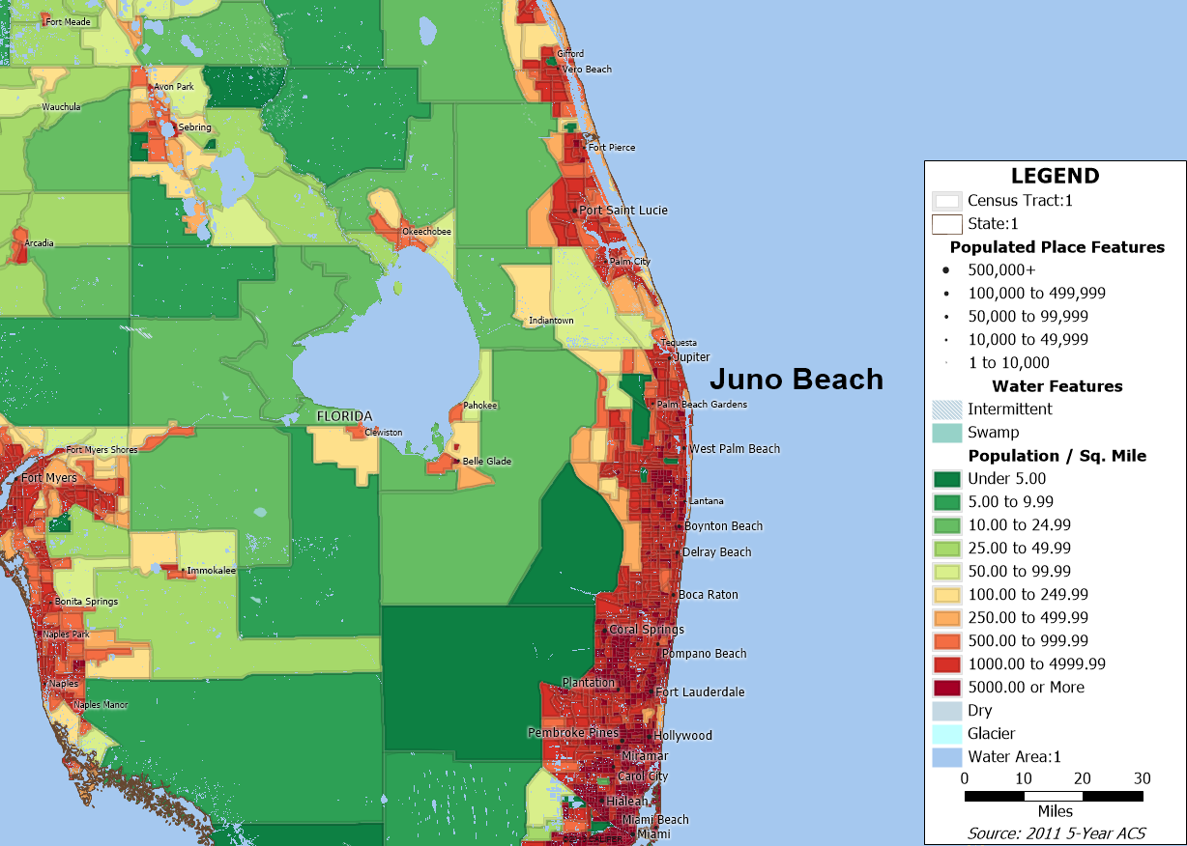
Data: U.S. Census, 2011 5-Year American Community Survey

Figure 2: Household Income in Census Tracts around Juno Beach Area
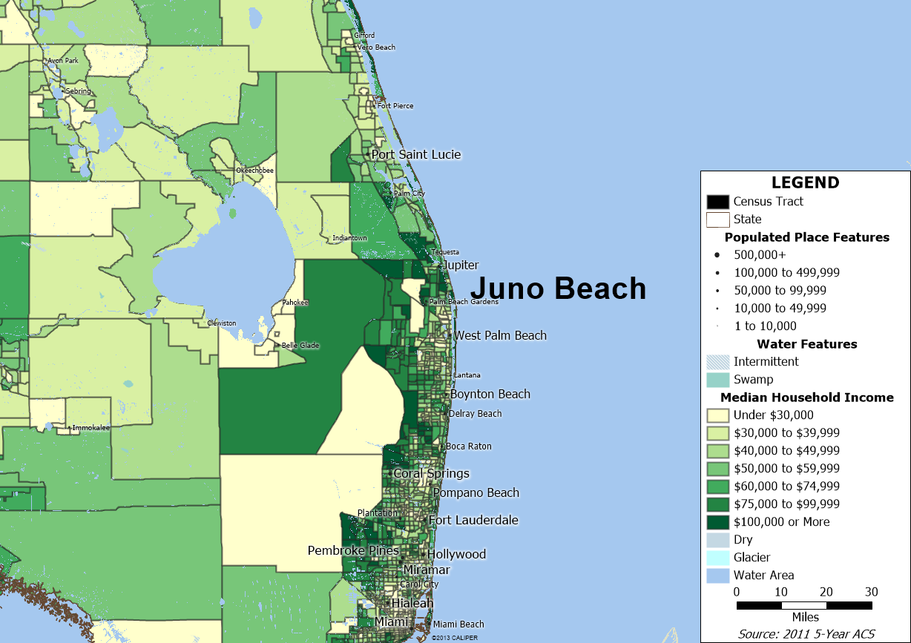
Data: U.S. Census, 2011 5-Year American Community Survey

Figure 3: Close Up of Household Income in Census Tracts around Juno Beach Area
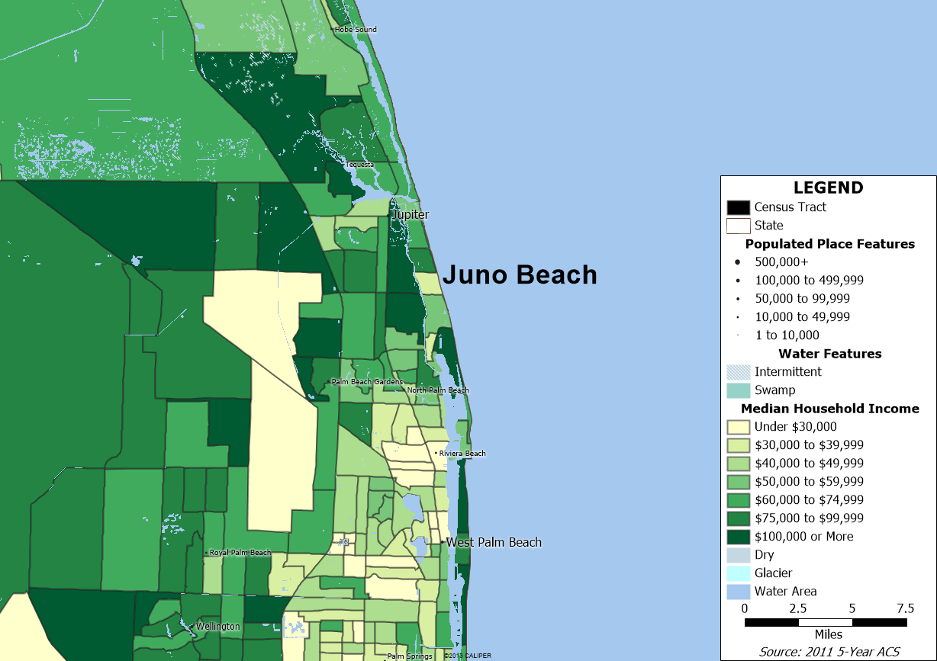
Data: U.S. Census, 2011 5-Year American Community Survey

Figure 4: 30, 60, and 90-minute driving bands around Juno Beach
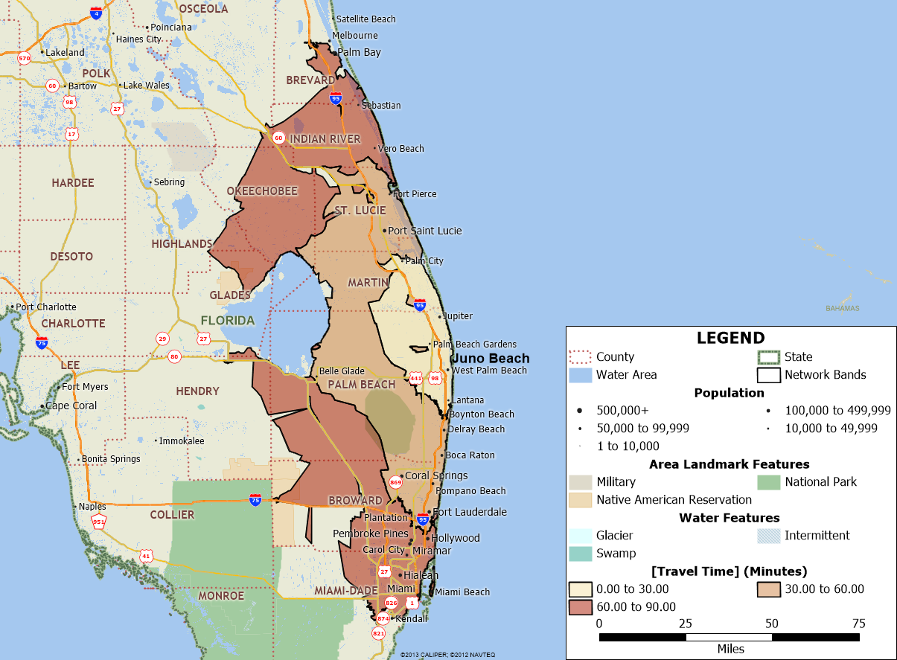
Data: Caliper Corporation, 2014

Figure 5: Residential Level 1 Programs near Juno Beach
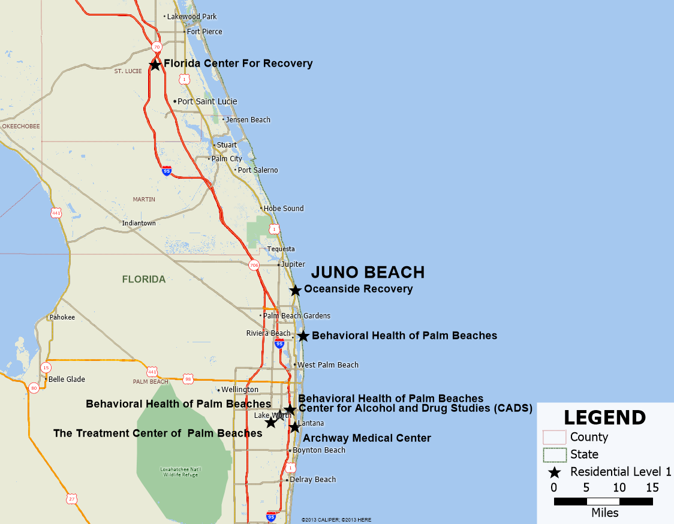
Data: Florida Department of Children and Families

Figure 6: Location of Residential Level 1 Programs Closest to Juno Beach, August 2013
Name | City | Miles from Juno Beach | Number of Licensed Beds
Behavioral Health of the Palm Beaches | Palm Beach Shores | 7 to south | 18
Behavioral Health of the Palm Beaches | Lake Worth | 20 to south | 20
Behavioral Health of the Palm Beaches | Lake Worth | 20 to south | 4
Center for Alcohol and Drug Studies | Lake Worth | 20 to south | 32
The Treatment Center of the Palm Beaches | Lake Worth | 20 to south | 44
Archway Medical Center | Lantana | 21 to south | 10
Florida Center For Recovery | Fort Pierce | 40 to north | 54
Data: Licensing and bed data from Florida Department of Children and Families

Figure 7: Areas of Influence around each Residential Level 1 Program in Juno Beach area and Number of Persons aged 18 years of age and older
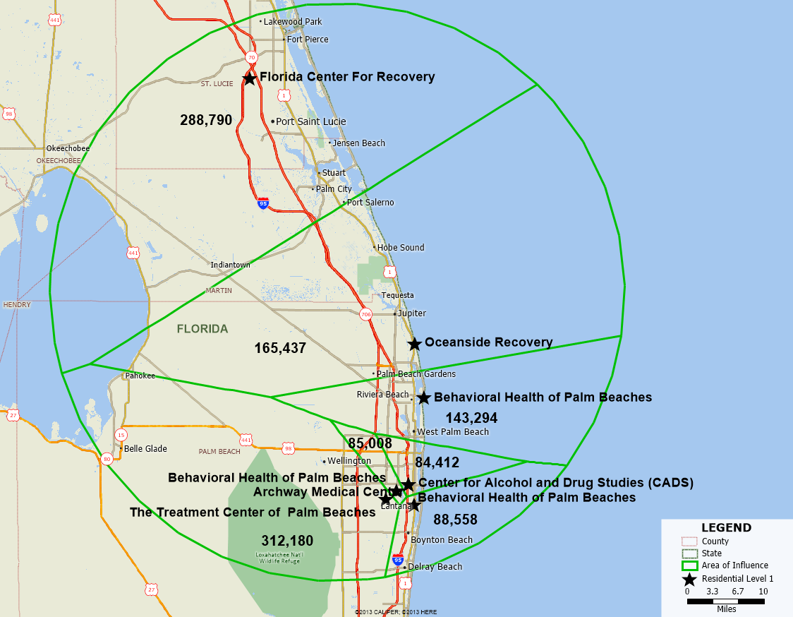
Data: Caliper Corporation, U.S. Census, 5-year 2011 American Community Survey
Note: The numbers in the green polygons are the number of persons aged 18 years of age and older. A green polygon, denoting the “area of influence” is calculated around each Level l program in the Juno Beach area. The polygon is drawn so that all locations in in the polygon are closer to that program than they are to any other program. In other words, if you live in a given polygon then the distance to another program outside your area is farther than the distance to the program within your area.
Figure 8: Detoxification Programs near the Oceanside Detox Program in Juno Beach
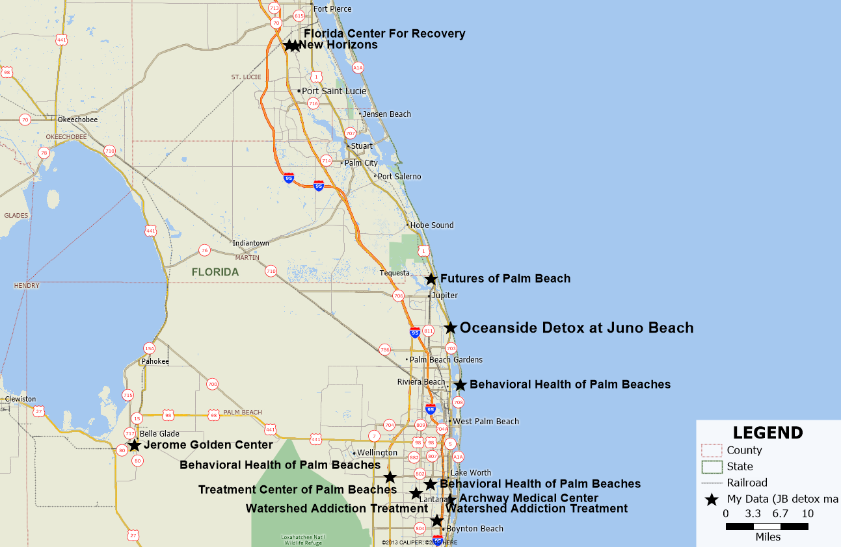
Data: Florida Department of Children and Families

Figure 9: Location of Detoxification Programs Closest to Juno Beach, August 2013
Name | City | Miles from Juno Beach | Number of Licensed Beds
Futures of Palm Beach | Tequesta | 7 to north | 10
Behavioral Health of the Palm Beaches | Palm Beach Shores | 7 to south | 6
Behavioral Health of the Palm Beaches | Lake Worth | 20 to south | 82
Behavioral Health of the Palm Beaches | Lake Worth | 20 to south | 10
Treatment Center of the Palm Beaches | Lake Worth | 20 to south | 70
Archway Medical Center | Lantana | 21 to south | 18
New Horizons of the Treasure Coast | Fort Pierce | 40 to north | 12
Florida Center For Recovery | Fort Pierce | 40 to north | 18
Data: Licensing and bed data from Florida Department of Children and Families

Figure 10: A Hand-Drawn Polygon of the 30, 60, and 90 Minute Drive Bands in Areas West and North of Juno Beach
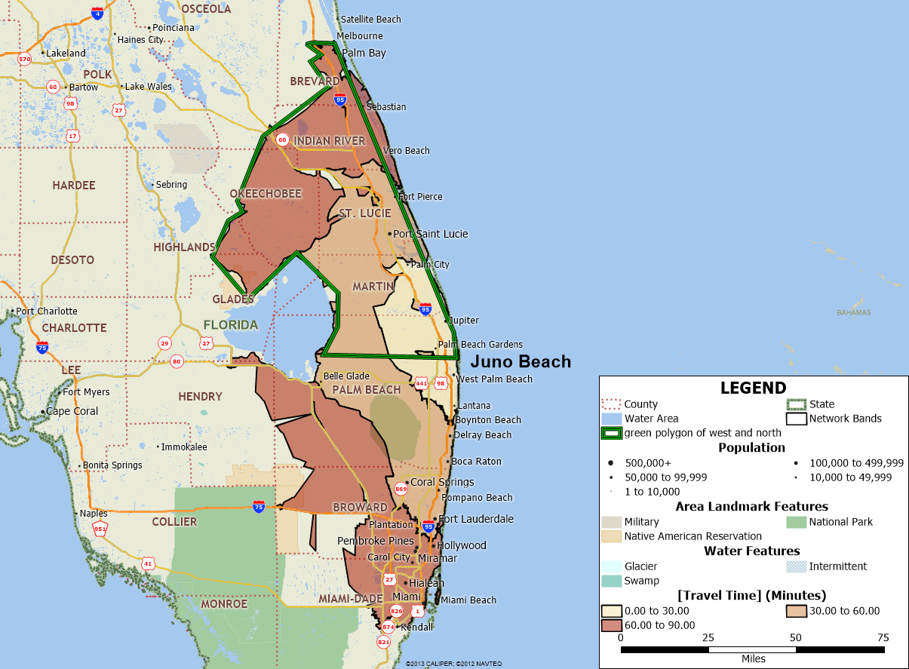
Data: Caliper Corporation and U.S. Census, Five-year 2011 American Community Survey (ACS)
Note: The hand-drawn green polygon is used to enclose the areas west and north of Juno Beach that are within the 30, 60, and 90 minute drive bands. This permits the block level aggregation of census data to determine the number of person 18 years of age and older within the area.

Figure 11: Substance Abuse and Mental Health Services Administration Substate Estimates for Florida, 2008-2010
Percentage of Persons over the age of 18 | Dependence or Abuse of Illicit Drugs or Alcohol in the Past Year | Needing But Not Receiving Treatment for Illicit Drug Use in the Past Year | Needing But Not Receiving Treatment for Alcohol Use in the Past Year
Florida | 8.54% | 2.28% | 6.67%
Circuit 15 (Palm Beach) | 7.75% | 1.08% | 6.23%
Circuit 19 Indian River, Martin Okeechobee, St Lucie | 8.71% | 2.69% | 6.42%
Data: Substance Abuse and Mental Health Services Administration, N-SSATS 2011.
Note: Data are percentages of persons over the age of 18. Columns are independent of one
another.

Figure 12: Estimated Number of Persons and Drug and Alcohol Conditions
in area West and North of Juno Beach
Data from SAMHSA Tables | Dependence or Abuse of Illicit Drugs or Alcohol in the Past Year | Needing But Not Receiving Treatment for Illicit Drug Use in the Past Year | Needing But Not Receiving Treatment for Alcohol Use in the Past Year
Estimated population west and north of Juno Beach in the 90-minute driving band | 740,028 | 740,028 | 740,028
Circuit 19 Indian River, Martin Okeechobee, St Lucie | 8.71% | 2.69% | 6.42%
Estimated number of persons over the age of 18 | 64,456 | 19,907 | 47,510
Data: Substance Abuse and Mental Health Services Administration, N-SSATS 2011, U.S.
Census, American Community Survey, 2011, Calculations by Hendrickson Development.

Figure 13: Average Length of Stay in DCF Residential and Detoxification
Programs, FY 2012-2013
Service Level | Number of Patients Treated | Units of Service | Average Length of Stay
Residential Level 1 | 934 | 24,400 | 26.12
Residential Level 2 | 7,978 | 401,125 | 50.28
Residential Level 3 | 504 | 40,958 | 81.27
Residential Level 4 | 518 | 29,297 | 56.56
Substance Abuse Detoxification | 21,750 | 110,494 | 5.08
Grand Total | 31,684 | 606,274 | 19.14
Data: Patients and Units of Service from Florida Department of Children and Families.
Calculations by Hendrickson Development

Figure 14: Estimates Number of Patients that could be Treated in Existing Juno Beach Programs, FY 2012-2013
Beds in Existing Juno Beach Programs | Number of Beds | Number of Beds at .90 Occupancy | Average Length of Stay | Number of Patients Treated per Year
Residential Level 1 | 11 | 9.9 | 26.12 | 138
Detoxification | 9 | 8.1 | 5.08 | 582
Data: Calculations by Hendrickson Development

See retrieved on 8-22-2013 from https://www.flrules.org/gateway/chapterhome.asp?chapter=65D-30
See retrieved on 8-23-2013 from http://www.census.gov/compendia/statab/2012/tables/12s0014.pdf
For example, in the data reviewed in this report, the correlation between county income and the percent of behavioral health visits to the hospital emergency department is -.70. See Figures 2 and 6.
See, McDonald, D., et al. (2012, October), Geographic Variation in Opioid Prescribing in the U.S., J Pain. 13(10): 988–996. retrieved on 12-8-2013 http://www.ncbi.nlm.nih.gov/pmc/articles/PMC3509148/pdf/nihms399782.pdf
For example, some seven million persons in the United States are estimated to abuse prescription drugs See , http://www.reuters.com/article/2012/04/25/us-usa-healthcare-drugs-idUSBRE83O04W20120425 retrieved on 11-16-2013
For example see, retrieved on 9-14-2013, from http://www.floridatrend.com/article/1475/floridas-ritzy-rehab-centers?page=1
Census data used is based on 2011 U.S. Census figures from the American Community Survey (ACS).
The selection of the 90-minute drive zone is a reasonable estimate to use given that areas immediately south of Juno Beach are excluded from consideration and studies of distance traveled show that persons will travel further to attend residential programs.
These aggregated estimates are based on the years of 2008-2010 and can be found at http://www.samhsa.gov/data/NSDUH/substate2k10/toc.aspx
Chapter 65E-14.021 of the Florida Administrative Code describes the unit of cost payment system used by DCF. The unit of service for Residential and Detoxification programs is one bed day as specified at Rule 65E-14.021(x) and Rule 65E-14.021(hh). See retrieved on 8-24-2013 from https://www.flrules.org/gateway/RuleNo.asp?ID=65E-14.021
The DCF regulatory definitions of the residential levels can be found at 65D-30.007, retrieved on 8-25-2013 from, https://www.flrules.org/gateway/chapterhome.asp?chapter=65D-30

