Program Need Assessment Juno Beach
Summary
The purpose of this report is to briefly examine the need for a small 11-bed substance abuse residential level 1 program in Juno Beach, Florida and a 9-bed substance abuse detoxification program. The programs already exist and are currently operated under the business name of Oceanside Detox.
The geographical area around Juno Beach is densely populated.
Within a ninety-minute driving distance of Juno Beach there are an estimated 4.3 million people over the age of 18.
An examination of the distances from Juno Beach to the other Residential Level 1 and Detoxification programs shows that the area west and north of Juno Beach has fewer programs than the area south of Juno Beach. The heaviest cluster of programs is about 20 miles south. Given the distribution of existing programs it makes sense to focus on the areas west and north of Juno Beach where there few other residential and detoxification beds.
Statewide, the average size of a Residential Level 1 program is 24 beds and the average size of a Detoxification program is 18 beds approximately.
There are an estimated 740,028 persons over the age of 18 in the area west and north of Juno Beach within a 90-minute driving distance.
Federal statistics estimating the percentage of the population over the age of 18 that is involved with alcohol and drugs can be applied to estimates of population size in the area west and north of Juno Beach. This analysis indicates that in the area west and north of Juno Beach approximately 64,456 persons were dependent on or abused illicit drugs or alcohol. Approximately 19,907 needed but did not receive treatment for illicit drugs, and approximately 47,510 needed but did not receive treatment for alcohol.
Assuming statewide average length of stays, approximately 138 patients a year could be treated in the Juno Beach Residential Level 1 program and could serve and 582 persons in its Detoxification program.
The Juno Beach Residential Level 1 and Detoxification programs supply a need for services. These are small programs located in an area of higher than average need. Even if they operated at 100% occupancy, more services are still needed in this geographic area.
Florida Administrative Rules
In the Florida Administrative Code regulating the Department of Children and Families (DCF), at Rule 65D-30.007, a Level 1 Residential program is described as “… those that provide services on a short-term basis. This level is appropriate for persons who have sub-acute biomedical problems or behavioral, emotional, or cognitive problems that are severe enough that they require inpatient treatment, but do not need the full resources of an acute care general hospital or a medically managed inpatient treatment program.” Descriptions of the other levels in Rule 65D-30.007 indicate that they assumed to entail longer stays than Level 1 Residential programs.
These same regulations at Rule 65D-30.006 of the Florida Administrative Code describe the standards for a Residential Detoxification program. A reading of the Rule shows that medical staffing is associated with these programs since Detoxification treats persons at a sub-acute stage of drug addiction at a slightly more intense level than Residential Level 1 treatment but less intense than actual hospitalization. The program not only provides medical and nursing care while the patient is helped to detoxify from substances, but also provides social services addressing personality and social conditions that led to the drug addiction. The program requires a range of skilled staff that are expensive to provide. In the architecture of drug treatment, the Residential Detoxification programs are an essential gateway to successful drug addiction treatment.
Population Density
The map of population density in the greater Juno Beach area shows the coast is a densely populated area. Many of the zip codes along the coast contain 1,000 to 5,000 persons per square mile. For contrast, New Jersey is the most densely populated state in the country and in 2010 it had a population density of 1,195 persons per sq. mile.
Map of Population Density Here

Population in Driving Bands around Juno Beach
The map showing 30, 60 and 90-minute driving zones around Juno Beach encompasses a significant population. Based on U.S. Census statistics from the 2011 American Community Survey (ACS), there are an estimated 625,959 persons over the age of 18 in the 30-minute driving band around Juno Beach, an estimated 1,482,057 persons in the 30-60 minute driving band, and an estimated 2,161,919 persons in the 60-90 minute driving band persons in the 30-60 minute driving band. Roughly speaking, within an hour and half drive of Juno Beach there are approximately 4.3 million persons over the age of 18.
Map of 30, 60 and 90-Minute Driving Bands Here
Average Size and Locations of Existing Residential Level 1 and Detoxification Programs
Residential Level 1 Programs
Data supplied by DCF show that in Florida in August 2013 there were 36 licensed Residential Level 1 programs with a total licensed bed capacity of 850 beds. The average licensed bed capacity was approximately 24 beds. At 11 beds, the Juno Beach residential program is less than half the size of the average Residential Level 1 program.
The next map shows the location of Residential Level 1 programs in the Juno Beach area.
Map of Residential Level 1 Programs Here
Table 1 below shows the distances of nearby Residential Level 1 programs to Juno Beach. The nearest program to the north is about 38 miles away in Fort Pierce. The nearest program to the south is about 7 miles away. After that, to the south there is a cluster of programs in the Lake Worth area, which is about 20 miles from Juno Beach. There are a sizeable number of beds in these programs. An internet search for information about these programs shows that the Palm Beach County area is known for a concentration of expensive treatment programs marketed primarily to wealthy out-of-state individuals. These programs are not comparable to the modest treatment program in Juno Beach.

Table 1: Location of Residential Level 1 Programs Closest to Juno Beach, August 2013
Name | City | Miles from Juno Beach | Number of Licensed Beds
Behavioral Health of the Palm Beaches | Palm Beach Shores | 7 to south | 18
Behavioral Health of the Palm Beaches | Lake Worth | 20 to south | 20
Behavioral Health of the Palm Beaches | Lake Worth | 20 to south | 4
Center for Alcohol and Drug Studies | Lake Worth | 20 to south | 32
The Treatment Center of the Palm Beaches | Lake Worth | 20 to south | 44
Archway Medical Center | Lantana | 21 to south | 10
Florida Center For Recovery | Fort Pierce | 40 to north | 54
Data: Licensing and bed data from Florida Department of Children and Families
Detoxification Programs
Data supplied by DCF show that in Florida in August 2013 there were 58 licensed Detoxification programs with a total licensed bed capacity of 1,057 beds. The average licensed bed capacity was approximately 18 beds. At nine beds, the Juno Beach Detoxification program is half the size of the average Detoxification program.
The next map shows the location of Detoxification programs in the Juno Beach area.
Map of Detoxification Programs Here
Table 2 below shows the distances of nearby Detoxification programs to Juno Beach. There is a 10 bed program in Tequesta to the north and the next programs to the north are about 40 miles away in Fort Pierce. These two programs are licensed for 12 and 18 beds. To the south the nearest program is seven miles away and is a small one with six licensed beds. There is a cluster of programs in the Lake Worth area with a sizeable number of beds among them.

Table 2: Location of Detoxification Programs Closest to Juno Beach, August 2013.
Name | City | Miles from Juno Beach | Number of Licensed Beds
Futures of Palm Beach | Tequesta | 7 to north | 10
Behavioral Health of the Palm Beaches | Palm Beach Shores | 7 to south | 6
Behavioral Health of the Palm Beaches | Lake Worth | 20 to south | 82
Behavioral Health of the Palm Beaches | Lake Worth | 20 to south | 10
Treatment Center of the Palm Beaches | Lake Worth | 20 to south | 70
Archway Medical Center | Lantana | 21 to south | 18
New Horizons of the Treasure Coast | Fort Pierce | 40 to north | 12
Florida Center For Recovery | Fort Pierce | 40 to north | 18
Data: Licensing and bed data from Florida Department of Children and Families
This location information show that there are, relatively speaking, few programs to the north of Juno Beach and the nearest concentration of beds to the south is about 20 miles away. Given the distribution of existing programs it makes sense to focus on the areas west and north of Juno Beach where there are few other Residential and Detoxification beds.
The Area West and North of Juno Beach
The map below with the green polygon roughly corresponds to the area due west of Juno Beach and north that is within the 90-minute driving zone. There are estimated 740,028 persons over the age of 18 in this area based on 2011 U.S. Census figures from the American Community Survey (ASCS). If distance were the only factor influencing where patients seek treatment, then these persons could potentially use programs n Juno Beach.
Map of Area West and South of Juno Beach within Approximate 90-minute Driving Band Here
Substance Abuse Treatment Need in Florida
The federal Substance Abuse and Mental Health Services Administration (SAMHSA) estimates the need for substance abuse treatment services by interviewing households and aggregating the data across multi-year periods. The answers are further broken out by substate estimates. SAMHSA provides data on each circuit in Florida. The area around Juno Beach spans Circuit 15 to the south and Circuit 19 to the west and north. Circuit 19 includes the counties of Indian River, Martin, Okeechobee, and St. Lucie. These Circuit 19 counties are generally those that would be potentially served by a program in Juno Beach and are captured in the green polygon on an attached map.
The table below shows the SAMHSA estimates for Florida as a whole and substate estimates for Circuits 15 and 19. These estimates are in terms of the percentages of persons over the age of 18. Each column in the Table represents a separate question and the percentages in one column are independent of the percentages in the other two columns across answers The data show the Juno Beach area to the west and north has higher rates of substance abuse characteristics than the state as a whole and Circuit 15 to the south.
Table 3: Substance Abuse and Mental Health Services Administration Substate Estimates for Florida, 2008-2010. Data is percentages of persons over the age of 18.
Percentage of Persons over the age of 18 | Dependence or Abuse of Illicit Drugs or Alcohol in the Past Year | Needing But Not Receiving Treatment for Illicit Drug Use in the Past Year | Needing But Not Receiving Treatment for Alcohol Use in the Past Year
Florida | 8.54% | 2.28% | 6.67%
Circuit 15 (Palm Beach) | 7.75% | 1.08% | 6.23%
Circuit 19 Indian River, Martin Okeechobee, St Lucie | 8.71% | 2.69% | 6.42%
Data: Substance Abuse and Mental Health Services Administration, N-SSATS 2011.
Federal statistics estimating the percentage of the population over the age of 18 that is involved with alcohol and drugs can be applied to estimates of population size in the area west and north of Juno Beach. The next table takes the federal percentages for the drug and alcohol conditions and calculates the number of persons affected by them in the geographical area west and north of Juno Beach. The data indicate that these are sizeable numbers of persons impacted by problems with drugs and alcohol in this area.

Table 4: Estimated Number of Persons and Drug and Alcohol Conditions in area West and North of Juno Beach.
Data from SAMHSA Tables | Dependence or Abuse of Illicit Drugs or Alcohol in the Past Year | Needing But Not Receiving Treatment for Illicit Drug Use in the Past Year | Needing But Not Receiving Treatment for Alcohol Use in the Past Year
Estimated population west and north of Juno Beach in the 90-minute driving band | 740,028 | 740,028 | 740,028
Circuit 19 Indian River, Martin Okeechobee, St Lucie | 8.71% | 2.69% | 6.42%
Estimated number of persons over the age of 18 | 64,456 | 19,907 | 47,510
Data: Substance Abuse and Mental Health Services Administration, N-SSATS 2011, U.S. Census, American Community Survey, 2011, Calculations by Hendrickson Development.
Numbers of Persons Potentially Treated by a Residential and Detoxification Program in Juno Beach
Data was obtained from the DCF on the number of patients treated and the number of units of service provided for each of the 171 state-funded Residential and Detoxification programs in FY 2012-2013. Chapter 65E-14.021 of the Florida Administrative Code describes the unit of cost payment system used by DCF. The unit of service for Residential and Detoxification programs is one bed day as specified at Rule 65E-14.021(x) and Rule 65E-14.021(hh).
Information from DCF on the patients treated and the units of service was aggregated for each of Florida’s five Residential levels and Detoxification services and an average length of stay was calculated. The results of this calculation are shown in the table below. Consistent with the regulatory descriptions provided above, the Residential Level 1 service level has the lowest average length of stay (ALOS) of the five Residential levels and Detoxification is a short intensive program whose ALOS reflects its brevity.

Table 5: Average Length of Stay in DCF Residential and Detoxification Programs, FY 2012-2013.
Service Level | Number of Patients Treated | Units of Service | Average Length of Stay
Residential Level 1 | 934 | 24,400 | 26.12
Residential Level 2 | 7,978 | 401,125 | 50.28
Residential Level 3 | 504 | 40,958 | 81.27
Residential Level 4 | 518 | 29,297 | 56.56
Substance Abuse Detoxification | 21,750 | 110,494 | 5.08
Grand Total | 31,684 | 606,274 | 19.14
Data: Patients and Units of Service from Florida Department of Children and Families. Calculations by Hendrickson Development
The following table takes the ALOS data and uses it to estimate the number of patients that could be treated at the Juno Beach programs given the bed sizes of those programs. The number of beds is discounted by 10% to reflect the fact that programs rarely operate at 100% occupancy for an entire year and, instead, a 90% occupancy rate is assumed. The data show that the number of patients that can be served is low compared to the number of persons needing services in the area west and north of Juno Beach.
Table 6: Estimates Number of Patients that could be Treated in Existing Juno Beach Programs, FY 2012-2013
Beds in Existing Juno Beach Programs | Number of Beds | Number of Beds at .90 Occupancy | Average Length of Stay | Number of Patients Treated per Year
Residential Level 1 | 11 | 9.9 | 26.12 | 138
Detoxification | 9 | 8.1 | 5.08 | 582
Data: Calculations by Hendrickson Development
Conclusions
Based on these data, I conclude that the Juno Beach Residential Level 1 and Detoxification programs supply a need for services. These are small programs located in an area of higher than average need. Even if they operated at 100% occupancy, more services are still needed in this geographic area.
Les Hendrickson, Ph.D.
leslie.c.hendrickson@gmail.com
http://www.hendricksondevelopment.biz
Map of Population Density in Zip Codes around Juno Beach Area
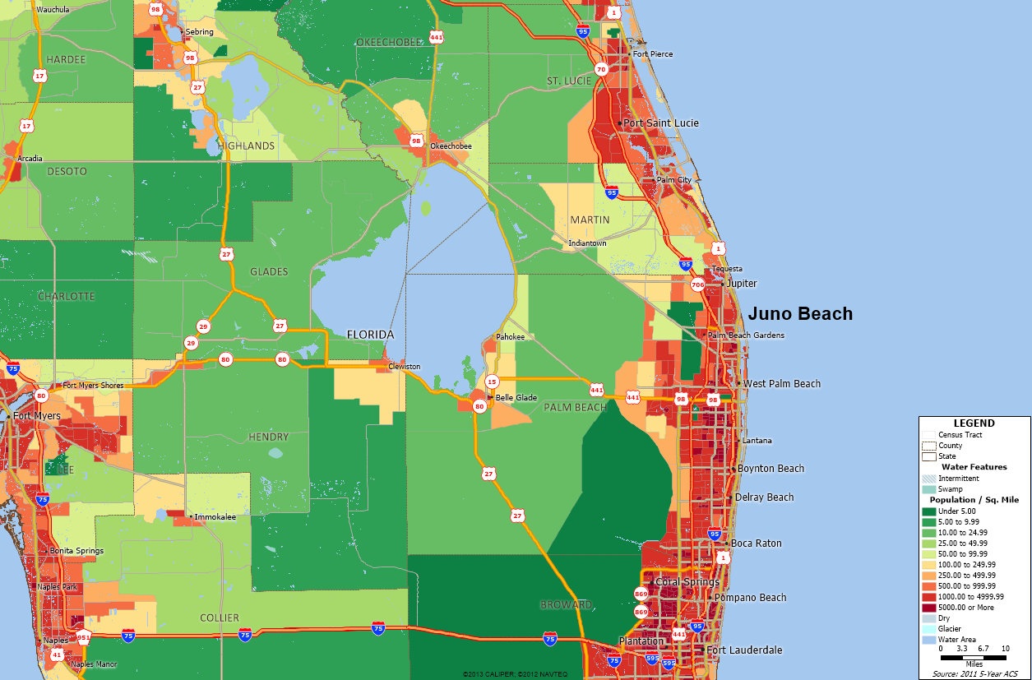

Map of 30, 60 and 90-Minute Driving Bands around Juno Beach
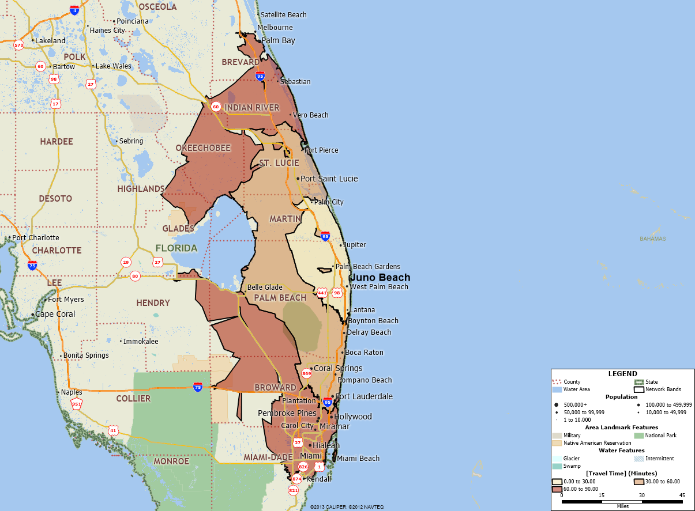

Map of Residential Level 1 Programs near the Oceanside Detox Program in Juno Beach
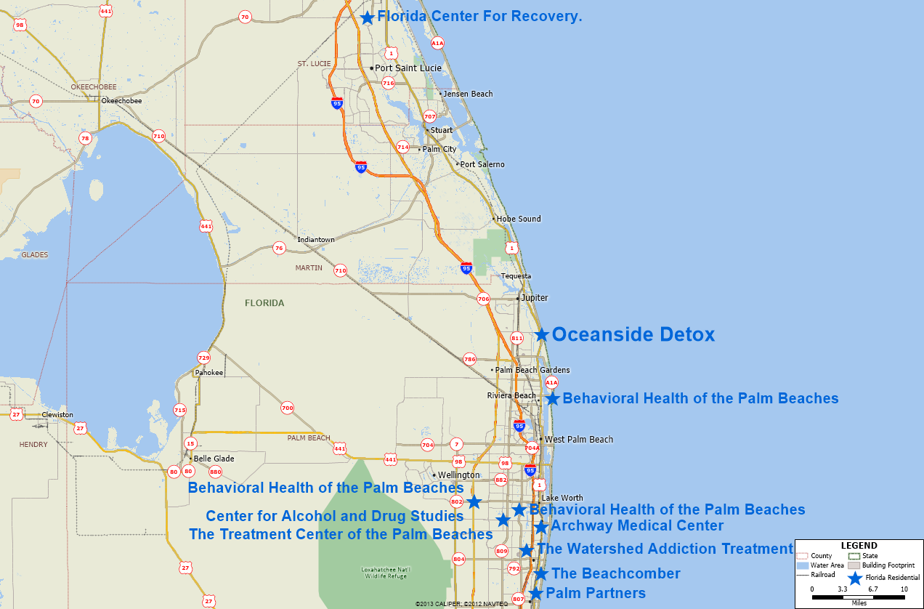

Map of Detoxification Programs near the Oceanside Detox Program in Juno Beach
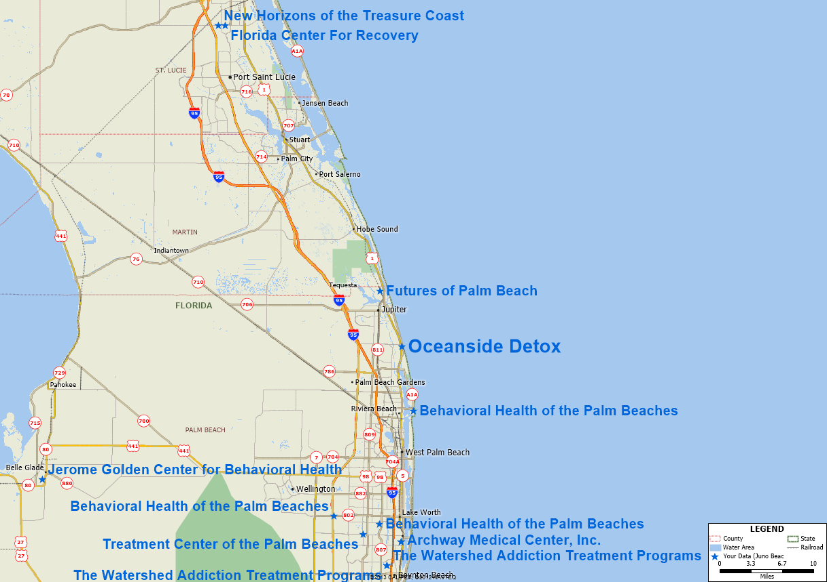

Map of Area West and North of Juno Beach within 90-minute Driving Band
The green polygon on the map was hand drawn and used to calculate the estimated population of persons aged 18 and older inside the polygon.
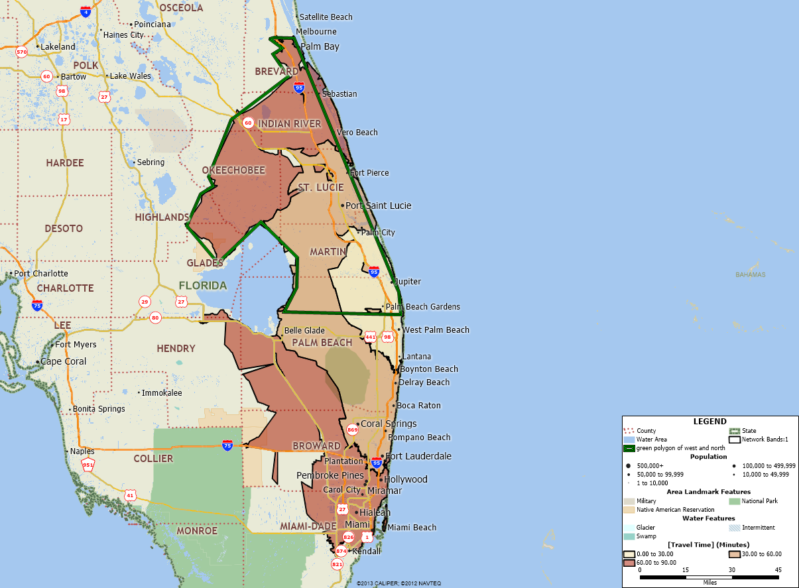

See retrieved on 8-22-2013 from https://www.flrules.org/gateway/chapterhome.asp?chapter=65D-30
See retrieved on 8-23-2013 from http://www.census.gov/compendia/statab/2012/tables/12s0014.pdf
For example see, retrieved on 9-14-2013, from http://www.floridatrend.com/article/1475/floridas-ritzy-rehab-centers?page=1
These aggregated estimates are based on the years of 2008-2010 and can be found at http://www.samhsa.gov/data/NSDUH/substate2k10/toc.aspx
See retrieved on 8-24-2013 from https://www.flrules.org/gateway/RuleNo.asp?ID=65E-14.021
The DCF regulatory definitions of the residential levels can be found at 65D-30.007, retrieved on 8-25-2013 from, https://www.flrules.org/gateway/chapterhome.asp?chapter=65D-30

